**2023 MAMMO   
  
1. What is the therapy which can suppress some specific genes related with occurrence and progress of breast cancer?**

a) Targeted Therapy

b) Radiation Therapy

c) Anti-hormone Treatment

d) Chemotherapy

**2. What is the score for 'mass in Phantom image evaluation?**

a. 3

*b. 3.5*

c. 4

d. 4.5

**3. What is the BI-RADS Category of lesion?**

a) Category 1

*b) Category 2*

c) Category 3

d) Category 4

**4. Which of the following is correct to explain the structure distortion?**

a) Structure distortion means suspected positive opinion.

b) It has tumor with absence of normal structure.

c) Breast tissue could be seems like piled up and it looks both sides of projection.

*d) It means subside or deformation of the edge of mammary gland parenchyma.*

**5. What is the clinical stage if the tumor size is exceeded 5cm with NO lymph node metastasis?**

a) Stage 1

*b) Stage 2*

c) Stage 3

d) Stage 4

**6. Which part of the following could be most easily transferred from the breast cancer?**

a) Pulmonary lymph node  
b) Clavicular lymph node

c) Sternal lymph node

*d) Axillary lymph node*

**7. Which of the following is the distribution suggesting the malignancy that shows calcification distributed along the branches of the mammary duct?**

a) Diffuse

b) Regional

c) Clustered

*d) Segmental*

**8. Which of the following belongs to intermediate concern of calcification?**

*a) Amorphous calcification*

b) Rod-like calcification

c) Coarse calcification

d) Fine pleomorphic calcification

**9. Which of the following is correct explanation of lymph node?**

a) It wraps cell’s surface and is supplied blood from capillary vessel connected to tissue.

b) It can be divided to level 1,2,3,4, according to arrangement of lymph node in axillary part.

*c) Lymph node inside the breast is focused in UOQ(Upper oblique quadrant) for 25% of whole breast.*

d) Two important pathways that through the lymphatic system are skin lymphatic net and nipple lymphatic net.

**10. Which of the following belongs to malignant breast disease?**

a) Sclerosing adenosis

b) Intraductal papilloma

*c) Ductal carcinoma in situ*

d) Atypical ductal hyperplasia

**11. Which one is the appropriate additional method for taking image of lesion that is located to lateral portion of breast and hard to see in the basic craniocaudal projection?**

a) Cleavage projection

b) Spot compression projection

*c) Exaggerated craniocaudal projection*

d) Superiolateral to inferiomedial oblique projection

**12. Which of the following belongs to ‘Malignancy’ among the intra mammary tumor evaluation standard?**

*a) Irregular*

b) Homogeneous

c) Well-circumscribed

d) Wide scatter Calcification

**13. Which of the following is Quality Control item that must be checked for every 6 months?**

a) Repeat analysis

b) Clinical image assessment

c) Measurement of Average Glandular dose

*d) Quality Control using standard phantom*

**14. Which of the following is correct of the image?**

|  |
| --- |
| **EMB00000f185a2b** |

a) This method is used for Wide excision

b) This method is to do Biopsy of lesion on palpable mass.

c) Must control the paddle to get loose automatically.

*d) The track of the needle should be the shortest distance from skin to lesion.*

**15. Which of the following is correct about Fine needle aspiration?**

*a) This method is less likely to transfer the cancer along the needle track.*

b) Confirm by stereotactic biopsy can be performed.

c) Exam when the diagnosis with non – Palpable mass.

4) Easy to check and increase the amount of tissue pathological examination high accuracy.

**16. Which part of following generates X-rays when electron crash into target?**

*a) Focus*

b) Actual Focus

c) Effective Focus

d) Nominal Focus

**17. The light field/x-ray alignment for mammography units must be accurate to within ±\_\_\_% of the SID**

*a) 2*

b) 3

c) 4

d) 5

**18. Which of the following is the correct explanation of Tube Voltage?**

a) Allowable error of Domestic standard is under the 5%.

b) An important exposure factor that decide the resolution of image.

*c) Available range of Tube Voltage in Mammography system is 22~35kVp.*

d) Increasing exposure time is better than raise the Tube Voltage in case of Thick and dense breast tissue.

**19. Which of the following is correct of the image?**

|  |
| --- |
|  |

a) It is 10% of whole breast cancer.

b) The disease is cause of accumulating fat in breast.

*c) It shows up with lump or touchable subpapillary hyperplasia.*

d) The disease can cause a lot around the axilla.

**20. Which of following image has the lowest sensitivity?**

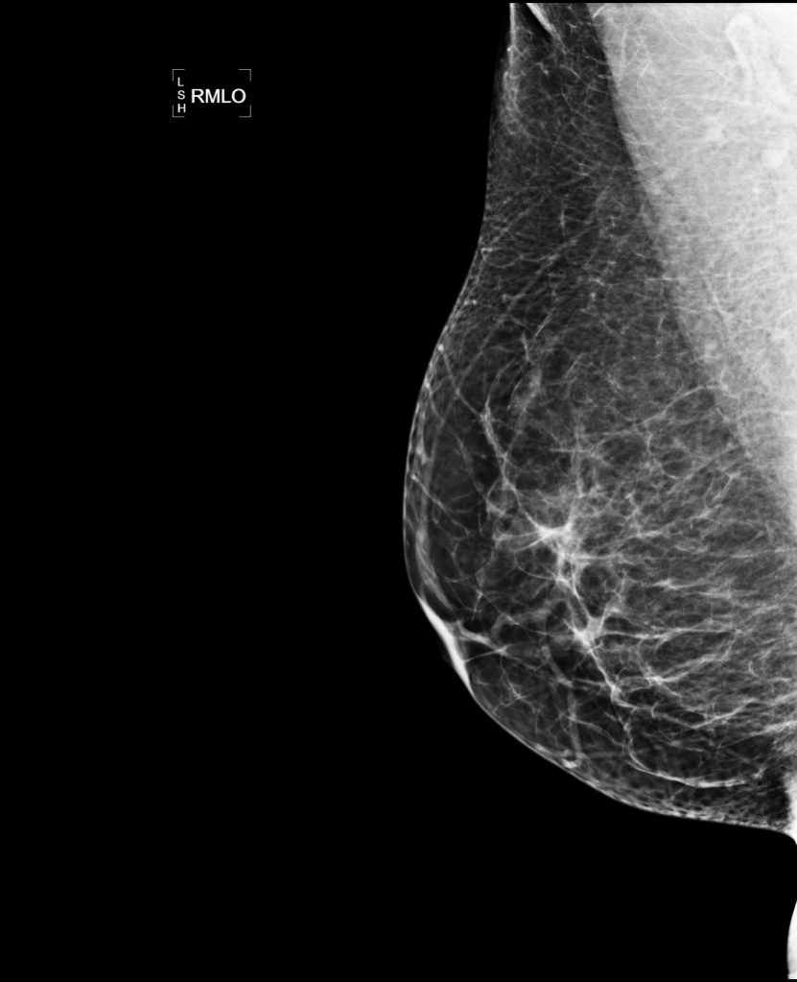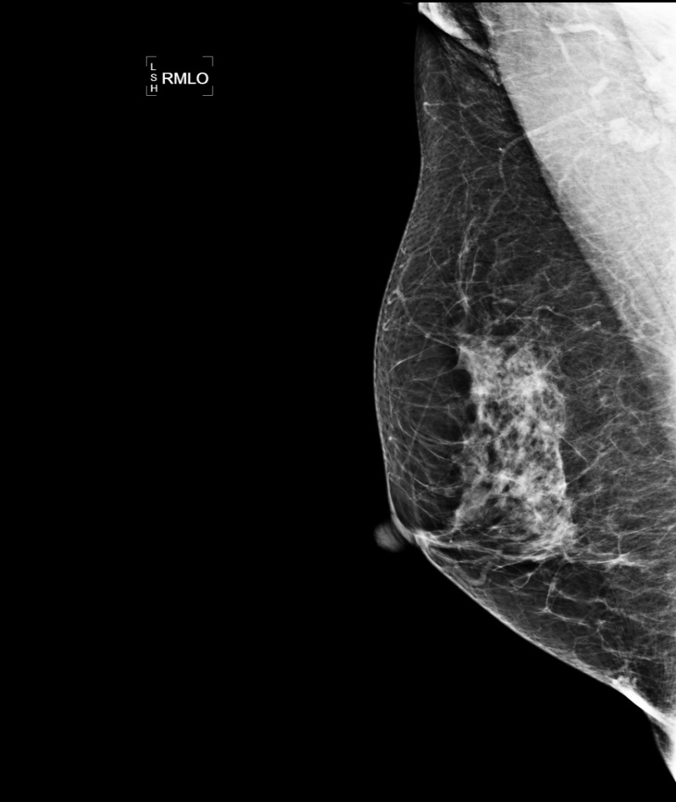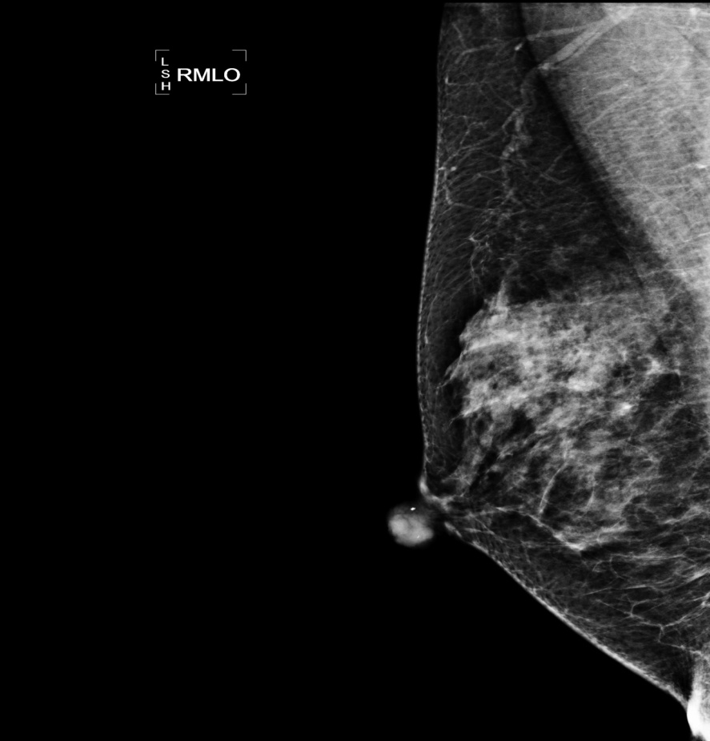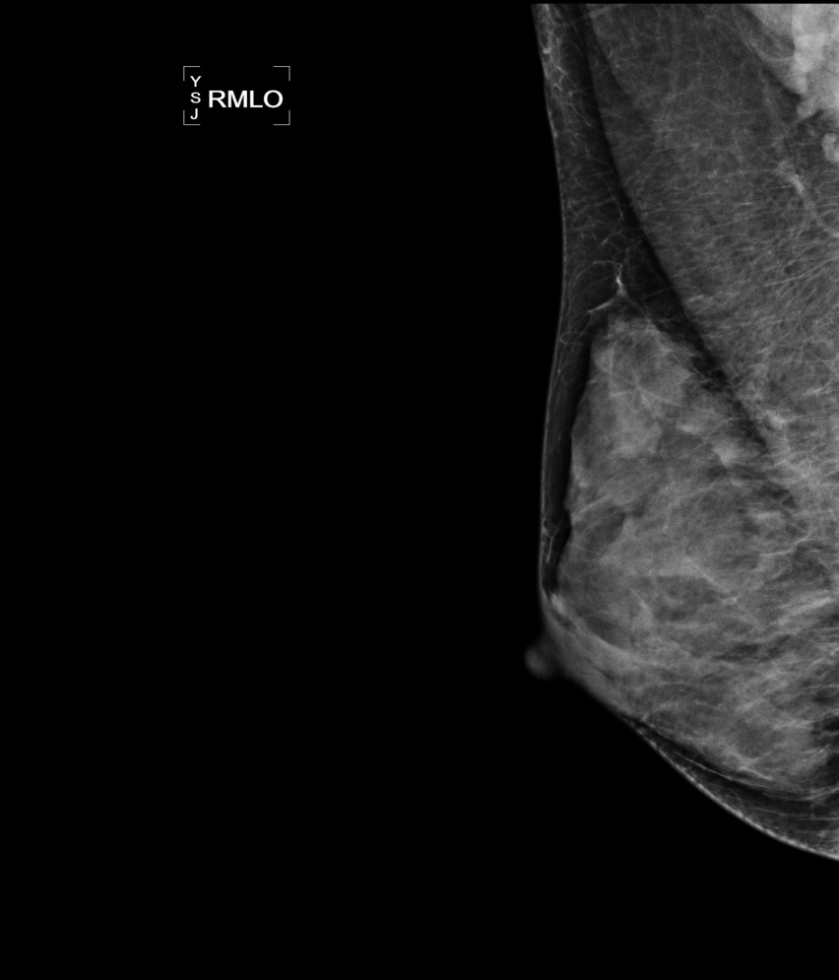

a)

b)

c)

d)

a) b) c) d)

**21. Which of following is correct about the image?**

|  |
| --- |
| **F:\사진\%BA%CE%C0%AF%B9%E6_2.jpg** |

*a) The disease is derived from less degeneration.*

b) It can be found out in the malignant or inflammatory disease.

c) The disease is derived from over growth of breast tissue.

d) The disease takes place due to lack of protein and is rare phenomenon.

22. What is the first using commercial Mammography?

a) Senegraphe

b) Mammomat

c) Mammodiagnost

d) Mammorex

23. Which of the following is the correct combine Anode/Filter for increasing the contrast?

a) Mo/Mo

b) Mo/Rh

c) Rh/Rh

d) Rh/Mo

24. Why should be the chest wall located by Cathode of X-ray tube in Mammography?

a) Anode Heel Effect

b) Line Focus Principle

c) Filament Heating Unit

d) Anode Target Material

25. When the Mammography exam, using the Single emulsion film is the different of the Double emulsion film. What is it?

a) Base

b) Halation layer

c) Emulsion layer

d) Protective coating or Supercoat

26. Which of the following is the most using spot size for Mammography?

a) 0.03mm

b) 0.06mm

c) 0.3mm

라) 0.6mm

27. Which of the following is NOT explanation of MTF (modulation transfer function)?

a) Qualitative expression of image quality in digital image

b) Falling off in image quality as a diffusion of light cause result of decrease MTF

c) Difficult of recognizing object because high MTF images are clearly expression of noise

d) MTF value over efficiency measurement range means high sharpness

28. Which of the following is Not relation with patients exposure dose?

a) kVp b) SID c) grid ratio d) focal spot size

29. What is the grid ratio in this image?

**5 mm**

**0.5 mm**

**1.0 mm**

**납 판**

a) 2:1 b) 5:1

c) 10:1 d) 16:1

30. Which of the following is correct explanation of geometric unsharpness?

a) When X-ray tube is used small focus, unsharpness is increased.

b) When object-film distance is decreased, unsharpness is increased.

c) Unsharpness is more decreased at cathode than anode of X-ray tube.

d) Unsharpness is more increased in rotated anode x-ray tube than fixed anode x-ray tube in same actual focus

31. Which of the following is correct of Point Processing?

1. It is the processing that using changed wave through the body
2. When a pixel size change, commonly using the Look Up Table
3. It is the processing that location of image is moving or size changing
4. It is the processing that making new pixels using for around pixels in image

32. What is the meaning of change continuous density value to a positive number?

a) Sampling

b) Quantization

c) Image compression

d) Image reconstruction

33. Which of the following is correct description of the Line Focus Principle?

a) Relationship between Actual focus spot and Effective focus spot

b) Relationship between Grid ratio and rate of liner per inch

c) Relationship between changing the SID and film density

d) Film exposure and result density of film

34. Which of the following is NOT effective Quantum mottle?

1. Film speed
2. Film contrast
3. Film graininess
4. Screen effective rate

35. As using the Air-gap technique compared to grid, how to change exposure parameter and patient dose?

1. Increasing exposure parameter and decreasing patient dose
2. Increasing exposure parameter and increasing patient dose
3. Decreasing exposure parameter and increasing patient dose
4. Decreasing exposure parameter and decreasing patient dose

36. Among the contrast of the Radiolgraphy, which of the following is NOT effect of the film contrast factor?

1. Film fog
2. Developing conditions
3. Tube voltage
4. Screen characteristic

37. What is the largest vein in the breast?

1. Azygos vein n
2. Axillary vein
3. Intercostal Vein
4. Internal mammary vein

38. What is the Montgomery Gland function?

1. Lubrication function
2. Stimulate function
3. Stabilization function
4. Evacuator function

39. What is NOT the histological name of the mammary duct?

1. Myoepithelial cells
2. Epithelial cells
3. Basement membrane
4. Cutaneous lymphathic plex

40. Which of the following is NOT the main muscle around breast?

A) Deltoid muscle

B) Pectoralis major muscle

C) Pectoralis minor muscle

D) Serratus anterior muscle

41. Which of the following is correct explanation of the epithelial tissue?

a) Almost breast disease is happened in Epithelial layer.

b) Epithelial tissue is divided columnar shape basement membrane and Myoepithelial cell layer

c) Epithelial layer and basement membrane are less affected by hormone on breast tissue

d) It is located in basement membrane. It is regenerate the column-shaped cells

42. Which of the following is NOT true about Involution of breast tissue?

a) Breast tissue trances to fat tissue.

b) The number of the lobe of inside breast is getting to reduce dramatically.

c) The time of starting involution is the time of menopause.

d) The supporting tissue lose elasticity when the breast tissue involutes unrelated to individual differences in breast size.

43. Which of the following is INCORRECT of the Mammography?

1. Breast combine with parenchyma, fibrotic tissue and fatty tissue
2. Parenchyma and fibrotic tissue is lower density and fatty tissue is high density
3. Observe linear shape of the duct, ligament and vessel in the Fatty breast
4. Breast parenchyma type is decided rate of fibrotic tissue and relative sensitivity of the Mammography

44. Which of the following is correct about relationship between Kilovoltage(kV) and Half-value layer(HVL)

a) If the kV increased, the HVL thickness is increase.

b) If the kV increased, the HVL thickness is decrease.

c) If the kV increased kV twice, the HVL thickness is increase twice.

d) If the kV increased kV twice, the HVL thickness is increase Squa

45. What is NOT correct abbreviation?

1. RCCRL – Roll projection
2. RFB – Caudocranial projection
3. RMCC – Magnification projection
4. RLM – Lateromedial oblique projection

46. What is the best examination that region located between breast valley?

a) Cleavage Projection

b) Tangential Projection

c) Craniocaudal Projection

d) Spot Compression Projection

47. Which of the following is NOT correct compression in the Mammography?

1. As reducing thickness of beast and scattering ray, the contrast is increasing.
2. By increasing OID, increase resolution
3. Separate breast tissue and archive uniformity image density
4. Make a flat breast as a result x-ray attenuate equally

48. Which of the following is NOT correct describe of the MLO projection?

1. 45 degree angle examination is good to skinny and tall women
2. Breast is not slagging due to weak compression
3. IMF(Infra Mammary Fold) is spread Including image
4. As including the pectoralis major muscle of the BCS(Breast Conserving Surgery) patients is difficult

49. When use the Tangential projection?

1. Nipple eczema
2. Palpable ma
3. Nipple discharge
4. Skin calcification

50. Which of the following is NOT correct description of the Implant displacement view?

1. Using push-back method projection
2. Consideration of movement of the implant for mammography
3. Compression intensity is endurance
4. Only using Auto exposure control is reducing exposure

51. **Which of the following is incorrect explanation about diagnosis of micro-calcification?**

a) Magnification

*b) Gun Biopsy*

c) Localization

d) Stereotactic Biopsy

52. Which of the following is NOT indication of magnification projection?

a) To observe margin of mass

b) To observe number and shape of micro calcification

c) In case of micro calcification located near the skin

d) To define micro calcification caused by vascular, fat necrosis, or secretory calcification

53. What is the best description of this image?

|  |
| --- |
| EMB00000f185a2a |

a) Take images by using Auto exposure.

b) It is applied to micro-calcification lesion.

c) Sometimes it exerts pressure while put in on the magnification device.

d) Purpose is to confirm whether the sample of tissue is included or not after the Biopsy

54. When the breast device quarter parts, where is the lowest incidence of breast cancer?

1. Upper Outer Quadrant
2. Upper Inner Quadrant
3. Lower Outer Quadrant
4. Lower Inner Quadrant

55. Which is not true purpose about Roll View ?

A) Apply to show to spread the high dense part’s tissue

B) Unclear, but apply to determined existing abnormal tissue, apply for an accurate diagnosis

C) The case of observing only one method,

D) Although left and right side images are not observing the resion, apply to touch something

56. What is the best description about the image?

|  |
| --- |
|  |

1. To mastitis patient
2. To patient for discharge of the both breast nipples
3. To patient for discharge of viscosity or bleeding
4. After galacto needle insert within the duct, lots of contrast inject rapidly

57. Which of the following is correct for the Galactocele?

1. Traumatic breast disease
2. Benign cyst contain of the lactation
3. Calcification of the shell-shaped
4. Mammary cystic hyperplasia contain of the lactation

58. Which of the following is NOT describe of the DCIS(Ductal Carcinoma In Situ)?

1. Treatment is cure, and prognosis is better
2. DCIS with micro calcification
3. The mass is palpable and movable, and it usually occure in 20 to 30 years old people.
4. Limit in the only ductal, and often occurred TDLU

59. Which of the following is correct of the epithelial hyperplasia?

1. It means the calcification of hematoma by trauma
2. It means hyperplasia of the mammary grand tissue of the skin
3. means hyperplasia of lactiferous or lobule as a hyperplasia breast disease
4. It means hyperplasia of the pectoralis major muscle or lobule cell as a hyperplasia breast disease

60. Which of the following correct description of the breast cancer?

1. Prognosis of mucinous carcinoma is better
2. ILC(Invasive Lobular Carcinoma) is amount of 5% entire breast cancer
3. When the ductal basement membrane is not through DCIS (Ductal Carcinoma in Situ) or IDC (Infiltrated Ductal Carcinoma)
4. LCIS (Lobular Carcinoma in Situ) is rare detection of calcification and palpable mass

61. What is the most population breast cancer about 80% of entire breast cancer?

1. Ductal carcinoma in situ
2. Invasive ductal carcinoma
3. Invasive lobular carcinoma
4. Mucinous carcinoma

62. Which of the following is correct description of the BI-RADS?

1. Organization of terms and report system
2. Differentiation of the reading of breast image and patient care
3. For communication of reading in a hospital
4. The first generation in 1992 included Mammography, Beast Ultrasound and Breast MRI

63. **Which of the following portion is hard to be structurally seem in the basic Craniocaudal(CC) view?**

a) Medial

b) Lateral

*c) Upper*

d) Lower

64. What is INCORRECT to projection check list about the image evaluation of the standard Mammography?

1. Nipple
2. Projection angle
3. Slagging
4. IMF fold

65. Which one of the following is NOT correct of the standard image evaluation in the CC view?

a) Include an internal breast tissue

b) Observe nipple contour on lateral view in middle of breast

c) Include a retromammary fat

d) Length of posterior line of nipple is over 1cm than internal-external of the breast

66. What is “Probably benign – short interval follow-up suggested” in the overall impression of BI-RADSTM?

a) category 1

b) category 2

c) category 3

d) category 4

67. Which is the following is CORRECT description of calcification in this image?

1. Lobular calcification show one spot distribute of the breast
2. Calcification should be have mass or single region
3. Casting calcification looks like powder
4. Size of calcification, uniformity of density and scatter of the calcification are malignancy

68. Which one of the following is NOT correct description of the mass analyses Algorism?

1. Focal asymmetry show lesion only single directional image
2. Added external examination when focal asymmetry has a disease
3. Focal asymmetry disease is not clearly margin
4. If the conscious mass lesion is in Mammography, should be distinguish mass or focal asymmetry

69. Which of the following is the correct of the Digital Mammography?

a) Spatial Resolution is high

b) Characteristic Curve of the Image receptor is linear

c) Reducing and deleting of Noise are difficult

d) Dense breast difficult finding of Pathology because it is low SNR signal

70. What is the distinguish standard to vessel and mammary duct in breast Ultrasound image.

1. Direction
2. Length
3. Distribution
4. Diameter

71. Which of the following is INCORRECT description of the CAD (Computed Aided Detection)?

1. Reducing recall rate
2. Saving time, labor and cost
3. Available using double reading
4. Possible think of second opinion

72. Which of the following is NOT correct description of the Tomosynthesis?

1. Reducing exposure due to decrease repeat rate
2. Boundary of the mass find distinctly and ill-defined
3. Achieve one 3D mammography image which gets many planes with various angle

d. Increase overlapping image than common mammography

73. Which of the following is NOT correct explanation about breast Ultrasonography?

a) It has advantages to distinguish micro calcification.

b) It distinguishes malignancy tumor by echo

c) It can evaluate the insertion of breast implant.

d) It distinguishes malignancy for tumor shape

74. What is the best answer the indirectly sign?

1. Skin thickening
2. Nipple retraction
3. Dilatation duct
4. Architecture

75. Which of the following is NOT correct about the BSE (Breast Self Exam)?

1. After finishing menstruation every month
2. Compare to change of the nipples shape
3. Using 2nd, 3rd and 4th fingers touchable in clockwise
4. Every month check after ovarietectomy or becoming menopause naturally

76. Who is the lowest breast cancer probability?

1. Sister has breast cancer
2. Takes pill birth control
3. Sister has thyroid cancer
4. The faster of the first menstruation and the late of the menopaus

77. Which of the following is NOT preventing situation of the BSC (Breast conserving surgery)?

A) Diffuse calcification patient is probably malignancy

B) the positive results of biopsy test the boundaries margin

C) Received radiation therapy patient to the breast or chest wall

D) in spite of the quarter area, has more than two calcifications or greater mass

78. What is not included treatment after surgery of the breast cancer?

1. Chemotherapy
2. Hormone therapy
3. Bone marrow transplantation
4. Leukocyte growth factor therapy

79. Which of the following is NOT correct emergency patient care about the Vasovasal syncope reaction?

1. Massage to neck and shoulder to patient
2. Continues movement to keep consciousness
3. Patient head located to between both knees position
4. Supply to oxygen or fanning

80. Which of the following is the correct explanation about TNM system?

A) Nx: no local lymphatic gland metastasis

B) Mo: remote metastasis including upper clavicle of body side lymphatic gland

C) T2: maximum length of breast is over 2cm and less 5 cm

D) T4: DCIS, LCIS

81. Which of the following is CORRECT description of hormone therapy for breast cancer?

a) The incidence of cervix cancer can be decrease.

b) The effect is good when the hormone receptor is positive.

c) The therapy makes activity female sex hormone.

d) If tamoxifen takes long time, bone density would be increase.

82. Which of the following is NOT explanation of sampling process change analog signal to digital signal?

a) It is convert continuous data to separate data

b) It can know frequency to decide sampling using a line pair of resolution chart

c) If it make sampling using over than 2 times the highest frequency, it can make digital signal without information loss

d) If it makes a lot of sampling with minimum data loss, it can get a high quality image

83. Which of the following is correct meaning of figures?

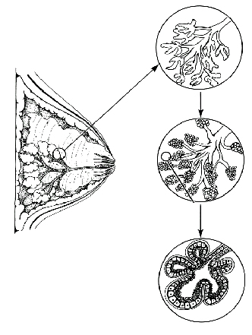

a) Change breast lobula according to age

b) Change breast lobula before and after menopause.

c) Change breast lobula of pregnancy and breast feeding

d) Change breast lobula according to increased weight

84. Which of following is different to others in this image?

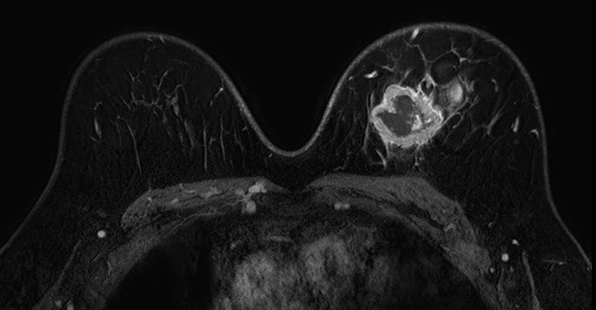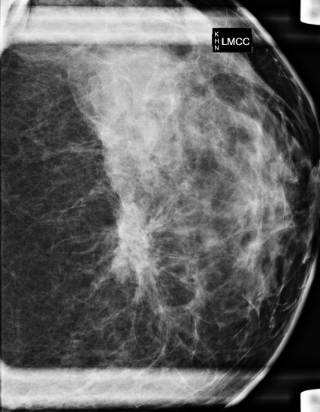

가) 나)

다)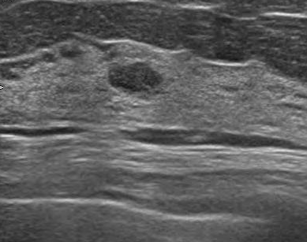 라) 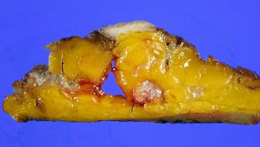

85. Where is the lowest effective metastasis?

1. Bone
2. Liver
3. Brain
4. Ovary

86. Which of the following is the pixel size to indicate 10 lp/mm resolution in the digital mammography?

A) 0.01mm B) 0.05mm C) 0.1mm D) 0.5mm

87. Which of the following is NOT correct explanation about mamary duct ectasia?

A) It caused by involution and atrophy of mamary.

B) Lactiferous wall became thin due to inflamation.

C) It appears in large lactiferous duct including lactiferous sinus.

D) It can be caused by primary mastadenitis aroud ducts

88. **. In case of Radiation Therapy for Breast cancer, tangential beam technique is commonly used. Which of the following is the main reason?**

a) Nipple protection

b) Skin protection

c) Reduction of Lymphadenoma

*d) Reduction of Radiation Pneumonia*

89. Which of the following is correct relative hormone and function?

1. Estrogen – is secreted in the anterior pituitary gland during pregnancy. It makes breast growth and galactoria acceleration.
2. Oxytocin – supply for amino acid, fatty acid, grape sugar and calcium to mother’s milk
3. Prolactin – develop mammary duct length and proliferate linear organization
4. Progesterone – increase mammary duct and epithelium of the lobule, and the acinar grow acceleration become pregnancy

90. **Which of the following factor is related to the scatter ray?**

a) Filtration

b) kVp

*c) Compression*

d) Target material