2023MIIA

1.What is the minimal unit for single character in digital?

A) 1 bit

B) 4 bits

C) 1 byte

D) 4 bytes

E) 8 bytes

2.Which is NOT the operating system?

1. NIX
2. Windows
3. Apache
4. iOS
5. Android

3.What is BIOS an acronym for?

A) basic input output system

B) boot initial operating startup

C) basic input output startup

D) bootstrap initial operating system

E) bootable internal operating system

4.Which is arranged in order of SI unit size?

A) Kilo → Mega → Giga → Tera

B) Kilo → Mega → Tera → Giga

C) Kilo → Giga → Tera → Mega

D) Tera → Giga → Mega → Kilo

E) Tera → Mega → Giga → Kilo

5.What is the process which makes continuous signal to discontinuous signal?

A) Pre-processing

B) Post-processing

C) Quantization

D) Sampling

E) Down-sizing

6.Which is location of patient hospital number in DICOM Tag/header ?

A) (0008,0008)

B) (0010,0020)

C) (0010,0030)

D) (0010,1000)

E) (0010,1300)

7.Which is mean the physical address in below image ?

A) TCP/IPv4

B) IP Address

C) MAC Address

D) Subnet Mask

E) Default Gateway

8. Which is indicated distance of point to point in a monitor ?

A) Contrast

B) Brightness

C) Resolution

D) Dot Pitch

E) Matrix

9. Which is can be found who PACS access or edit image data?

A) Config File

B) IP Security

C) DICOM Header

D) Access Log

E) Configuration Data

10.Which of the following is correct sharing method of a storage using Ethernet LAN?

A) DAS

B) Database

C) Broker

D) Backup

E) NAS

11.Which of the following is a method of attaching storage using USB?

A) DAS

B) Database

C) Broker

D) Backup

E) NAS

12.Which of the following is used when storing the DICOM image in CD or DVD?

A) HL7 layer

B) Modality SCU

C) DICOM DIR

D) Modality SCP

E) DICOM Worklist

13.What is DICOM basic unit?

A) DIMSE(DIcom Message Service Element)

B) SOP(Service Object Pair)

C) SCU(Service Class User)

D) IOD(Information Object Definition)

E) DICOM storage class

14.Which of the following is the volatile memory that need electricity for keeping data?

A) RAM

B) SSD

C) ROM

D) HDD

E) CD

15.Which of the following is NOT acquired from DICOM Header?

A) Patient name

B) Date of birth

C) IP Address

D) Modality

E) Date

16.Which of the following is acquired from American law about personal information management and security?

A) DICOM

B) HIPPA

C) IHE

D) HL7

E) XML

17.What type of connector is used to plug a CAT6 line into a router?

A) RJ-11

B) RJ-45

C) RJ-10

D) COM1

E) COM8

18.What is the compression method which original data is reserved?

A) Cosine transform coding

B) Run-Length compression

C) Wavelet transform coding

D) Truncation coding

E) Fractal compression

19.Which of the following is needed for the modality when transferring image from modality to server?

A) Storage SCU

B) Storage SCP

C) Query/Retrieve SCU

D) Query/Retrieve SCP

E) Verification SCU

20.What technique combines several hard disks/solid state disks into a single logical disk to overcome physical limitation of a disk?

A) SCSI

B) RAID

C) IDE

D) SAN

E) SATA

21.Which instruction is for checking a connection of a network?

A) ipconfig

B) ping

C) tracert

D) root

E) nslookup

22.Which 3D reconstruction technique is proper to display various curved vessels such as hepatic artery, splenic artery, renal artery, Willis circle artery?

A) SSD(Shaded Surface Display)

B) VRT(Volume Rendering TechniquE)

C) Virtual endoscopy

D) MPR(Multi Planner Reformat)

E) Iterative reconstruction (IR)

23.Which is the following is NOT able to make 3D image in modality?

A) Ultrasound

B) Computed radiography(CR)

C) Computed tomography(CT)

D) Magnetic resonance imaging(MRI)

E) Positron emission tomography (PET)

24.Which of the following is the correct explanation below?

A) DAS

B) NAS

C) SCU

D) NFS

E) SAN

25.Which of the following is a proper term which is the standard for interchange text from the different equipment?

A) IHE

B) HIPPA

C) HL7

D) RIS

E) HIS

26.What standard guideline is used for the medical image performance evaluation in AAPM (American Association of Physicists in Medicine)?

A) AAPM Task Group 16

B) AAPM Task Group 17

C) AAPM Task Group 18

D) AAPM Task Group 19

E) AAPM Task Group 20

27.Which of the following is correct for DICOM identification for each equipment in PACS?

A) AE Title

B) Study UID

C) Station Name

D) SOP instance UID

E) IP Address

28.What is the minimal unit for digital image?

A) Pixel

B) Digit

C) Matrix

D) Record

E) File

29.What is the correct evaluation point in the pattern shown below?

A) Black brightness

B) White brightness

C) Brightness reaction

D) Geometric distortion

E) Noise

30.What is TAG for checking whether files are compressed or not and knowing the method?

A) File meta information version (0002, 0001)

B) Media storage SOP class UID (0002, 0002)

C) Transfer syntax UID (0002, 0010)

D) SOP instance UID (0008, 0018)

E) Quality Control Image (0028,0300)

31.Which of the following is the correct explanation below?

A) DAS

B) NAS

C) SCU

D) NFS

E) SAN

32.What is the process of converting data from an imaging modality acquired B into A or C?

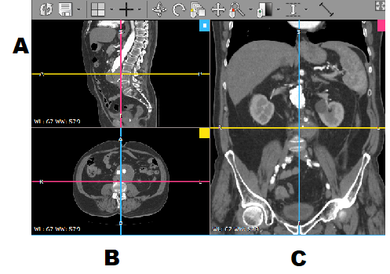

A) SSD (Shaded Surface Display)

B) VRT (Volume Rendering Technique)

C) Virtual endoscopy

D) MPR(Multi Planner Reformat)

E) Iterative reconstruction (IR)

33.What is the cable type in this following image?

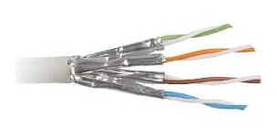

A) UTP cable

B) STP cable

C) Fiber optic cable

D) Coaxial cable

E) RJ45 cable

33.What is the cable type in this following image?

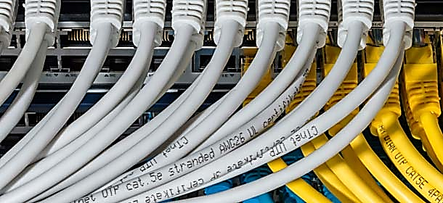

A) UTP cable

B) STP cable

C) Fiber optic cable

D) Coaxial cable

E) RJ45 cable

34.What information is described in the following table?

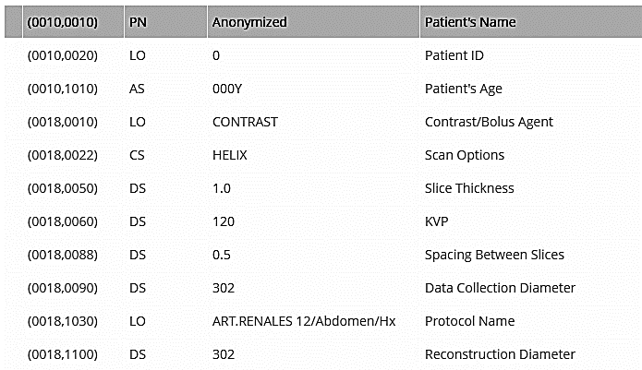

A) RIS

B) HL7

C) IHE

D) DICOM

E) XML

35. What is the digital gate technique used in the following truth table?

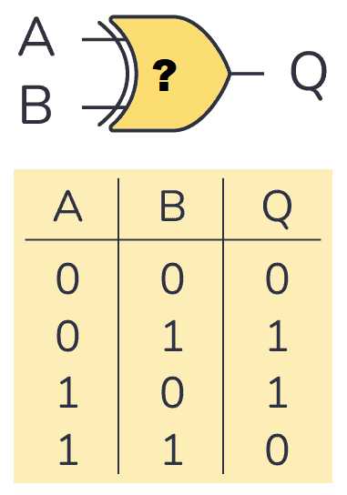

1. AND
2. OR
3. NOT
4. XOR
5. NOR

36.How many steps in grayscale can be represented using 11 bits pixel depth?

A) 256

B) 512

C) 1024

D) 2048

E) 4096

37. Which of the following RAID level has slowest write performance?

A) RAID 0

B) RAID 1

C) RAID 2

D) RAID 5

E) RAID 6

38. Which of the following RAID level provides no data protection against disk failure?

A) RAID 0

B) RAID 1

C) RAID 2

D) RAID 5

E) RAID 6

38. Which of the following RAID level provides use 100% data redundancy?

A) RAID 0

B) RAID 1

C) RAID 2

D) RAID 5

E) RAID 6

39. What does the following image represent?

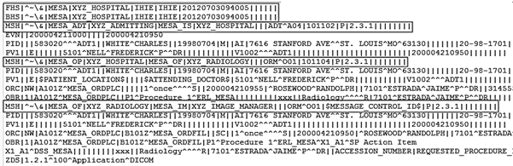

A) DICOM header

B) HL7 version 3

C) HL7 version 2

D) XML

E) DICOM SOP

40. What does each box in the following image represent?



A) Message header

B) HIS Connection parameter

C) Patient Clinical Parameter

D) Message segment

E) Message event

41. Which RAID level is presented in the following diagram?

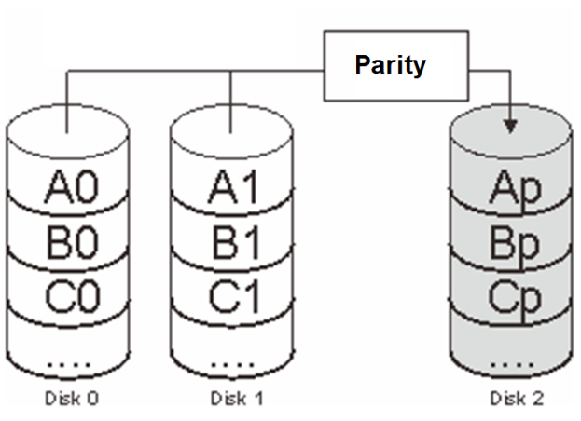

A) RAID 0

B) RAID 1

C) RAID 3

D) RAID 5

E) RAID 6

42. Which of the following statement is incorrect regarding the following image? ข้อใดต่อไปนี้กล่าว **ไม่ถูกต้อง** จากผลลัพธ์ที่ได้ดังภาพ

A) 216.58.196.36 is the www.google.com IP address

B) the packet sent is 32 bytes in size

C) the fastest packet take 46ms

D) the result is from the tracert command

E) the round-trip time is 50ms in average

43. What is the command that is used to generate the following result?

A) ping

B) tracert

C) nslookup

D) ipconfig

E) ifconfig

44. From the OSI model, IP address is represented in which layer?

A) Physical layer

B) Session layer

C) Datalink layer

D) Application layer

E) Network layer

45. What is the correct order in optical storage density technology?

A) CD -> BLUE Ray -> DVD -> DVD-DL

B) DVD -> CD -> DVD-DL -> BLUE Ray

C) CD -> DVD-DL -> DVD-SL -> BLUE Ray

D) CD -> DVD-SL -> DVD-DL -> BLUE Ray

E) DVD -> DVD-DL -> DVD-SL -> BLUE Ray

46. What HDD probably has the fastest average data access time?

A) 512GB 7200RPM

B) 1TB 5200RPM

C) 2TB 5400RPM

D) 1.5TB 15000RPM

D) 4TB 10000RPM

47. From the following image, which item is correct?

A) DICOM header

B) DICOM tag

C) DICOM Transfer Syntax UID

D) HL7 Message v2

E) IHE Radiology Profile

48. What best describes the following diagram below?

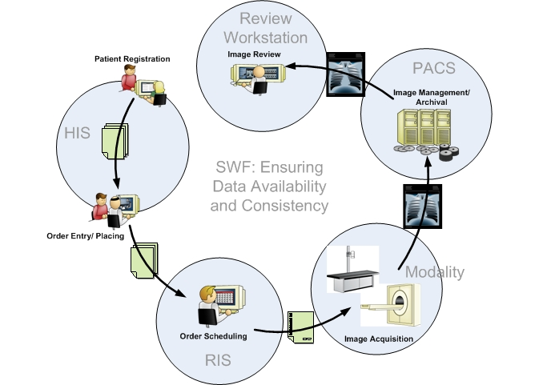

A) IHE Scheduled Workflow

B) IHE DICOM workflow

C) Patient Information Reconciliation IHE diagram

D) IHE Radiology Profiles

E) IHE Radiation Oncology Profiles

49. What item best describes the flowing image?

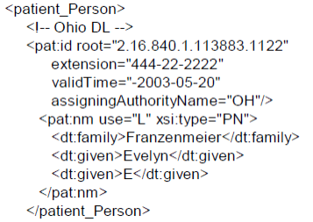

A) DICOM Tag

B) DICOM Transfer Syntax UID

C) IHE Radiology Profile

D) HL7 Message v2

E) HL7 Message v3

50. What item is incorrect describing the flowing image?

A) the CD has highest storage density

B) the Blu-ray use the shortest laser wavelength for reading

C) DVD has greater storage density than the CD

D) the Blu-ray has highest storage density

E) the DVD use the shorter laser wavelength than CD for reading

51. Which of the following is correct for explanation about Cache Memory?

A) It is bigger capacity than RAM

B) It is applicable to control tool of system

C) It is applicable to assistant of memory tool

D) It keeps a program or data which is the most frequently using in the computer

E) The performance will fall off when it has bigger capacity

52. What is the technique to share Storage though Network?

A) Acquisition

B) Database

C) SAN

D) Backup

E) Broker

53. This is DICOM Modality Worklist diagram. What is the most suitable for ① and ② ?



A) ① DICOM Worklist SCP ② DICOM Worklist SCP

B) ① DICOM Worklist SCU ② DICOM Worklist SCU

C) ① DICOM Worklist SCP ② DICOM Worklist SCU

D) ① DICOM Worklist SCU ② DICOM Worklist SCP

E) ① DICOM Broker SCP ② DICOM Broker SCU

54. Which of the following is a correct flow of data in PACS?

(1) Modality (2) Disk array (RAID) (3) Server (4) Backbone (network)

A) (1) → (2) → (3) → (4)

B) (1) → (3) → (2) → (4)

C) (1) → (4) → (3) → (2)

D) (1) → (3) → (4) → (2)

E) (3) → (1) → (4) → (2)

55. Which of the following is needed when transferring image from CT modality to PACS server?

A) Query/Retrieve SCP

B) Query/Retrieve SCU

C) Storage SCP

D) Storage SCU

E) SOP Instans UID

56. What is the blank in the compression process of image?



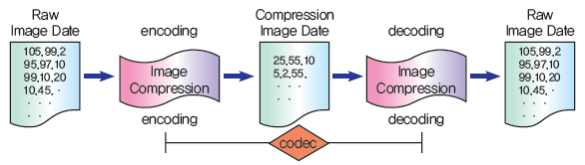

A) Decoding

B) Encoding

C) Format

D) Transfer

E) Elimination

57. Which of the following is the correct explanation of compression method of image?

A) It is the lossless compression as the simplest method

B) The effect get less when it has bigger

C) The effect is far better in Radiology

D) The block of repeated pixel express the repeat times of factor and that factor

E) It is shown low compression ratio in images, cartoons and graphics made by computer.

58. Which of the following is to be able to exchange between HIS and PACS?

A) ACQ Server

B) Broker

C) DB Server

D) Gateway

E) HUB

59. Which of the following is representing the monitor size?

A

B

C

A) Length of A

B) Length of B

C) Length of C

D) Length of A + B

E) Length of B + C

60. Which of the following is the evidence data to chase the adapter or deletion of image data?

A) Access Log

B) IP Security

C) DICOM Header

D) Configuration Data

E) Configuration file

61. Which of the following is the correct for division each equipment in PACS

A) AE Title

B) Study UID

C) Station Name

D) SOP instance UID

E) IP Address

62. Which of the following is the correct explanation below image?

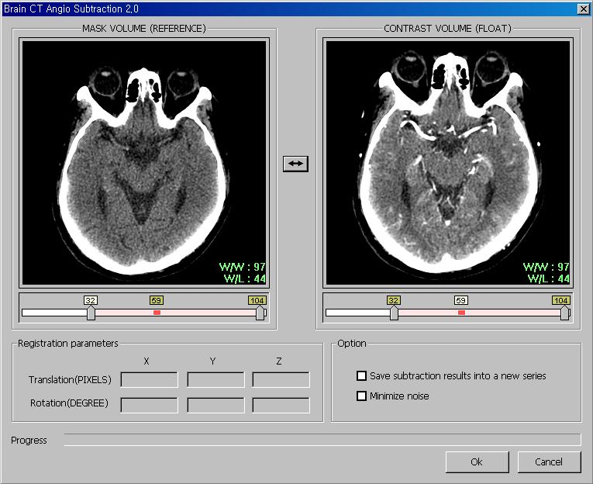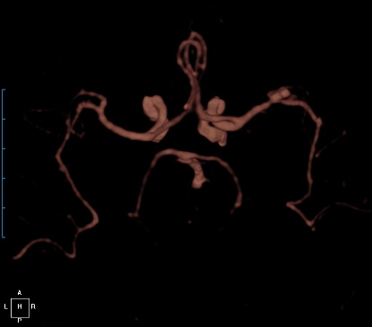

A) The MRA image which is reconstructed image by using to check rate of blood flow

B) Cerebral vascular image by using the 3-dimentonal image in Intervention

C) CT image of cerebral vascular which made by subtraction Pre & Post contrast CT scan

D) Cerebral vascular image by using doppler

E) CT image of cerebral vascular which made by a false endoscopy

63. What does spatial resolution of 5 lp(line pairs)/mm?

A) Black 5 lines in 1mm

B) White 5 lines in 1mm

C) Black 2.5 lines and White 2.5 lines in 1mm

D) Black 5 lines and White 5 lines in 1mm

E) Black 1 lines and White 1 lines in 5mm

64. Which of the following is related with Modulation Transfer Function(MTF) in high frequency?

A) Contrast resolution

B) Image noise

C) Image linearity

D) Image uniformity

E) Spatial resolution

65. Which of the following is the most suitable method to check image quality for contrast and noise?

A) DQE (Detective Quantum Efficiency)

B) MTF (Modulation Transfer Function)

C) Resolution

D) Capture Graphic Card

E) SNR (Signal to Noise Ratio)

66. It makes the image of space clearly when it is in rather cloudy, but over-stressing high frequency also can increase the noise. What is this method?

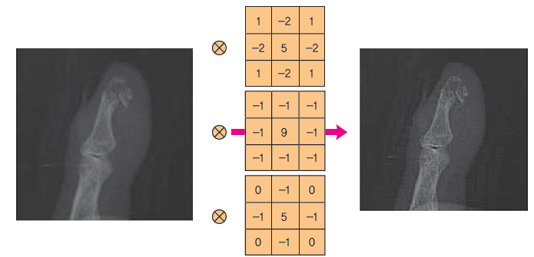

A) Low Pass Filter

B) High Pass Filter

C) Edge Detection Filter

D) Arithmetic operation

E) Windowing

67. What is the compression technique suitable for showing better high resolution image when DICOM image is compressed?

A) JPEG 2000

B) Huffman coding

C) G3/G4 compression

D) Run-Length compression

E) MPEG

68. What is the name of the test pattern shown below? รูปแบบภาพทดสอบต่อไปนี้เรียกว่า

A) TG18-LN

B) TG18-CT

C) TG18-BN

D) TG18-CX

E) TG18-AD

69. Which of the following ROC curves is the largest in sensitivity and peculiarity?

FP

a

b

c

d

TP

e

A) a

B) b

C) c

D) d

E) e

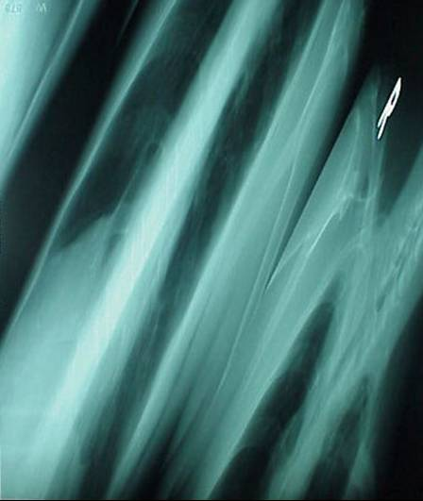70. What is the cause of the error in this image?

A) CR Error

B) IP Scratch Error

C) Compression Error

D) DB Connect Error

E) Bit collapse

71. Which of the following describes the distance between two dots in display monitor?

A) Contrast ratio

B) Brightness

C) Dot pitch

D) Pixel size

E) Bit depth

72. what is the resolution of 3MP diagnostic monitor?

A) 768 x 4096

B) 1600 x 1966

C) 1200 x 2621

D) 1966 x 2621

E) 2048 x 1536

73. What item is an explanation of the process shown in the image below?

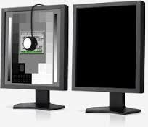

A) Distortion calibration

B) Gray scale checking

C) Monitor contrast checking

D) Luminance calibration

E) Ambient light checking

74. How much is the total data per year if 100GB data occurs per day in the hospital? (Suppose that a month is 20 days.)

A) 24GB

B) 240 GB

C) 2.4 TB

D) 24 TB

E) 240 TB

75. Which of the following is the most appropriate reading-monitor for Mammography?

A) General Monitor

B) 1K Monitor

C) 2K Monitor

D) 3K Monitor

E) 4K Monitor

76. What is the number of bit difference between the IPv4 (Internet Protocol version 4) and the IPv6 (Internet Protocol version 6)

A) 8bits

B) 16 bits

C) 24 bits

D) 64 bits

E) 96 bits

77. Which of the following corresponds to a 16:9 display aspect ratio?

A) XGA

B) SXGA

C) UXGA

D) QXGA

E) 2K/FHD

78. There is a 14-bit 512 × 512 image. What is the size of image data?　(Only, 512 × 512 = 262144)

A) About 36.7 Kbyte

B) About 367 Kbyte

C) About 45.9 Kbyte

D) About 459 Kbyte

E) About 4.5 Mbyte

79. What is likely the cause of this LCD display malfunction?

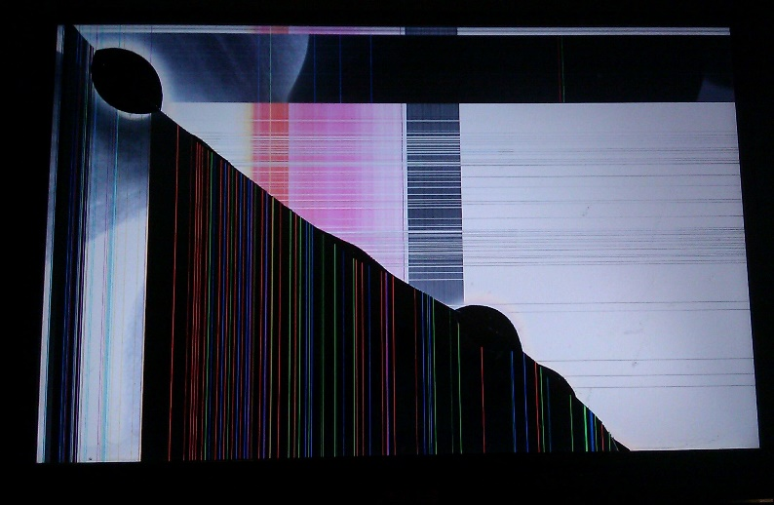

1. CR error
2. IP error
3. Compression error
4. Cracked Screen
5. Scanline error

80. What is the tool frequently using for DICOM monitor testing?

A) AAPM Task Group 18 Test Patterns

B) MoPH Task Group 99 Test Patterns

C) SEMTE18 Test Patterns

D) DICOM MHGS 18 Test Patterns

E) ACR Test Patterns

81. Which of the following is to express altogether Image compression and restoration hardware ?

A) Codec

B) Endecoding

C) Decoder

D) Encoder

E) Compressor

82. What is the correct artifact which is occurred by discordance of Nyquist frequency between grid and detector?

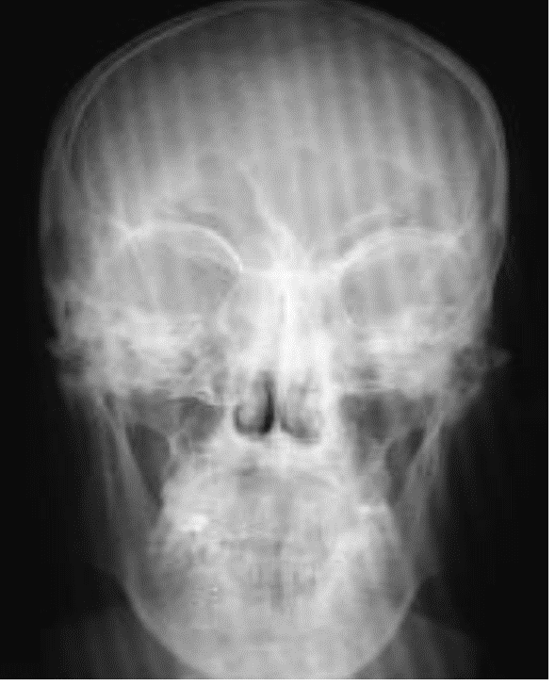

A) Moving artifact

B) Mirror artifact

C) Cutoff artifact

D) Heel artifact

E) Moire artifact

83. What is the correct CNR shown below?

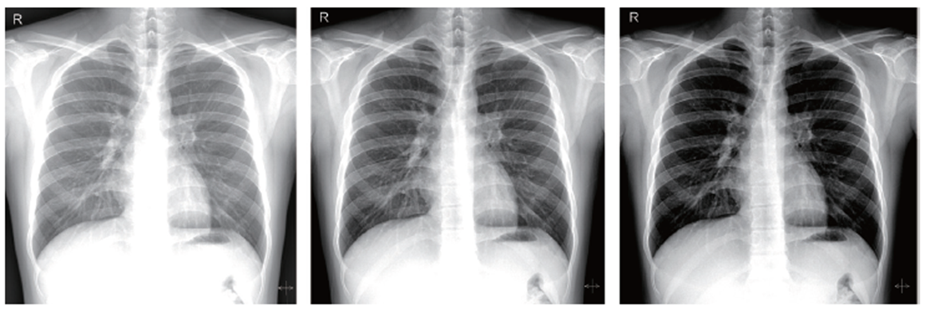

Mean = 200

SD = 2

Mean = 100

SD = 2

A) 4

B) 20

C) 50

D) 100

E) 200

84. Which of the following is NOT DICOM Message Service Element (DIMSE)?

A) C-store

B) C-get

C) N-store

D) N-get

E) E-Move

85. What is the element to convert X-ray to electric signal directly?

A) a-Se

B) a-Si

C) CsI

D) Gallium Arsenide

E) Cesium Arsenide

86. What command in Windows gives the result similar to the provided picture below?

1. Ping 10.4.2.200 –l 255
2. Ping 10.4.2.200 –t
3. Ping 10.4.2.200 –f
4. Ping 10.4.2.200 –t 32
5. Ping 10.4.2.200

87. What is the unit of brightness of reading monitor?

A) lm/㎡

B) lx/㎡

C) cd/㎡

D) pm/㎡

E) Gx/㎡

88. Which of the following is CORRECT when the quantization bit rate is changed from 9 bit to 8 bit?

A) The volume of image data decreases to 75%

B) The volume of image data decreases to 50%

C) The volume of image data decreases to 25%

D) The volume of image data decreases to 15%

E) The volume of image data decreases to 5%

89. Which is this image processing technique called?

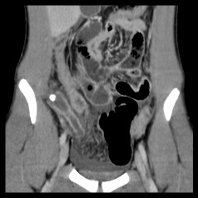

1. Shaded Surface Display
2. Volume Rendering Technique
3. Multi Planner Reformat
4. Virtual endoscopy
5. Surface Rendering Technique

90. A malicious program whose aim is to replicate itself to spread to other computers through

networks and has a strong reproductive ability. What virus type is it?

A) Trojan horses

B) Worms

C) Macro

D) Mutation

E) Artificial Intelligence