- For a 128 square matrix and an FOV of 25 cm, the pixel size is about:
(1) 0.5 mm
(2) 1 mm
(3) 1,5 mm
(4) 2 mm
- Advantages of FSE include all of the following except:
(1). increase speed
(2). decrease ferromagnetic susceptibility artifacts
(3). decrease motion artifacts
(4). increase number of possible slices
- When voxel size decreases, signal to noise ratio______.
(1). Increase
(2). Decrease
(3). Stays the same
(4). Varied.
- Which one of the following is the fast pulse sequences at present?
(1). FSE
(2). EPI
(3). GRE
(4). FFSP
- In an IR sequence, the TI to null a tissue is given by:
(1). 0.693T2
(2). 0.693T1
(3). (1/0.693)T1
(4). (1/0.693)T2
- Major water suppression techniques is :
(1). STIR
(2). FIR
(3). FLAIR
(4). TIR
- What is the Larmor frequency of proton in 1.5T MR scanner?
(1). 42.6MHz
(2). 42.6KHz
(3). 63.9MHz
(4). 106.5KHz
- Which MR signal is the strongest in T1 weighted image?
(1). Air
(2). Fat
(3). Water
(4). Metal
- Which one is true for Fast Spin-Echo technique?
(1). The SAR is higher than conventional Spin-Echo technique
(2). The length of echo train is T2* dependent
(3). The MR signal is obtained from FID refocusing echo
(4). The acquisition time is longer than conventional spin echo technique.
- Which one is true for MR imaging?
(1). Increased FOV will increase spatial resolution
(2). Decreased bandwidth will increase slice thickness
(3). Increased TR will reduce scan time
(4). Reduced slice thickness will increase SNR
- How to obtain the T2-weighted MR image?
(1). Short TE and TR
(2). Short TE and long TR
(3). Long TE and Long TR
(4). None of above
- Define T1 relaxation.
(1). 60% transverse growth
(2). 36% longitudinal regrowth
(3). 63% of longitudinal magnetization regrowth
(4). The artifact is taking place in margin of air to tissue and bone to tissue
- The number of 180 degree rephasing pulse performed in a fast spin echo is known As__________.
(1). Echo time
(2). Inversion factor
(3). Echo train length
(4). Spoiler
- Which of the following is correct when number of excitation (NEX) is increased?
(1). Spatial resolution is changed.
(2). Scan time is reduced.
(3). Scan time is not changed.
(4). SNR is increased.
- Which of following is a correct explaining about T1 weighting imaging?
(1). Fat – Low signal intensity
(2). CSF(Cerebrospinal fluid) – High signal intensity
(3). Paramagnetic material – Low signal intensity
(4). Hemorrhage(sub acute) – high signal intensity
- What is definition between 90°pulse and 180°pulse in spin echo?
(1). TE
(2). TI
(3). TR
(4). TE/2
- The coils used to alter the magnetic field during scanning are known as?
(1). RF receive coil
(2). RF transmit coil
(3). Shim coil
(4). Gradient coil.
- Which of the following is NOT correct about the explanation of 3D volume acquisition?
(1). It can expect to get higher SNR than 2D generally.
(2). It can reduce the voxel size due to getting thinner slice thickness.
(3). It can reduce scan time.
(4). It is mainly used for MR Angiography.
- In Inversion Recovery pulse sequence, when does the longitudinal magnetization become zero (0)?
(1). Steady State
(2). Dummy pulse
(3). Null point
(4). Ernst angle
- What is the resonance frequency of a 3.0-tesla MRI system?
(1.)10.3 MHz
(2.)31.5 MHz
(3.)126 MHz
(4.)189 MHz
- Which of the following is most relevant to the nerve stimulation due to varying magnetic fields?
(1)Near the opening of the gantry
(2)The center of the magnet
(3)The position of the magnet is irrelevant
(4)When the bed enters the gantry
- How to decrease the SAR?
(1). Increase ETL.
(2). Decrease number of slice
(3). Decrease TR
(4). Increase flip angle
- On a T1 weighted image of the brain, white matter appears _______to gray matter.
(1). Hyperintensity
(2). Hypoinstensity
(3). Isointensity
(4).None of the above
- Which MR technique is useful to reduce “Motion artifacts” ?
(1). Fast Scan Imaging
(2). Flow compensation technique
(3). Respiratory gating
(4). All of above
- The SNR can be increased by the following parameters except:
(1) Increase slice thickness
(2)Increase FOV
(3) Increase bandwidth
(4)Increase voxel size
- Which of the following related to the Blood Oxygen-Level Dependent (BOLD) effect is wrong:
(1) It is T2* dependent.
(2) It is related to deoxygenated hemoglobin of the blood.
(3) It is independent of the magnetic field homogeneity.
(4) It can be used for functional MRI study.
- Which of the following tissue has the highest signal in a T2 weighted image:
(1) CSF
(2) White matter
(3) Gray matter
(4)Hemorrhage
- Which is not very much affected by static magnetic field strength?
(1) SAR
(2) T1 value
(3) T2 value
(4) SNR
- Increasing the main magnetic field, what is correct?
(1) Decreasing susceptibility artifacts
(2) Decreasing the danger from metallic projectiles
(3) Increasing T2 relaxation time
(4) Increasing the chemical shift
- Which image is the most sensitive to acute stroke:
(1)T1 weighted image
(2)T2 weighted image
(3)Diffusion weighted image
(4)Proton density image
- In a Fast spin echo sequence, the effective TE is the echo that is performed with:
- The outer views of K space
- The high amplitude phase encoding gradients
- The low amplitude phase encoding gradients
- The first phase encoding steps
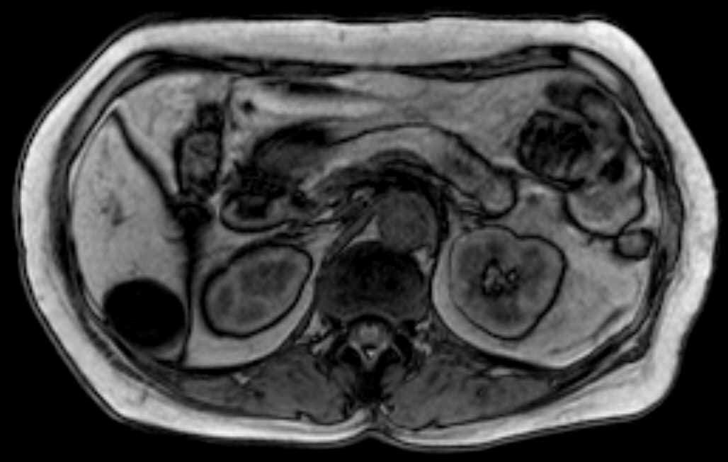
- What kind of artifacts is seen in this image (arrow) and what is this image?

- Motion Artifact, In phase
- Truncation Artifact, Out of phase
- Partial Volume Artifact, In phase
- Chemical Shift Artifact, Out of phase
- What structure does the arrow represent in the image?
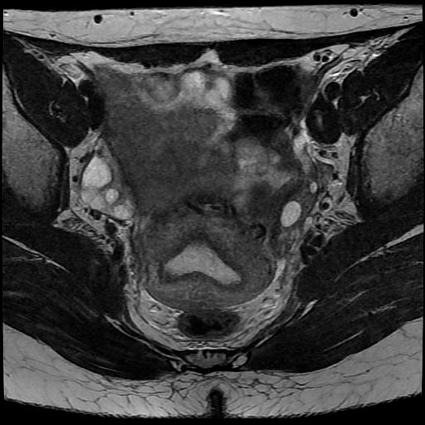
- Rectum
- Uterus
- Bladder
- Ovary
- Which of the following is correctly connected between image views? 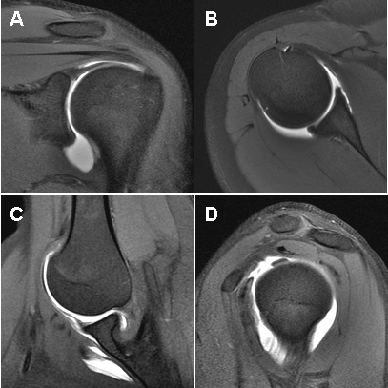
- A – Oblique Coronal plane
- B – Sagittal plane
- C – Axial plane
- D - ABER plane
- The recommended SAR limit of whole body in MR imaging is:
- 0.4Watts/kg
- 4.0Watts/kg
- 8.0Watts/kg
- 0.8Watts/kg
- In a T2 weighted images, a long TR is used to____________?
- Maximize T2 effects
- Minimize T2 effects
- Maximize T1 effects
- Minimize T1 effects
- Image data with high spatial resolution is stored in which area of K space?
- Outer lines
- Central lines
- Negative lines only
- Positive lines only
- The principle characteristic of acquiring a gradient echo is :
- The use of a 90° RF pulse
- The use of an alpha RF pulse
- The change in T1 relaxation time
- The change in T2 relaxation time
- Chemical shift is decreased by all of the following except:
- Lowering the bandwidth
- Using a fat suppression technique
- Using a lower field magnet
- Using a long TE
- Cross-talk artifacts can be reduced by all of the following except:
- Increasing the gradient strength
- Increasing interslice gaps
- Double acquisition with 100% gaps interleaved
- Improving the RF profile
- Which of the following metabolites is normally not seen?
  - NAA
  - Lactate
  - Cho
  - Cr
- What does the word ‘parallel’ refer to in parallel imaging?
  - The need to use fast computers for postprocessing
  - The simultaneous data acquisition by the coils
  - The blend of phase-encoding and phased-array coils
  - The arrangement of the coils needed to make it work
- The main MRA techniques include
  - TOF MRA
  - PC MRA
  - CE MRA
  - All of the above
- Saturation effects can be reduced by
  - Decreasing the flip angle
  - Increasing TR
  - MOTSA
  - All of the above
- Which technique does not typically have “bright blood” ?
  - FSE
  - True FISP
  - GRE
  - Postgadolinium GRE
- Which sequence is usually obtained in a “single shot”?
  - DIR FSE
  - Cine True FISP
  - HASTE
  - Phase contrast
- Which is metabolite is best to distinguish recurrent GBM from radiation necrosis?
  - NAA
  - Cr
  - Cho
  - mI
- Which is LEAST related to the diagnosis of super acute period cerebral infarct?
  - diffusion
  - T1 weighting
  - MRA
  - FLAIR

- The right figure presents a proton MRS spectra (TE: 144 msec) of a patient with mitochondrial encephalopathy. Which corresponds to the major peaks pointing downward?
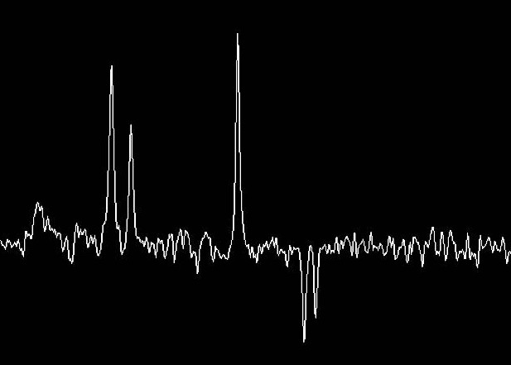

- choline
- creatinine
- lactic acid
- NAA
- Fat suppression was performed using STIR. Which is the appropriate setting for inversion time (TI) at static magnetic strength of 1.5 T and TR of 1000 ms or more?
  - 110 to 130 ms
  - 150 to 170 ms
  - 200 to 220 ms
  - 250 to 270 ms
- Which part of a superconducting MRI system must be cooled with liquid helium?
- Gradient magnetic coil
- Body coil
- Magnetostatic coil
- Shim coil
- Which of the following is correct about temperature and humidity in the MRI computer room?
- 50~60%, 20°~24°
- 30~40%, 20°~35°
- 70~80%, 20°~35°
- 80~90%, 25°~30°
- The following items are usually allowed to enter the scan room in high magnetic field systems?
  - Surgical stainless steel hemostats
  - Surgical stainless steel scissors
  - Copper tools
  - All of the above
- Absolute contraindications for MRI include:
  - Ferrous intracranial vascular clips
  - Cardiac pacemaker
  - Pregnancy
  - 1 and 2
- When scanning patients to rule out brain tumors, the weighted images acquired to evaluated the extent of the lesion, after injection of gadolinium, are:
  - T1
  - T2
  - Proton density
  - Gradient echo
- When imaging a patient with decreased consciousness an area of high signal intensity is noted on both the T1 and T2 weighted images. This type of lesion is likely to be:
- A metastatic lesion
- An abscess
- A hemorrhage
- A neurofibroma
- When imaging the male prostate, the use of an endorectal RF probe will:
- Increase the signal-to-noise ratio and allow for high-resolution images
- Decrease bowel motion and allow for artifact-free images
- Make the FOV amaller
- Change the RF frequency
- The scan time for a 3D acquisition is given by:
- TR × NSA × bandwidth × slice thickness
- TR × NSA × number of phase encoding × number of slabs
- TR × NSA × number of phase encoding × echo train length
- TR × NSA × number of phase encoding × number of slice
- Presaturation pulses are often used to:
- Improve spatial resolution
- Reduce flow artifacts
- Reduce scan time
- Turn flowing blood bright
- Which of the following is MRI weighted imaging in this figure?
A.T1 weighted image
B. T2 weighted image
C.T2 weighted FLAIR image
D.proton density image

- The figure below shows hemorrhage stroke in:
A. caudate nucleus
B. globus pallidus
C. thalamus
D. putamen
- One classification of MR contrast agents is according to:
A. route of administration
B. mass density
C. spin density
D. pulse sequence
- The pregnant patient:
A. should be imaged with MRI
B. should not be imaged in the first trimester with MRI
C. can be imaged at any time, provided the results will materially affect patient management
D. can be imaged at any time, following completion of satisfactory consent forms
- Generally, the appearance of tissue having a short T1 relaxation time on a T1 weighted image will appear:
A. dark
B. bright
C. gray
D. varies with tissue type
- The relaxation of M_{z} and M_{xy} are:
A. interdependent only during early relaxation
B. interdependent only during late relaxation
C. interdependent
D. independent
- The finest separation of peaks in an NMR spectrum will be obtained at magnetic field strength.
A. high
B. low
C. intermediate
D. variable
- Ferromagnetic material contains no hydrogen; therefore at that location:
A. spin density is zero
B. electron density is zero
C. T1 relaxation time is increased
D. T2 relaxation time is increased
- The partial volume averaging artifact can be reduced by:
A. obtaining more signal averages
B increasing TR
C. reducing flip angle
D. reducing slice thickness
- The figure below is the DWI image. The bright area demonstrates:
A. acute hemorrhage
B. acute brain infarction
C. subacute hemorrhage
D. chronic meningitis
- A free induction decay will be produced by a RF pulse followed by a RF pulse.
A. 90⁰, 90⁰
B. 180⁰, 180⁰
C. 90⁰, 180⁰
D. 180⁰, 90⁰
- In FSE the zero order spin echo is that which following the:
A. first 180⁰ pulse
B. late 180⁰ pulse
C. weakest phase-encoding gradient pulse
D. strongest phase-encoding gradient pulse
- STIR stands for:
A. safe time in recovery
B. sequence time in relaxation
C. soft tune inversion RF
D. short time inversion recovery
- When compared with a spin echo, a gradient echo:
A. is less intense
B. takes a longer time
C. is more T2 dependent
D. is more T1 dependent
- The principle parameters influencing the character is an MRI pixel are:
(1) spin density
(2) T1 relaxation
(3) T2 relaxation
(4) electromagnetic induction
A. 1, 2, and 3
B. 2 and 4
C. 1 and 3
D. all of the above
- Causes of intravascular signal gain include:
A. FRE
B. even-echo rephrasing
C. diastolic pseudogating
D. all of the above
- True FISP sequences cannot produce which of the following?
A. cine images
B. static images
C. ejection fractions
D. flow velocity
- What feature improves temporal resolution?
A. lower TR
B. higher views per segment
C. short R-R interval
D. higher phase-encode steps
- Which metabolite is best to distinguish recurrent GBM from radiation necrosis?
A. NAA
B. Cr
C. Cho
D. mI
- Advantages of high performance gradients include all of the following except:
A. faster scanning
B. smaller FOV
C. reduced chemical shift
D. diffusion imaging
- N/2 ghosts are generally seen with:
A. constant phase EPI
B. blipped EPI
C. multishot EPI
D. none of the above
- An asymmetric FOV may result in all of the following except:
A. reduced SNR
B. increased potential wraparound
C. increased resolution
D. increased scan time
- A lower BW leads all of the following except:
A. reduces minimum TE
B. increased chemicalshift artifacts
C. decreases coverage
D. increased SNR
- How to obtain the Proton-density weighted MR imaging?
A. short TE and TR
- short TE and long TR
- long TE and Long TR
- none of above
- What is the true for arterial spin labeling (ASL) technique?
- it is a method to assess the micro-circulation with contrast agent
B. the MR signal is dependent on the longitudinal magnetization
- by using 90-degree saturation pulse to tag the regional of interest
- none of above
- Which procedure could be used to reduce “cross-talk” artifacts?
A. increased the slope of the spatial gradient
B. decreased the slope of the spatial gradient
C. increased the space between consecutive bandwidths
D. decreased the space between consecutive bandwidths
- What effect dose an MRI contrast agent have on the tissue?
A.the cells within the tissue produce extra hydrogen molecules
- the T1 value of the protons within the tissue is longer
- the T2 value of the protons within the tissue is shorter
- none of the above

- Which one is the Diffusion Weighted Imaging?
Ans.(4)

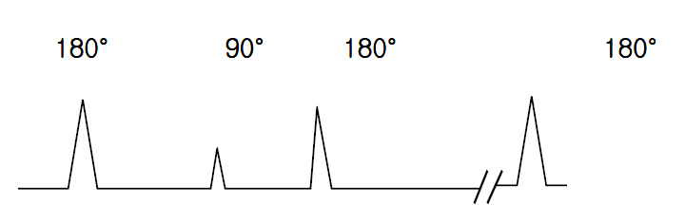
- Which one is correct for the following pulse sequence diagram?

(1). This sequence can acquire angiography.
(2). A specific signal(fat, water) can attenuate.
(3). This sequence can acquire magnetization transfer image(MTI).
(4). This sequence can acquire dynamic image.

- What is this kind of effect increased?
(1). Reduced TE (2). Used fast spin echo
(3). Used high field magnet (4). Decreased slice thickness

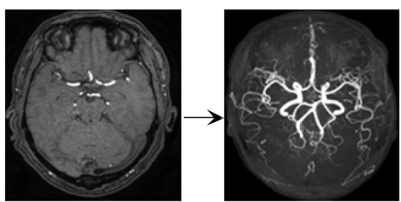
- Which post processing method is used on below images?
(1). MPR (2). ADC (3). MIP (4). SCIC

