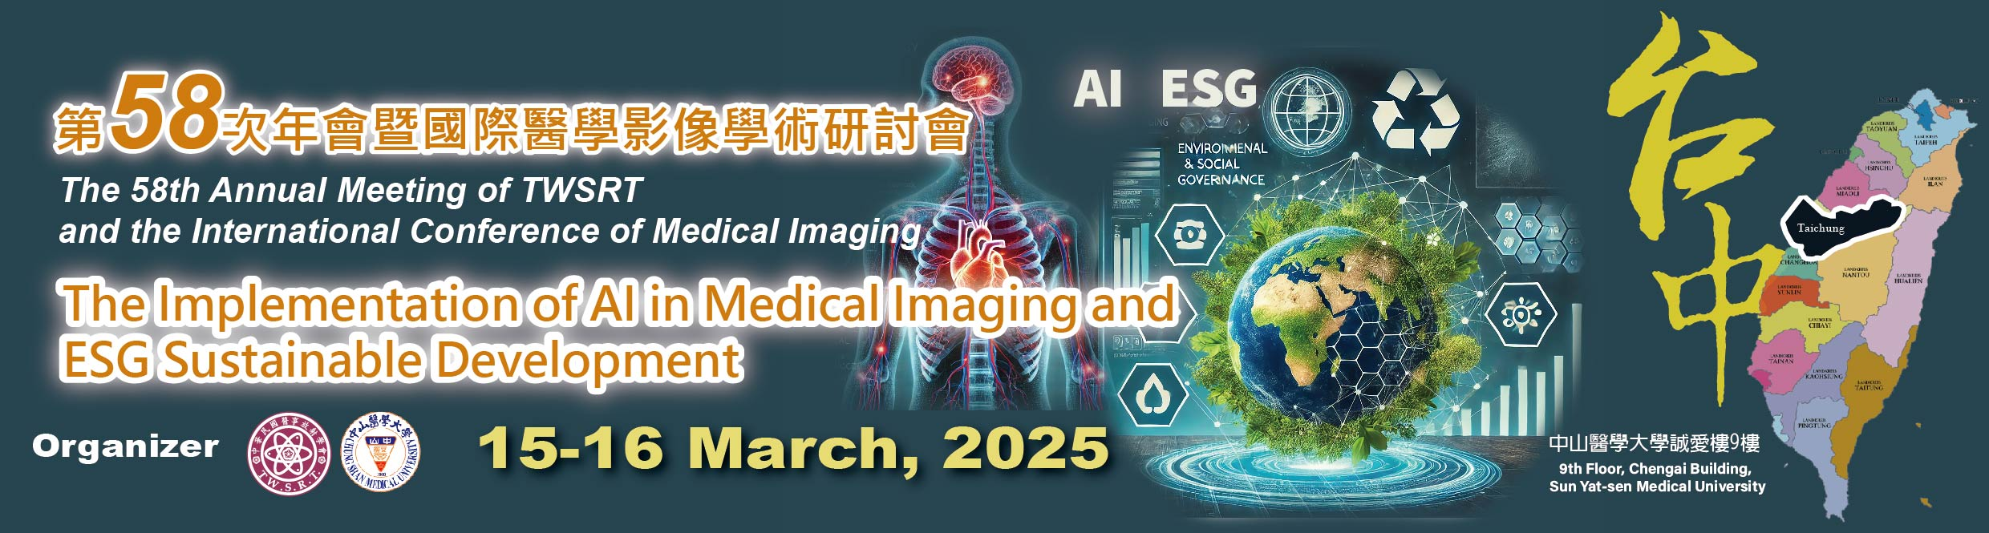

The 58th Annual Meeting of TWSRT and the International Conference of Medical Imaging
<Call for Abstracts>
Congress Theme： | The Implementation of AI in Medical Imaging and ESG Sustainable Development
Organizer： | Taiwan Society of Radiological Technologists(TWSRT)  Chung Shan Medical University
Dates： | 15-16th March 2025
Venue： | Chung Shan Medical University, Taichung, Taiwan  No.110,Sec.1,Jianguo N.Rd.,Taichung City 40201,Taiwan.

1. Invitation

Papers are invited on the subject of novel developments in radiation technology and Doctor-Patient relationships etc. Concerning Routine X-Ray, Mammography, Interventional Radiography, Computed Tomography, CT, Magnetic Resonance Imaging(MRI), Cardiac Catheterization, Ultrasound, Radiation Therapy(RT), Nuclear Medicine, Dental X-Ray, Educational Programs, Artificial Intelligence, Evidence-Based Medicine, and other related topics are encouraged. Review the list of suggested topics to verify that your research aligns with the goals of this conference.
2. Abstract

The abstract (max. 300 words) should state the “Purpose” of your study, “Material and Methods”, “Results

(Important findings)”, principal “Conclusion” and “Keywords”.
3. Oral and E-Poster Presentation
The oral presentation is 10 minutes; includes 7 minutes of speech and 3 minutes of question and answer.
The format of the E-poster will be announced in the acceptance letter.
Please submit your Abstract via Google Form:
4. Deadline for Paper
10th Jan 2025

