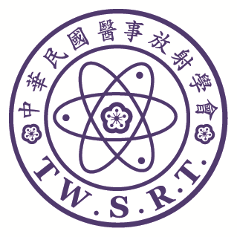

**The 58th Annual Meeting of TWSRT and**

**the International Conference of Medical Imaging**

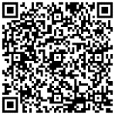

Deadline: 2024/12/31

Submission Form

Name:

Institute: Department: E-mail:

Phone: Ext: Fax:

Address:□□□

Presentation Option:

□ Oral Speaker： □ E-Poster

Notes:

1. Abstract text: limited to 300 words.
2. When you complete abstract, please delete the yellow-marked texts about the format’s regulation, such as (Times New Roman, 11 Points, Bold type) and (Please list 3-5 keywords), etc.
3. If the submitting author isn’t same as corresponding author, please mark corresponding author by “**\***”.

|  |
| --- |
| **Title (Times New Roman, 12 Points, Bold, Centered)**  **Name1 XXX2 (Times New Roman, 11 Points, Bold, Centered)**  **1Authors Affiliation (Hospital and Department) 2XXX(Times New Roman, 11 Points, Bold, Centered)**  **(If the authors belong to the same department, the numbers are waived)**  **Examples: Ying-Ling Chen 1 Jyun-Ru Chen2**  **1** **Department of Radiology, Cathay General Hospital 2 Department of Radiology,** **MacKay Memorial Hospital** Purpose (Times New Roman, 11 Points, Bold type) …………………………………………………..………………………..…………………………………………………………………………(Times New Roman, 11 Points, Single space)  **Materials and Methods (Times New Roman, 11 Points, Bold type)**  …………………………………………………..………………………..…………………………………………………………………………(Times New Roman, 11 Points, Single space) Results (Times New Roman, 11 Points, Bold type) …………………………………………………..………………………..…………………………………………………………………………(Times New Roman, 11 Points, Single space)  **Conclusion (Times New Roman, 11 Points, Bold type)**  ………………………………………………………………… (Times New Roman, 11 Points, Single space).  **Keywords: Please list 3-5 keywords (Times New Roman, 11 Points, Bold type)**  …………………………………………………………………(Times New Roman, 11 Points, Single space) |



