放射線機器管理士測驗

Medical Imaging and Radiologic Systems Manager

2018年8月26日星期日

1. Choose the item that can be measured by using test charts of the star-pattern camera method.

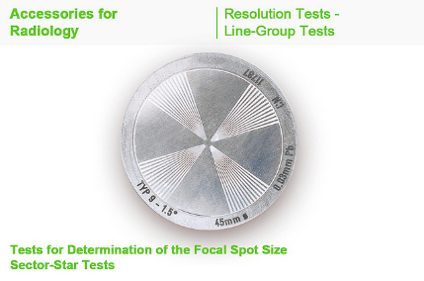

1. mA Linearity
2. mAs reciprocity
3. kVp accuracy
4. Focal spot test
5. What is this test for?

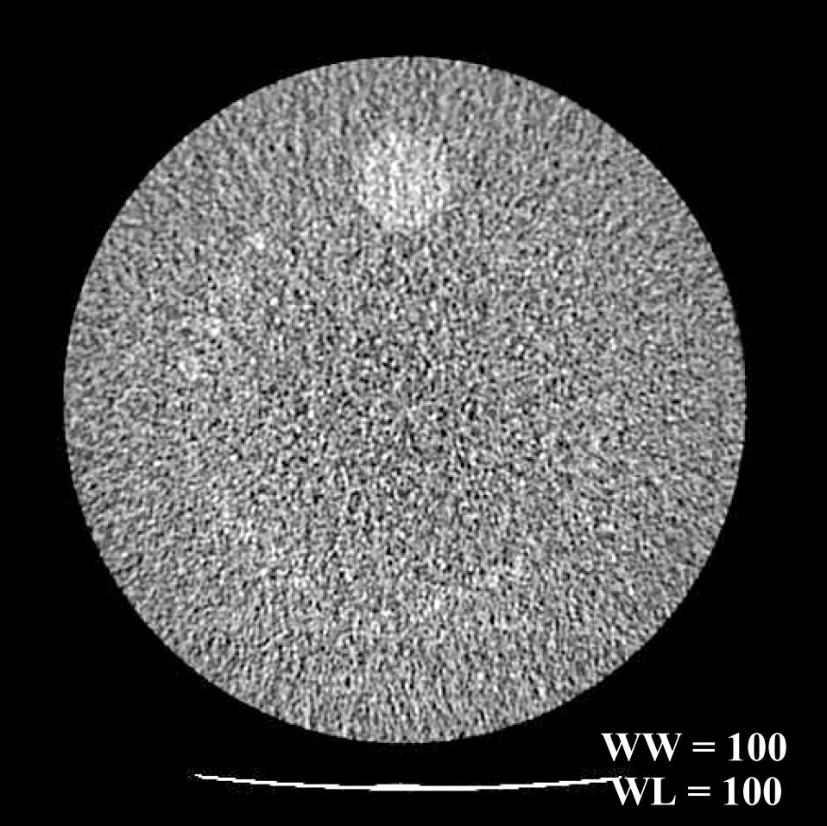

1. Slice thickness determination
2. Uniformity determination
3. Low contrast resolution measurements
4. High contrast (spatial) resolution
5. Choose the answer that correctly describes the discrepancy between the X-ray field and the light field.
6. 0.5% of the source image distance (SID)
7. 1.0% of the SID
8. 2.0% of the SID
9. 3.0% of the SID

1. Choose the property that is not relevant to the performance of automatic exposure control.
2. Response time
3. Tube voltage
4. Subject thickness
5. Tube current
6. The second half-value layer (HVL) of a photon beam is approximately the same as first HVL:
7. For all X-ray tube generated photon beams
8. Only if the energy is below 100 kVp
9. Only if the beam is monoenergetic ( e.g., gamma rays)
10. Never, it is always less
11. List the following types of X-ray equipment in order of increasing focal spot size.
12. CT, mammography, angiography, chest unit
13. Mammography, angiography, chest unit, CT
14. Angiography, CT, chest unit, angiography
15. Chest unit, mammography, angiography, CT
16. In X-ray tube, off-focus radiation?
17. is low-energy bremsstrahlung radiation from the non-target part of the anode
18. will not make up more than 1% of the tube output
19. has no effect on image quality
20. makes no contribution to patient dose
21. A major limitation of many early full-field digital mammography units is the?
22. Focal spot size
23. Detector size
24. Lack of compression capability
25. Limited angulation
26. In mammography, what would an SMPTE pattern be used for?
27. Evaluation of system resolution
28. Evaluation of focal spot size
29. QC of laser image printer and display monitor
30. View box QC
31. The interventional reference point (defined by the International Electro technical Commission) is located?
32. At 15 cm from the isocenter toward the image receptor
33. At 15 cm from the isocenter toward the x-ray tube
34. At isocenter
35. At the port of the x-ray tube
36. Which one of the following provides the best estimate of the maximum skin dose delivered during an interventional procedure?
37. The displayed dose at the reference point
38. The displayed kerma area product (KAP)
39. The total number of DSA frames used for case
40. The total fluoroscopic time used for case
41. A 64-slices CT scanner can obtain sixty-four 0.625 mm wide slices in a single 0.5 second axial acquisition. How many 5 mm wide slices can it obtain in a single 1.0 second axial acquisition?
42. 8
43. 16
44. 64
45. 128
46. In order to estimate the effective dose in mSv from a CT exam, which of the following is “not” needed?
47. the length of the CT scan study
48. a dose-length product to effective dose conversion factor for body part imaged
49. the patient weight
50. CTDIvol of the patient
51. For MR imaging, the patient’s weight must be entered accurately during patient registration to?
52. Prevent damage to the RF coils
53. Prevent artifacts in the images
54. Prevent damage to the patient table
55. Enable calculation of the specific absorption rate (SAR)
56. The width of an ultrasound beam measured perpendicular to the image plane determines the?
57. Axial resolution
58. Depth resolution
59. Lateral resolution
60. Slice thickness
61. What is the ACR CT accreditation program reference dose for routine adult abdomen CT scan?
62. 60 mGy
63. 25 mGy
64. 35mGy
65. 10mGy
66. In MRI, which gradient is on during the time the echo is measured?
67. Slice selection
68. Phase encoding
69. Collimating
70. Frequency encoding
71. Which of the following is “not” a method of medical radioisotope production?
72. Bombarding with neutrons in a reactor
73. Bombarding with protons in a cyclotron
74. Bombarding with neutrons in a cyclotron
75. Elution of a metastable daughter from a parent
76. Scintillation detector conversion efficiency is?
77. The same as the detector detection efficiency
78. The fraction of deposited energy that is converted into light
79. The fraction of deposited energy that is converted into electrons
80. Decrease with the scintillator atomic number
81. The x-ray tube current is
82. Determined by the anode temperature
83. Adjusted through varying the filament current
84. Usually space charge limited
85. Usually 500 mA for mammography
86. The resolving capability of the focal spot is best:
87. Towards the anode side of the field
88. Directly under the central axis (center of the field)
89. Towards the cathode side of field
90. Towards the left side of the field perpendicular to anode-cathode axis
91. Geometric magnification can improve the detection of high contrast objects. The fundamental limitation on useful magnification is:
92. Blurring due to focal spot size
93. Blurring due to removal of the grid
94. MTF of the image receptor
95. H&D curve of the image receptor
96. Low contrast detectability refers to the ability of system to distinguish:
97. A calcified lung nodule
98. A non-calcified lung nodule
99. The size of large fracture
100. The size of small fracture
101. The image of a resolution test pattern placed in the center of the x-ray field and 4.5 cm from the image receptor shows a limiting resolution of 11 lp/mm. what resolution may be expected if the pattern is moved to the anode-side edge of the field?
102. 1 lp/mm
103. 10 lp/mm
104. 20 lp/mm
105. 12 lp/mm
106. In a CT image, the Hounsfield number of a material:
107. Is dependent on its linear attenuation coefficient
108. Increase if the window width is increased
109. Has units of per cm
110. Increase with mA
111. What is this phantom test for?



1. Radiation dose
2. Uniformity determination
3. Low contrast resolution measurements
4. High contrast (spatial) resolution
5. A DR system specification sheet says the field of view is 43\*43 cm, and the detector element size is 100\*100 microns. What is the spatial resolution?
6. 2.15 lp/mm
7. 2.5 lp/mm
8. 4.3 lp/mm
9. 5.0 lp/mm
10. What is this test for?

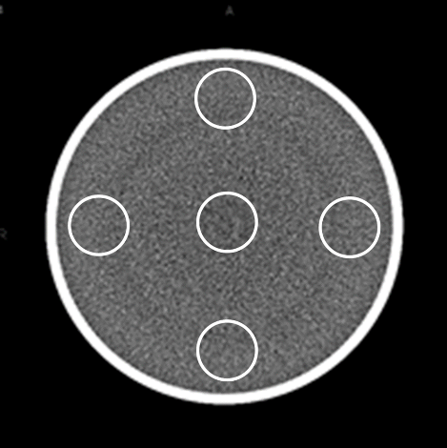

1. CT number calibration
2. Uniformity determination
3. Low contrast resolution measurements
4. High contrast (spatial) resolution
5. In mammography, what would be the impact of changing a Mo/Mo to a Mo/Rh target/filter system (AGD is average glandular dose)
6. The AGD would decrease and contrast would increase
7. The AGD would decrease and contrast would decrease
8. The AGD would increase and contrast would decrease
9. The AGD would increase and contrast would increase
10. What is the most common phosphor used in DR system?
11. CsI
12. NaI
13. GdOS
14. YGdO
15. Which modality require the most shielding in the wall, floor and ceiling?
16. DR unit
17. FFDM mammography unit
18. Fluoroscope unit
19. CT scanner
20. For the same collimation, at which pitch would helical mode CT have a higher patient dose than axial mode?
21. 3
22. 1.5
23. 1.8
24. 1
25. A computed radiography image with 10 bits per pixel. How many shades of gray and byte/pixel will have?
26. 256, 1
27. 1024, 1
28. 256, 2
29. 1024, 2
30. To keep patient dose as low as reasonably achievable for digital radiography exam using a CR or DR detector, the mAs is selected to provide acceptable:
31. Image contrast
32. Optical density
33. Luminance on the image monitor
34. Signal to noise ratio
35. Choose the item that is least relevant to medical quality.
36. Effectiveness
37. Efficiency
38. Accessibility
39. Scientific and technical quality
40. Choose the correct name of the stepwise approach consisting of setting an objective, making and executing a plan, and evaluating and managing the performance, so as to achieve the objective effectively; this method was developed in the 1930s and is still being used widely.
41. CPDA
42. DAPC
43. PDCA
44. ACPD
45. Choose the correct range of total filtration for X-ray equipment with a nominal

maximum tube voltage of 150 kV or less.

1. 1.5 mmAl or more
2. 2.0 mmAl or more
3. 2.5 mmAl or more
4. 3.0 mmAl or more
5. Choose the term that describes a way to provide image data at constant density regardless of the body shape of the patient by controlling exposure time and other factors.
6. Generator
7. Automatic exposure control (AEC)
8. Half value layer (HVL)
9. Timer
10. Choose the correct combination of items that affect the quality of mammographic images.

a. Absorption difference in the breast b. Size of focus c. Exposure field d. Filtration

1. Only a
2. a and b
3. a, b and c
4. All of a to d
5. Choose the item that can be measured by using the phantom shown below.

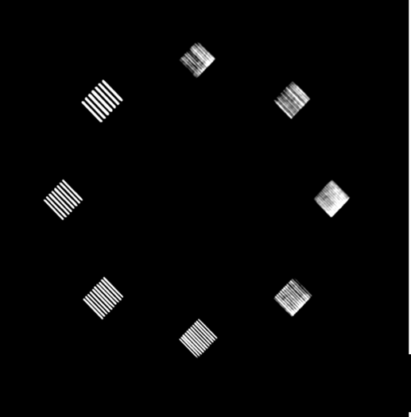

1. CT number calibration
2. Uniformity determination
3. Low contrast resolution measurements
4. High contrast (spatial) resolution
5. Choose the correct combination of items that are relevant to a multi-slice CT system.

a. RF coil b. Radio shield c. Cone beam d. Data acquisition system (DAS)

e. Sensitivity time control (STC)

1. a and b
2. a and e
3. b and c
4. c and d
5. Choose the answer that does not correctly describe the computed tomography dose index (CTDI) of a CT system.
6. A pensile-type ion chamber is used.
7. Phantoms of 16 and 32 cm in diameter are used.
8. The Z-side dose profile of multi-slice scan is integrated.
9. Data on patient exposure during the operation is provided.
10. Choose the description appropriate for the image shown below.



1. Spatial resolution measurement
2. Low contrast resolution
3. CT number measurement
4. Dosimetry
5. Choose the correct measure of the spatial resolution for a CT system.
6. Winer spectrum (SD)
7. cm-1/CT number
8. CT number
9. MTF (Lp/cm)
10. Choose the item that does not cause artifacts in the MRI.
11. Breathing motion
12. Intestinal gas
13. Cardiac motion
14. Buttons on clothes
15. Choose the item that should not be brought into an MR examination room.
16. Oxygen cylinder
17. Ceramic scissors
18. Wheelchair made of non-magnetic substances
19. Butterfly needle
20. How many imitation lesions are there in the mammo phantom (it is made out of 50 % breast parenchymal/50 % fat and is pressed in to 4.5 cm)?
21. Fiber 6 speck 5 mass 5
22. Fiber 6 speck 6 mass 5
23. Fiber5 speck 5 mass 6
24. Fiber 5 speck 6 mass 6
25. The MTF is one method to measure the:
26. Low-contrast resolution
27. High-contrast spatial resolution
28. Attenuation
29. Section Thickness
30. Which of the following is not related with the performance of automatic exposure control device?
31. The characteristic of response time
32. The characteristic of kvp
33. The characteristic of subject thickness
34. The characteristic of mAs
35. How often at least for Mammographic quality standards, phantom images with ACR accreditation phantom or equivalent phantom should be obtain?
36. Daily.
37. Weekly.
38. Monthly.
39. Yearly.
40. Choose the item not related to computed radiography (CR).
41. Cassette with intensifying screen
42. Imaging plate
43. Laser tube
44. A/D converter
45. Choose the item not related to a CT system.
46. Single slice
47. Multi-slice
48. Quenching
49. Helical scan
50. Choose the correct statement about an X-ray CT value.
51. Fat has a higher CT value than water
52. It is determined from the reflectance of an X-ray beam
53. It depends on the atomic number of the subject material
54. It is a relative value, with a zero value for water
55. Choose the item not relevant to the performance evaluation of a CT system.
56. Spatial resolution
57. Scintillator
58. Contrast resolution
59. Slice thickness
60. Choose the item not relevant to the start-of-day checking of a CT system.
61. Gantry operation and safety
62. Couch operation and safety
63. X-ray output dose measurement
64. Safety mechanism operation
65. Choose the item not relevant to the image noise of a CT system.
66. Structural noise
67. Acoustic noise
68. Electric noise
69. Quantization noise
70. Choose the item not relevant to the dosimetry of a CT system.
71. Low contrast resolution
72. DLP
73. MSAD
74. CTDI
75. Filtered back projection in CT refers to ?
76. spatial resolution
77. pre-patient collimation
78. beam filtration
79. image reconstruction
80. Which type of test tool may be used to demonstrate pincushion distortion?
81. Dosimeter
82. Wire mesh tool
83. Ion chamber
84. Homogenous phantom
85. Which of CT quality control is measured in the figure?

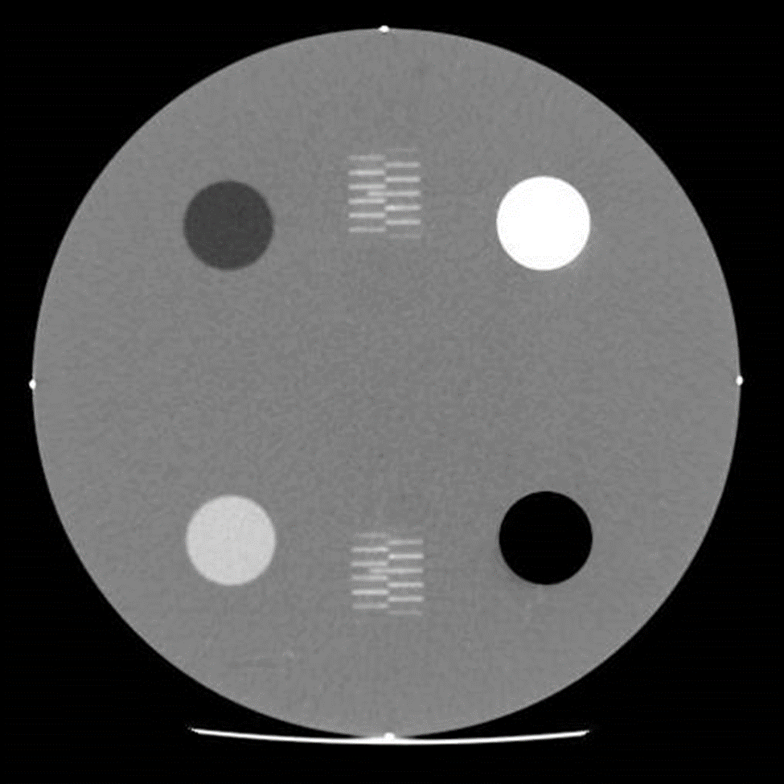

1. Noise and Uniformity
2. Spatial Resolution
3. Slice Thickness
4. Patient Dose
5. Which of CT quality control is measured in the figure?

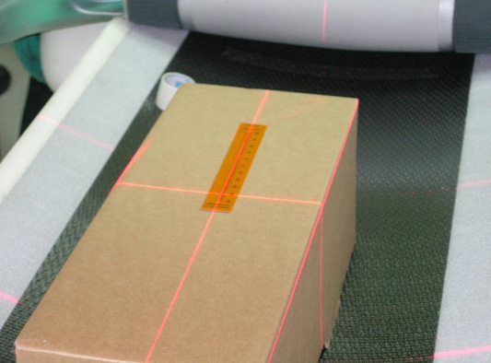

1. Noise and Uniformity
2. Radiation beam width
3. Slice Thickness
4. Patient Dose
5. Image noise in CT scanning depends on?
6. pixel size
7. detector efficiency
8. slice thickness
9. all of the above
10. The patient dose in CT is determined by?
11. Pre-detector collimator
12. Pre-patient collimator
13. Post-patient collimator
14. all of the above
15. In MRI, signal to noise ratio can be increase by all of the following expect:
16. switching from body to head coil
17. increasing the number of acquisitions
18. increasing the static magnetic field strength
19. decreasing the slice thickness
20. Chemical shift artifacts in MRI are:
21. secondary to using gadolinium contrast
22. seen in the frequency encoding direction
23. not affected by the gradient strength
24. more severe for lower magnetic field strength
25. A 4 MHz ultrasound beam travels through 7.5 cm of soft tissue with an attenuation of 1 dB/cm/MHz. The original intensity is reduced by?
26. 30 dB
27. 100 dB
28. 300 dB
29. 3 dB
30. If an ultrasound pulse is about three wavelengths long and wavelength in soft tissue is 0.33 mm. what is the achievable axial resolution in mm?
31. 0.5
32. 1.0
33. 3.3
34. 9.9
35. The SI unit of absorbed dose from ionizing radiation is the?
36. Becquerel
37. MeV
38. Gray
39. Rem
40. Sievert is a unit of?
41. Exposure
42. Equivalent dose
43. Dose rate
44. Energy
45. The roentgen is a unit of:
46. Radiation exposure
47. Absorbed dose
48. Equivalent dose
49. Radioactivity
50. If the linear attenuation coefficient is 0.5 cm-1, the HVL is ?
51. 13.86 cm
52. 1.386 cm
53. 0.05 cm
54. 0.0347 cm
55. Which of following rays are electromagnetic waves?
56. Beta
57. Gamma
58. Delta
59. Alpha
60. 1 Bq is equal to?
61. 2.7\*10-11Ci
62. 3.7\*1010Ci
63. 3.7\*10-10Ci
64. 2.7\*10-7Ci
65. Which of the following types of radiation is not electromagnetic?
66. Microwave
67. Ultrasound
68. Radiowaves
69. Heat radiation
70. An H&D curve illustrates the dependency of?
71. Dose upon exposure
72. Optical density upon dose
73. Dose upon depth
74. Film transmission upon depth
75. Pixel size for full-field digital mammography units is ?
76. 0.05 to 0.1 mm
77. 0.2 to 0.5 mm
78. 1 to 2 mm
79. 0.8 to 1 mm
80. In PACS, large-matrix display stations(for DR or CR) have all of the following except:
81. A magnification function
82. Interactive window and level function
83. Ability to measure the linear attenuation coefficient accurately
84. Ability to invert the gray scale value of the image
85. To store images with 256shades of gray, each pixel in the image will require:
86. 1 byte
87. 6 bytes
88. 1 bit
89. 6 bits
90. For a similar RF coil, 3T MRI always has which than 1.5T MRI?
91. Higher resolution
92. Higher SNR
93. A shorter scan time
94. Less artifacts
95. In PACS, which of the following is a mass storage device
96. DICOM
97. NEMA
98. RAID
99. ISDN
100. The effective energy of an x-ray beam?
101. linearly increase with the atomic number
102. affects subject contrast
103. is equal to the kVp
104. is proportional to the mAs
105. What is this test for?

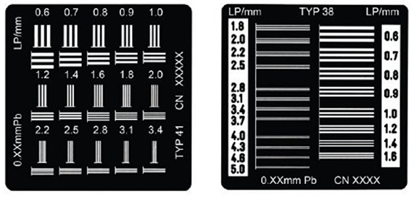

1. Spatial resolution measurement
2. Low contrast resolution
3. Focal spot measurement
4. Dosimetry
5. What is this test for?

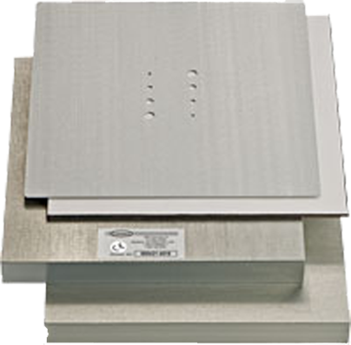

1. Spatial resolution measurement
2. Low contrast resolution
3. Focal spot measurement
4. Dosimetry
5. What is this test for?

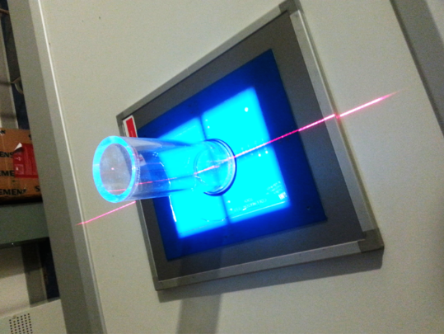

1. Spatial resolution measurement
2. Beam collimation
3. Focal spot measurement
4. Dosimetry
5. What is the purpose of the directions in the image?



1. Gray scale steps
2. Contrast resolution
3. Uniform background
4. 5 % Contrast patches
5. Choose the item relevant to CT resolution in the axial direction.
6. Scan time
7. Helical pitch
8. Display pixel size
9. Detector sensitivity
10. Which of the following is correct standard range when using 250mAs in CT equipment QC?
11. 10 %
12. 2.15 %
13. 20 %
14. 25 %
15. Which effect is true about inhomogeneity of CT number from characteristics of X-ray in an object in Computed Tomography?
16. Photon effect
17. Cupping effect
18. Partial volume effect
19. Beam hardening effect
20. In phantom image exam of CT equipment, What is the standard range of CT number and Noise?
21. 7 HU below, 7 HU below
22. 10 HU below, 8 HU below
23. 5 HU below, 10 HU below
24. 7 HU below, 10 HU below
25. Choose the correct action to be taken in advance of a power system maintenance outage in an area including an MRI examination room.
26. In the case of a Resistive magnet MRI system, keeping the power to the Static magnetic field coil is not related with eliminating the magnetic field.
27. In the case of a Permanent magnet MRI system, sudden change in temperature in the examination room is not related with magnetic field.
28. In all types of MRI systems, because the Static magnet field disappears during an outage, there is not need to prohibit access to the MRI examination room.
29. In the case of a Superconducting magnet MRI system, because helium consumption increases when the refrigerator stops, add a sufficient amount of helium to avoid the occurrence of quenching.