放射治療測驗

Radiotherapy

2019年8月25日星期日

1. 除題意不清楚或是圖片有問題，禁止詢問與試題有關的問題。
2. 應答時禁止使用任何文件。
3. 請在電腦答案卡上圈選作答

項目 | 填寫內容
姓名 | 您的中文與英文姓名
試題名稱 | RT Test
項目 | 不用填寫
科目 | 不用填寫
受試者識別代碼 | 您的准考證號碼 25XXX  將您選定之數字的圓圈塗滿。
科目代碼 | 不用填寫
地點代碼 | 不用填寫
作答方式 | 本測驗共有90題問題。請使用1到90作答欄位。  請將測驗卷Q1的答案填入答案卷的答案選擇1。Q2 = 答案選擇2，Q3 = 答案選擇3…Q90 = 答案選擇90。

- Which of the following is true about Window Width of CT Simulator?
- If Window Width is extremely narrow, black and white of an image is clearly visible.
- The wider the Window Width, the narrower the range of the CT values displayed.
- The narrower the Window Width, the wider the range of the CT value displayed on the monitor.
- If Window Width is wide, an image has high contrast and improved resolution.
- If Window Width is narrow, an image has low contrast, and it can reduce the penumbra of the image.

- Which of the following is true about the artifact of CT simulator?
- Beam-hardening effect is caused by physical cause.
- Beam-hardening effect is reduced if the thickness of the subject increases.
- Cupping effect is that the CT value is higher in the middle than the surrounding.
- Capping effect is that the CT value is higher in the surrounding than the middle.
- To reduce beam-hardening effect, thin slice thickness or low tube voltage is used.

- Which of the following is true about the noise increase of the image in CT simulation scan?
- Noise increases proportionally to the slice thickness of the image.
- Noise increases proportionally to the entrance dose of the subject.
- Noise increases proportionally to the pixel size of the image.
- Noise increases proportionally to the number of photon by the detector.
- Noise increases proportionally to the attenuation of cross-sectional area through the subject.

- Which of the following is directly related to the CT number (Hounsfield Unit)?
- Attenuation coefficient
- Slice thickness
- Entrance dose
- Pixel size
- Tube voltage, tube current

- Which of the following factors has the greatest effect on the resolution of CT simulation scan image?
- Pitch
- Filter
- Pixel size
- Slice thickness
- CTDI

- What is the effect of smaller FOVs with the same image matrix size in CT simulation scan?
- The spatial resolution of the image is improved.
- The contrast of the image gets worse.
- The slice thickness of the image gets thick.
- Beam hardening artifacts of the image decrease.
- Partial volume artifacts of the image increase.

- According to the Report No. 38 of ICRU, which of the following dose distinguishes HDR (High Dose Rate Brachytherapy) from LDR (Low Dose Rate Brachytherapy)?
- 2 cGy/min
- 20 cGy/min
- 200 cGy/min
- 20 cGy/hr
- 200 cGy/hr

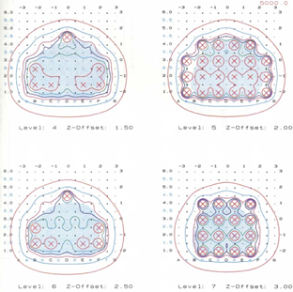
- The following figure shows the arrangement of nuclide and dose distribution for brachytherapy of any site. Which of the following is correctly connected with the site, nuclide, and treatment?
Fig.1

1) Prostate - Ir-192 - (Semi)Permanent implant
2) Prostate – Ir-192 - Intraluminal irradiation
3) Prostate – I-125 - (Semi)Permanent implant
4) Uterus – Ir-129 – Intracavitary irradiation
5) Uterus – I-125 - Intracavitary irradiation

- Which of the following treatments must place the (rotation) axis of the treatment beam in the body?
- FSRT(Fractionated Stereotactic Radiotherapy)
- TSEI(Total Skin Electron Irradiation)
- CSI(Craniospinal Body Radiation Therapy)
- SBRT(Stereotactic Body Radiation Therapy)
- TBI(Total Body Irradiation)
- SRS(Stereotactic Radiosurgery)
- VMAT(Volumetric Arc Therapy)
- a, b, c
- b, c, d
- a, b, f
- c, d, g
- b, c, e

Q10. The following image shows sagittal plane of the patient using belly-board. Which of the organs have benefit from using the device?
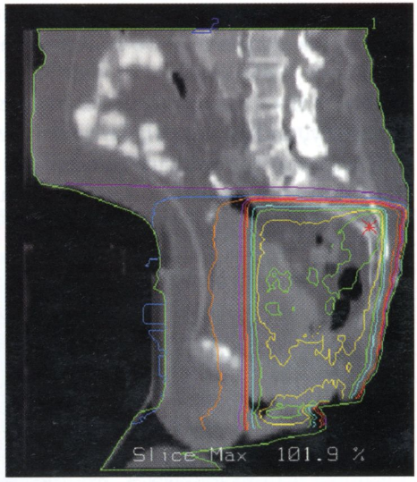 Fig.2
- Uterus
- Bladder
- Rectum
- Small bowel
- Both femoral heads

- The following is an explanation of SBRT (Stereotactic Body Radiation Therapy). Which one is true?
- SBRT needs to deliver the same dose to a lower MU compared to IMRT.
- SBRT using protons is difficult to implement because RBE values are different.
- SBRT can deliver the uniform dose to CTV compared to conventional 3D CRT.
- SBRT uses stereotactic frame specially constructed for precision similar to SRS.
- Compared to conventional 3D CRT, the goal of SBRT is to deliver less number of treatments and higher total doses.

- Which of the following nuclides of seed type is available to delivery in brachytherapy?
- Cobalt-60
- Cesium-137
- Iodine-125
- Radium-226
- Iridium-192

- Which of the following parameter would increase treatment beam time in Tomotherapy?
- Making field width wider
- Raising modulation factor
- Making the speed of gantry rotation faster
- Raising Pitch(the speed of couch movement)
- Using dynamic jaw function(using edge in superior-inferior) of Tomo Edge

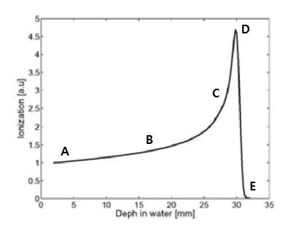
Q14. The following figure shows depth dose distribution of the proton. Choose the point that is associated with the lowest energy of the proton and the highest RBE (Relative Biological Effect)

Fig.3

- A
- B
- C
- D
- E

- Which of the following devices overlaps the Bragg-peak of the proton sequentially so that the proton can spread out widely and match with the volume of the tumor?
- Degrader
- Scanning magnet
- Range Compensator
- Energy Selection System
- Range Modulator Wheel

- Choose the correct angle for the accelerated electron to bend through the bending magnet before it hits the target in LINAC.
- Chromatic 90 degree, Chromatic 180 degree bending magnet
- Chromatic 90 degree, Achromatic 180 degree bending magnet
- Chromatic 180 degree, Achromatic 270 degree bending magnet
- Chromatic 180 degree, Achromatic 180 degree bending magnet
- Chromatic 90 degree, Achromatic 270 degree bending magnet

- Which of the following factors determines the angle of Dynamic Wedge Filter?
- Dose rate
- Moving speed of gantry
- Changes in irradiation field size
- Rates of irradiated MU mounts
- Moving speed of collimation jaw

- Which of the following is true about Tomotherapy?
- It uses 10 MV X-ray in treatment.
- It can use MVCT in IGRT.
- It can use Cone Beam CT in IGRT.
- The operation method of the MLC for IMRT is Window Sliding.
- The latest one can implement gantry fixation treatment in table fixed.

- Which of the following is true about Cyber-knife?
- SAD is 100 cm
- It uses MLC of Gimbaled.
- It can use CBCT for image acquisition
- It can treat various parts by using isocentric method.
- It can implement tumor-tracking radiation therapy by using synchrony respiratory tracking system..

- Which of the following systems can integrate CT imaging system with LINAC to determine the precise location of the tumor?
- BAT
- ANZAI
- CBCT
- Brainlab Exactrac
- Calypso imaging system

- Which of the following is the calculation algorithm using in Cyber-knife?
- Acuros
- AAA calculation
- Monte Carlo calculation
- Pencil Beam calculation
- Superposition-convolution algorithm

- Choose the correct component that is mainly used for the ion chamber of LINAC
- High atomic number material
- Low atomic number material
- Tungsten
- Lead
- Platinum

- What is the advantage of lung cancer's respiratory gated radiation therapy?
- Reduced treatment time
- Reduced therapeutic range
- Improvement of target dose range
- Reduced movement of tumor
- Increased reproducibility of patient positioning

- As defined in the ICRU-62 report, what are a and b in an equation of a = b + IM (internal margin)?
- a-CTV, b-GTV
- a-CTV, b-ITV
- a-ITV, b-CTV
- a-ITV, b-GTV
- a-PTV, b-CTV

- Which of the following is true about Hyper-fraction?
- Total exposure dose decreases.
- Dose per fraction is 180-200 cGy.
- Dose per fraction is 500-600 cGy.
- Total exposure dose and the period of treatment decrease
- Total exposure dose increases but the period of treatment and the late complication do not increase.

- What is the chemical factor that affects radiation response?
- Oxygen
- Cell Cycle
- The quality of radiation
- Dose rate of radiation
- fractionated irradiation of radiation

- What is the typical tumor marker test for prostate cancer?
- AFP
- CEA
- DRE
- PSA
- CA₁₉₋₉
- Which cancer is marked as FIGO staging system?
- Bladder cancer
- Breast cancer
- Pancreatic cancer
- Thyroid cancer
- Uterine cervix cancer

- What is the maximum dose limit of the pacemaker compared to the treatment total dose as defined in the AAPM Task Group report 34?
- Not more than 0.1 Gy
- Not more than 0.2 Gy
- Not more than 1.0 Gy
- Not more than 2.0 Gy
- No limit dose

- What is the most common metastatic part of Ewing’s sarcoma?
- Lung
- Liver
- Breast
- Prostate
- Pancreas

- What are the most important predictive factors in breast cancer?
- The size of tumor
- The location of tumor
- The number of tumor
- Metastasis
- The number of axillary lymph node invasion

- What the dose uniformity of treatment target is defined in ICRU-50 report?
- +3%~-3%
- +3%~-5%
- +5%~-3%
- +5%~-7%
- +7%~-5%

- Where does the Hot spot move when the right wedge filter changes to 45 degrees in the following treatment plan?
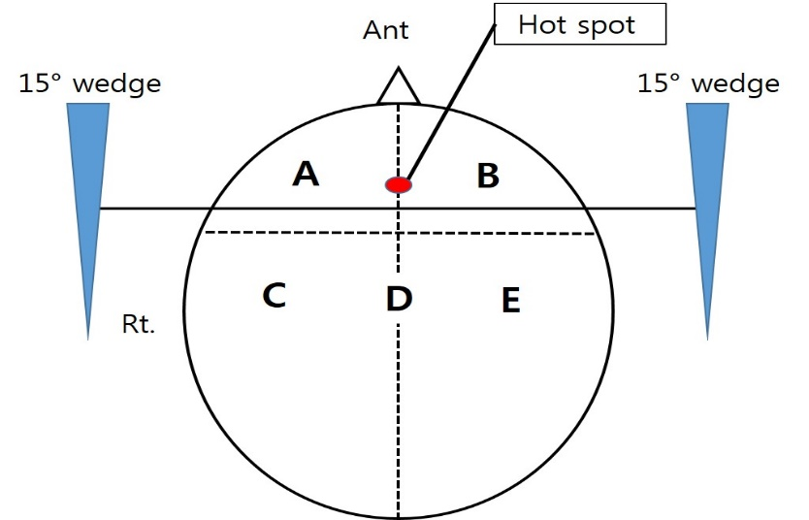
Fig.4
- Part A
- Part B
- Part C
- Part D
- Part E

- What is the position of axillary lymph nodes 2nd level in the image?
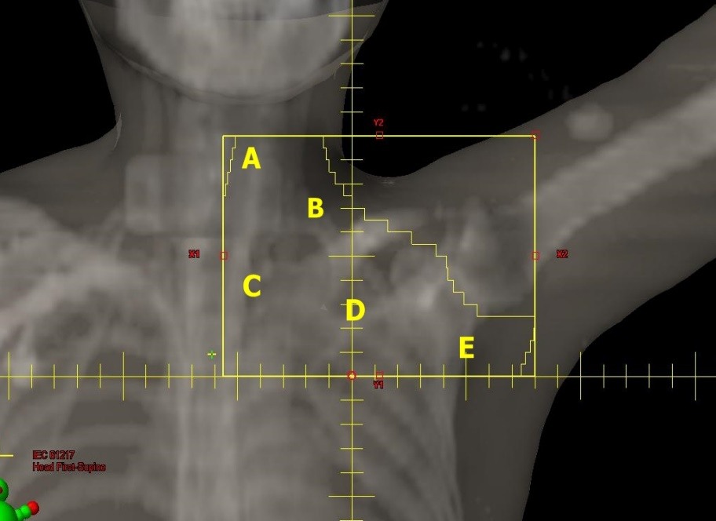
Fig.5
- A
- B
- C
- D
- E

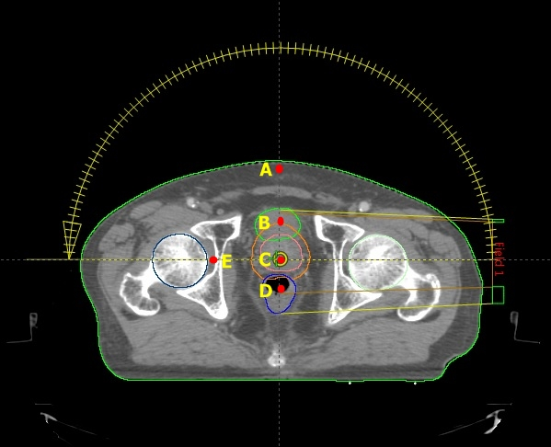
- Which one is the maximum dose point in the following treatment planning image?
Fig.6
- A-point
- B-point
- C-point
- D-point
- E-point

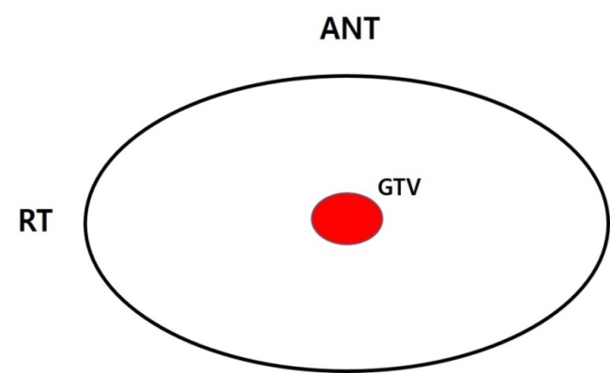
- What is the treatment that has the least integral-dose for treating GTV in the image?
Fig.7
- 180 degree Arc
- Opposing portal irradiation(AP & PA)
- Opposing portal irradiation(Rt. lat & Lt. lat)
- Four portal irradiation(AP & PA & Rt. lat & Lt. lat)
- Four portal irradiation(Four oblique)

- Which of the following is true about the surface dose?
- The proton beam is higher than the electron beam.
- As the energy of electron beam increases, it decreases.
- As the size of the irradiation field increases, it decreases.
- It has nothing to do with the energy and is the result of the forward scattering.
- As incidence angle increases in the oblique incidence, it increases.

- Which of the following is true about SAR (Scatter Air Ratio)?
- No related to field size
- No related to SSD(Source Skin Distance)
- No related to Photon Energy
- Useless in irregular treatment field
- Dose ratio of Max dose point in phantom

- Which one is unnecessary extra treatment in TSEI (Total Skin Electron Irradiation)?
- Sole
- Palm
- Vertex
- Axillar
- Perineum

- Which of following dose rate (cGy/min) in low dose TBI (Total Body Irradiation, 3~5 fraction/week)?
- 5~15
- 30~40
- 90~100
- 100~120
- 150~170

- ( ) has the lowest integral dose of lung in breast cancer radiation treatment.
- SRS technique
- IMRT technique
- VMAT technique
- Wedge technique
- Arc rotation technique

- Which of the following depends on SSD (Source Skin Distance)?
- TMR
- TAR
- BSF
- SAR
- PDD

- Which of the following adequate electron beam energy to treat tumor in 3 cm depth?
- 6 MeV
- 9 MeV
- 12 MeV
- 16 MeV
- 20 MeV

- AAPM TG-40 recommends which of the following for Monthly QA of Simulator?
- Exposure rate
- Field size indicator
- Cross hair centering
4) Focal spot axis indicator
5) Light / radiation field coincidence

- Where is Malignant Melanoma most commonly found?
- Arm
- Face
- Sole
- Palm
- Calf

- Which one is commonly risk factor to be taken the liver cancer?
- Sex
- Age
- Alcohol
- B Hepatitis
- C Hepatitis

- Which of the following does not ionize directly?
- Positron
- Neutron
- Alpha particle
- Proton
- Electron

- What material made of flattening filter?
- Zinc or Copper
- Inert materials
- Low Z material
- Lead or tungsten
- Equivalent material

- Calibration of a machine primarily deals with:
- Mechanical parameters
- Digital displays
- Laser equipment
4) Radiation beam parameter
5) All of the above

- Which of the following is not an accelerator component?
- Waveguide
- Transducer
- Circulator
- Modulator
- Thyratron

- Which of following sources are accelerating power in linear accelerator?
- Klystron and magnetron
- Thyratron and electron gun
- Magnetron and electron gun
- Bucher and Pre-buncher
- Bending magnet and collimator

- Which of the following is the clinical RBE of proton?
- 0.9
- 1.0
- 1.1
- 1.2
- None of the above

- Which of following software application is the current communication standard for the transfer of imaging data between?
- NEMA
- ACR
- IHE
- MITA
- DICOM

- DICOM-RT is the standard for the transfer of all of the following EXCEPT:
- RT structure sets
- RT images
- RT optimization parameters
- RT plans
- RT dose

- How many tenth-value-layer must be added to the secondary barriers in a vault if the number of monitor units per treatment on a LINAC increases by a factor of five but the dose rate behind the barrier must remain the same?
- 0.1
- 0.4
- 0.7
- 1.4
- 2.1

- Which of the following is not part of a diagnostic X-ray machine?
- Filament
- Transformer
- Target
- Rectifier
- Buncher

- Compton-scattered electrons can be emitted at with respect to the direction of the incident photon.

- 0°–90°
- 30°-110°
- 90°-180°
- 0°-270°
- None of the above

- According to the ICRU, Which of the following represents the expansion for an organ at risk, analogous to the PTV expansion for a target?

- OAR
- IM
- SM
- PRV
- EUD

- Choose the correct answer that defines the mechanical isocenter.
- Center of treatment field
- Point where the lasers intersection
- Point defined by star shot taken at different gantry angles
- Normalization point
- Point of intersection of the couch, collimator, and gantry axes of rotation

- A field of collimator setting 8 x 30 cm has an equivalent square of cm.
- 10.5
- 12.6
- 19
- 22.4
- 25

- Which of following imaging modality for target localization in Cyber-knife?
- Cone beam CT
- OBI
- Portal vision image
- Ultrasound
- Orthogonal X-ray

- A 10 x 10 cm 16 MeV electron beam has 90% depth dose at about cm.
- 1.5
- 3
- 5
- 8
- 10

- Choose the correct answer that the commonly material for neutron shielding in treatment room door.
- Paraffin Wax
- Concrete
- Lead
- Tungsten
- Borated polyethylene
- Which of the following isotope is the most commonly used in PET imaging?
- ¹⁵F
- ¹⁸F
- ¹²⁷I
- ¹¹C
- ⁶⁰Co

- Choose the correct answer that presents a Sievert Unit.
- Exposure
- Equivalent dose
- Absorbed dose
- Dose rate
- Monitor Unit

- Which of the following chemical species is responsible for causing approximately two-thirds of the damage through the indirect action of X-ray?
  - ^{ㆍ}OH
  - H₃O⁺
  - OH^{ㆍ}
  - H^{ㆍ}
  - H⁺

- The reason why a beam spoiler is used in a photon beam to
- Decrease the skin dose by filtering out electron scatter
- Decrease the PDD at the prescribe depth
- Increase the skin dose, but decrease dose in the build-up region
- Decrease the effective photon energy
- Increase dose in the build-up region while maintaining some skin sparing

- For calculating room shielding, the use factor, U, refers to
- The weekly dose at the isocenter
- The fraction of operation time that area in question is occupied
- The fraction of operation time that the beam is directed towards the barrier
- The fraction of the workweek that machine in in operation
- Summation MUs per a day
- What is the CT number in a CT image?
- Of a material is dependent on linear attenuation coefficient
- Increases if the window width is increased
- Decreases if the window width is decreased
- Increases with mAs
- No matter with linear attenuation coefficient

- For a radiation worker, such as a nuclear medicine physician or radiologist, the maximum permissible effective dose is mSv/year.
- 5
- 10
- 15
- 50
- 500

- KERMA is the :
- Energy per unit mass transferred from charged particles.
- Energy per unit mass absorbed or retained along the path of charged particle.
- Energy per unit mass transferred from photons to charged particles.
- Charge released by photons as they pass through a specified amount of air
- Charge released by photons as they pass through a specified amount of tissue

- TMR(Tissue Maximum Ratio) depends on:
- Energy, SAD, Depth and field size
- Energy, SAD, Field size
- SAD, Depth and field size
- Energy, Depth and field size
- SAD only

- Choose the range of typical residual positioning error after image registration for treatment.
- 1~2 cm
- 0.5~1 cm
- 1~5 mm
- <5 cm
- None of all above
- Prior to radiation treatment, the dose received at isocenter by cone beam CT is approximately cGy.
- 20~40
- 10~20
- 2~4
- 0.2~0.4
- 0.02~0.04

- Choose the true answer about total body irradiation (TBI).
- Only used electron
- In certain orientations, tissue compensators are necessary
- 4 directions (AP/PA, bilateral) can be used
- Lung doses are unlimited for treatment
- All of above

- Which of following tool is comfortable for measure skin dose?
- 99% pure Gel
- Film
- MOSFET
- TLD
- Glass dosimeter

- Which one is for delivery homogeneous dose distribution on broad field in X-ray treatment?
- Carousel
- Collimator
- Jaw
- Monitoring chamber
- Flattening filter

- Which is correct answer that the merit of MVCT more than KVCT?
- Less absorbed dose
- Better low contrast resolution
- Higher image quality
- Remark artifacts by high atomic number materials
- Reduced metal artifact
- Which angle wedge is inserted to 120º two portal beams for Thymoma?
- 15
- 30
- 45
- 60
- None of all above

- Hyper-fractionation radiation therapy is related to ( ), ( ) in 4R.
- Redistribution, Repopulation
- Repopulation, Reoxygenation
- Redistribution, Reoxygenation
4) Repair, Repopulation
5) Repair, Redistribution

- Which one is acute damage of radiation therapy?
- Production of cancer
- Blister
- Cataract
- Radiation Sickness
- Hereditary effect

- What material is commonly composed of thermoluminescence?
- CaSo₄
- CaF₂
- LiF
- Li₂B
- Li₃B

- With megavoltage film dosimetry, isodose curves can be measured to within:
- ±10%
- ±7%
- ±5%
- ±3%
- ±1%

- A consistency check of radiation beam should be performed at least:
- Daily
- Weekly
- Monthly
- Quarterly
- Annually

- A monitor unit in a LINAC usually represents an absorbed dose of :
- 1 Gy
- 0.01 Gy
- 0.05 Gy
- 100 Gy
- 0.1 Gy

- Which of the following is listed in the correct order from smallest to largest according ICRU definitions:
- GTV, ITV, CTV, PTV
- ITV, CTV, GTV, PTV
- GTV, CTV, ITV, PTV
- PTV, ITV, CTV, GTV
- GTV, CTV, PTV, ITV

- Proton plans compared to photon plans are typically conformal and uniform.
- More, more
- More, less
- Less, more
- Less, less
- More, equal

- The penumbra of proton beams is :
- Larger at small depths and smaller at large depths
- Smaller at small depths and larger at large depths
- Independent of depth
- Always sharper than photons
- None of all above

- Which of the following is true of annual QA for a linear accelerator?
1) Accuracy of MLC position
2) Indicator of gantry position
3) Coincidence of light and radiation field size
4) Coincidence of an X-ray beam quality (PDD₁₀ or TMR₁₀²⁰)
5) Optical distance indicator (ODI) check

Q90. Acceptable error of source position accuracy in daily QA of brachytherapy is:
1) 0.5 mm
2) 1.0 mm
3) 1.5 mm
4) 2.0 mm
5) 2.5 mm

