放射治療測驗

Radiotherapy

2017年8月27日星期日

1. 除題意不清楚或是圖片有問題，禁止詢問與試題有關的問題。
2. 應答時禁止使用任何文件。
3. 請在電腦答案卡上圈選作答

項 目 | 填寫內容：
姓名 | 您的中文與英文姓名
試題名稱 | RT Test
項目 | 不用填寫
科目 | 不用填寫
受試者識別代碼 | 您的准考證號碼 17XXX  將您選定之數字的圓圈塗滿。
科目代碼 | 不用填寫
地點代碼 | 不用填寫
作答方式 | 本測驗共有90題問題。請使用1到90作答欄位。  請將測驗卷Q1的答案於Answer Choices1填入答案卷。Q2 = Answer Choices2，Q3 = Answer Choices3…….Q90 = Answer Choices 90。

RT
Q1.What is the factor that changes the Tissue Maximum Ratio?
- Energy, SAD, Depth
- SAD, Depth, Field size
- Energy, Depth, Field size
- Energy, Dose rate, Field size
.
Q2. Choose the answer that does NOT considering the factor of IMRT Inverse planning
- Dose Weight
- Beam arrangements
- Segment or Control point
- Upper and Lower constraints

Q3. Choose the correct answer that describes the FFF technique.
(A) Generate higher electron beam
(B) Hard to describe accurate dose distribution
(C) Non flattering dose distribution
(D) Takes longer time than conventional RT

Q4. Which point occur hot spot with parallel opposed fields?
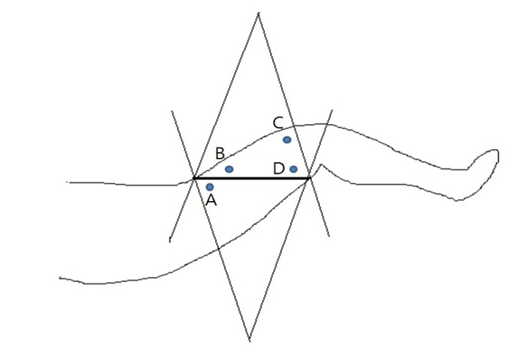
(A) A-point
(B) B-point
(C) C-point
(D) D-point

Q5. Choose the answer that correctly describes SBRT.
- 0~15 fraction
- Less fraction and higher total dose than 3D-CRT
- Delivery homogeneous dose to the PTV more than 3D-CRT
- One fraction dose is higher than Conventional radiation therapy

Q6. Which is the true about the correlation between TMR and TAR?
- TMR=TAR*PSF
- TMR=TAR/PSF
- TMR=TAR*SAR
- TMR=TAR/SMR

Q7. Choose the answer that does NOT correctly describe the equipment for establish 3D-RT plan
(A) EPID
(B) Sim-port film
(C) TLD dosimetry
(D) MV - fan beam CT

Q8. What is the true when SSD 80cm is increased to be SSD 100cm.
- Surface dose is increased
- Absorbed dose is increased at Dmax point
- Scattering dose is increased at Dmax point
- Percentage depth dose is increased at the same depth

Q9. Choose the answer that does NOT correctly describe the dosimeter.
- Mosfet is suitable for measuring absolute dose of photon beam
- TLD is independent of Energy
- Film is moderated for relative dose measurement in electron beam.
- Diode is appropriate to monitoring patient dose in real time

Q10.Choose the answer that does NOT correctly describe the way to minimize inter-treatment variation in IGRT.
- Rectal balloon
- CT Scan (Cone-Beam CT)
- KV X-ray
- Tumor Tracking

Q11.Which is true about Cyber-Knife?
(A) Stereotactic Radiosurgery is possible by using ‘Private flame‘.
(B) CBCT image can be acquired by the OBI System before treatment.
(C) It can irradiate in various directions through a way of Non-Isocentric treatment.
(D)A large target such as a craniospinal irradiation can be treated rapidly more than other treatments.
Q12. Choose the answer that correct electron field size for treatment 5cm width in reference depth.
- 5cm
- Less than 5cm
- More than 5cm
- All of the above

Q13. Choose the correct answer that describes a QA of the ICR
- Corrected source is monthly QA
- Tolerance error range of source calibration is under 5%
- Tolerance error of source position is 3mm
- Not including both cable and applicator in case of check radiation contamination

Q14. What is the most effective factor for radiation exposure in IMRT?
- Dose rate
- Head Scatter
- Leaf transmission
- Leaf round edge transmission

Q15. Which is correct about a plan of proton treatment?
- It doesn’t matter the patient position due to using Bragg peak.
- Proton therapy takes the same concept of PTV as the ICRU-62.
- Both selection beam direction and patient position are extremely important because of the dependence on the density change of the tissue on the beam path.
- The RBE in Proton is 2.5 times higher than X-ray, so it can expect to gain big biological effect.
Q16. Choose the normal tissue Alpha/beta ratio.
- 2
- 3
- 5
- 10

Q17. Choose correct description for correlation between OER, LET and RBE.
  - OER and LET is increased proportionally
  - RBE is going up when high LET radiation is exposed
  - Low dose is expected to gain huge hazard effect if RBE is low
  - In case of low LET radiation, it could destroy tumor cell through minimum dose

Q18. Available leakage dose of head and MLC are (A), (B).
  - Head: 1%, MLC: 1%
  - Head: 1%, MLC: 2%
  - Head: 1%, MLC: 5%
  - Head: 3%, MLC: 5%

Q19. Choose the answer that is directly connected with CT number
- Density
- Electron density
- Linear attenuation coefficient
- Effective atomic number

Q20. In case of that RAO field, wedge is not inserted, choose the dose distribution of A, B, C point.
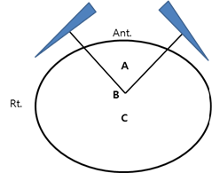
  - A - Hot B - Same C - Cold
  - A - Hot B - Hot C - Hot
  - A - Cold B - Same C- Cold
  - A - Cold B - Cold C - Cold

Q21. When is the most resistant cell cycle in the radiation treatment?
- G0
- G1
- M
- Late S

Q22. What composed SOBP (Spread Out Bragg Peak) in proton therapy?
  - Pb
  - PMMA
  - Cerrobend
  - Sweeping magnet

Q23. What is not the feature of fractionated irradiation which is to reduce the complication and reaction to the normal tissue and increase death to the malignant tumor cell?
- Repopulation
- Redistribution
- Reoxygenation
- Reconstruction

Q24. What does Bolus have equal material character of water?
- The number of electron per an atomic mass unit
- The number of electron per an atomic volume unit
- Quantumnumber per an atomic mass unit
- Quantumnumber per an atomic volume unit

Q25. Choose the answer that TMR excepted SMR with 10*10 field size
  - Scatter dose
  - TAR
  - TPR
  - Primary dose

Q26. Q26. Choose the correctly process (Increase volume) in ICRU.
  - GTV - CTV - PTV - ITV - TV - IV
  - GTV - CTV - TV - PTV - ITV - IV
  - CTV - PTV - GTV - ITV - IV - TV
  - GTV - CTV - ITV - PTV - TV - IV

Q27. Choose the correct answer that considerable factor for radiation shielding barrier.
(a) Scattered radiation (b) Neutron radiation
(c) Leakage radiation (d) Primary radiation
  - a,b
  - a,c
  - a,b,c
  - a,b,c,d

Q28. Choose the correct answer that is an acceptable error range in CT Number.
  - For water, 0 ± 2 HU
  - For water, 0 ± 3 HU
  - For water, 0 ± 5 HU
  - For water, 0 ± 10 HU

Q29. 6MV, SSD: 100cm, Field size 10*10cm^{3,} depth 10cm, PDD is 67%. Using Dmax = 1.5cm with the Mayneord F Factor. Which is the value of PDD in the same field size of 120cm?
- 65.3%
- 66.1%
- 67.9%
- 68.7%

Q30. What is the average energy at the surface if the depth giving the 50% dose of the electron beam is 3.8 CM?
  - 6 MeV
  - 9 MeV
  - 12 MeV
  - 15 MeV

Q31. Which is the following not true regarding evaluation electron beam energy?
- D max is higher with higher energy
- Correlate with practical range
- Correlate with D80
- Correlate with D50

Q32. Choose the uncorrected index of evaluating 3D-Conformal radiation therapy.
- Isodose curve
- Beam's eye view
- Dose-volume histogram
- Isodose surface

Q33. Choose the answer that does NOT correctly describe the digital imaging and communications in clinical field?
- RT Plan
- RT Algorithm
- RT Structure set
- RT Treatment Record

Q34. Revision that field size is 10*10cm, SAD=101.5cm, 1MU, 1cGy. Using SAD technique, parallel opposite field in thorax, what is the value of MU each field that is to be 90cGy?
(Output factor = 0.99, TMR = 0.626, Tray factor = 0.97, Wedge factor = 0.65, BSF = 1.01
- 131
- 133
- 135
- 141

Q35. What is the rate of loss of energy electron beam in the water?
  - O.5 MeV/cm
  - 1.0 Mev/cm
  - 2.0 MeV/cm
  - 3.0 Mev/cm

Q36. Which algorism is probable calculation of matter interaction in planning system?
- Monte Carlo
- IMRT Optimizer
- Clarkson Scatter
- Collapsed Cone Convolution

Q37. Choose the index which is not used to radiation shielding
- Use factor
- Beam energy
- Occupancy factor
- Scatter-air ratio

Q38. Choose the answer that correctly describes Dose Volume Histogram.
- Optimization of Radiation Treatment
- Evaluation dose distribution
- Demonstrate dose of normal tissue
- Presentation tumor dose from a round shape graph

Q39. Choose all the physical properties in case of choose the source of ICR.
    - Specific Activity B. Half-life C. Energy D. Atomic number
  - A, B
  - A, C
  - A, B, C
  - A, B, C, D
Q40. Which is NOT Daily QA checklist?
  - X-ray output constancy
  - Localizing lasers
  - Door interlock
  - Field Light / radiation field coincidence

Q41. Choose the factor which is not influence on biological effect.
  - QF(quality factor)
  - RBE
  - LET
  - KERMA

Q42. Which is NOT Monthly QA checklist?
  - Optical distance indicator
  - X-ray output constancy
  - Electron output constancy
  - Cross-hair centering

Q43.Which is NOT Annually QA checklist?
- X-ray output calibration constancy
- Gantry rotation isocenter
- Flatness
- Symmetry

Q44. Choose the item which is for MLC location accuracy in LINAC QA.
- Winston-Luts
- Picket Fence
- Alignment
- Star Shot

Q45. What is the cause of following Energy spectrum at X-ray tube?

- The anode and the cathode
- The anode and kV
- The cathode and average energy
- The cathode and kV

Q46. What is 'Wedge angle' in photon radiation therapy?
- The angle between the isodose curve at 10 cm depth and the central axis of exposure beam.
- The angle of the metal wedge itself.
- The angle which the isodose curve at 10 cm depth is turned by the wedge
- Half the hinge angle.

Q47. According to ICRU, HDR brachytherapy delivers the dose at ( ) or more.
- 2 cGy/min
- 10 cGy/min
- 20 cGy/min
- 40 cGy/min

Q48. Choose the answer that does NOT correctly describe the polarity effect.
- Increased by electron energy
- It depends on the draft of Ion chamber
- In case of electron beam, it occurs often more than photon beam.
- It occurred out of the ion cavity

Q49. Choose the outbreak part of pancreas cancer.
- Midsection of the pancreas
- Head of the pancreas
- Tail of the pancreas
- Whole pancreas

Q50. What is the deviation range of the prescribed dose for target in ICRU?
  - -3% ~ +5%
  - 5% ~ +7%
  - -7% ~ +10%
  - -10% ~ +10%

Q51. What are the calibration depth and measure effective depth when measuring output dose of 10MV high energy photon according to TRS-398
- Calibration depth 10cm, Effective depth measurement is the center of ionization chamber
- Calibration depth Dmax, Effective depth measurement is the center of ionization chamber
- Calibration depth 5cm, Effective depth measurement is 0.75r forward from the center of ionization chamber
- Calibration depth 10cm, Effective depth measurement is 0.75r forward from the center of ionization chamber

Q52. What is the reason of why TMR not using TAR?
- TMR doesn’t depend on Dmax
- TMR doesn’t depend on Field size
- It is difficult to measure the High energy in the air
- TMR is useful for rotating irradiation than TAR

Q53. What does mainly effectiveness occurs on the high Energy photon treatment?
- Photoelectric effect
- Compton scattering
- Electron pair production
- Photonuclear reaction

Q54. Choose the answer that does NOT correctly describe Dynamic wedge.
  - It can take 10 degrees angle wedge
  - Edgeless than static wedge in penumbra area
  - It formed by MLC
  - Limitation with Field Size

Q55. Choose the answer that does NOT best correctly treatment method for below CTV.
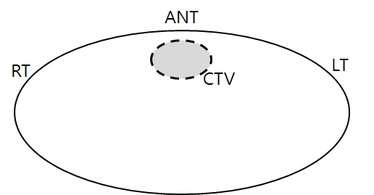
  - Anterior 180° arc at the center of the CTV
  - Two anterior oblique wedged fields
  - Anterior open field and wedged both lateral fields
  - Anterior split into two 90° arcs with wedges

Q56. Choose the answer that correctly describes whole body hyperthermia.
  - Effective temperature range is at 43~45 degrees.
  - Easier to get successful effect than local hyperthermia
  - Possible to apply the case of moderate severity in lung and heart
  - Possible to apply the case such as hematogeneous metastasis, lymph node metastasis, cytotoxic chemotherapy.

Q57. In electron beam treatment, the main factor cause x-ray contamination is ( ).
  - Patient Body
  - Electron Cone
  - Scattering foil
  - Collimator jaw

Q58. Choose the answer that correctly describes radiation treatment.
- In case of CCRT, after 1 hour radiation treatment injection 5FU
- BID( delay 8 hours), TID(delay 4 hours)
- Sensitizer agent is able to influence for treatment period or total dose
- OER is no matter with Oxygen pressure.

Q59. What is the true about the maximum dose point on the high energy photon treatment?
- Secondary electron is to be the electronic equilibrium point.
- Maximum dose point differs from maximum point of absorbed dose.
- The position of maximum dose point depends on the field size.
- High energy photon can randomly adjust the maximum dose point

Q60. What is the Maximum range when 6MeV penetrates 1cm tissue and lung tissue?
- 3cm
- 5cm
- 7cm
- 9cm

Q61. Choose the index which is ineffective for VMAT.
  - Dose rate
  - MLC speed
  - RTP software
  - Couch rotation

Q62. What is 10MeV loss ratio in the water?
- 0.51 Mev/cm
- 1.0 Mev/cm
- 2.0 Mev/cm
- 3.33 Mev/cm

Q63. What is the approximate dose at the geometric field boundary at the same depth when compared to the central axial dose?
  - 100 ± 3 %
  - 95%
  - 80%
  - 50%

Q64. What is the CT value of a tissue with a 25% attenuation coefficient for water?
  - 0
  - 25
  - 250
  - -250

Q65. Choose the answer that correctly describes the Collimator scatter factor (Sc)?
A) No concern with SSD
B) The value of Sc is decreasing if inserting protective barrier.
C) No concern with field size.
D) Inverse proportion with reference field size

Q66. Choose the couch angle to not occur overriding field of a CSI(WB FS= 20*20cm³, SAD=100cm, Post Spinal cord field size= 8×40 ㎠)
- 3.8°
- 5.7°
- 8.5°
- 11.3°

Q67. Which one is a good technique for treat the prominent tumor and irradiate chest wall with small volume dose?
  - Arc rotation technique
  - Tangential technique
  - Mantle technique
  - Field-in-Field technique

Q68. Choose the answer that does NOT correctly describe the merits of tomotherapy
  - Improvement of Setup accuracy with Cone-Beam CT
  - Applied to complicated target volume
  - Applied to large target volume
  - Applied to total lymphatic irradiation

Q69. Which is NOT correctly factor for shielding plan of treatment room?
- Beam energy
- Use factor
- Inverse square law
- Scatter – Air Ratio (SAR)

Q70. Which of the following statements about interstitial brachytherapy using Paterson Parker’s methods?
  - The source dose should show a uniform distribution within the inserted area.
  - A uniform dose distribution of around 10% should be seen in the treatment area within the insertion surface
  - A uniform dose distribution of around 10% should be seen at a distance of 0.5 CM parallel to the insertion part.
  - The center of the source should be the high-dose region and the peripheral of the source should be the low-dose region.

Q71. Choose the answer that does correctly target type of high energy linear accelerator.
  - Reflection Type
  - Transmission Type
  - Refraction Type
  - Rotation Type

Q72. Choose the answer that does NOT correctly description about Monte Carlo program.
  - Take short time to calculate
  - Advantage between different density tissues
  - Accuracy of dose distribution
  - Accuracy of dose calculation

Q73. Which frequency of the following operates the linear accelerator?
  - 2856 MHz
  - 3856 MHz
  - 4856 Mhz
  - 5856 MHz

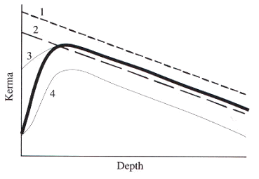
Q74. Choose the KERMA line that coincide dose distribution curve.
- 1
- 2
- 3
- 4

Q75. Choose the correct bladder point and rectal point in ICRU 38.
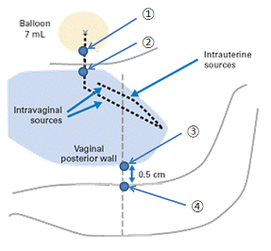
  - 1, 3
  - 1, 4
  - 2, 3
  - 2, 4

Q76. In prostate cancer, which the treatment type has the largest irradiation volume?
  - AP & PA
  - Four oblique technique
  - BOX technique
  - 360 arc rotation

Q77. Choose the correct answer that is an acceptable error range in CT Number.
  - For water, 0 ± 2 HU
  - For water, 0 ± 3 HU
  - For water, 0 ± 5 HU
  - For water, 0 ± 10 HU

Q78. What is the most important chemical factor about the radio reaction?
- Oxygen
- SH-cycle
- Cell cycle
- Fractionated irradiation

Q79. Choose the device for Calibration of linear accelerator.
      - Ion-chamber 2) TLD 3) Diode 4) Film
  - 1
  - 1, 2
  - 1, 2, 3
  - 1, 2, 3, 4

Q80. What is the treatment method expected rapid treatment reaction despite of decreasing total irradiation dose and treatment period in fractionated irradiation?
- Conventional Fractionation
- Hyperfeactionation
- Hypefractionation
- Accelerated Fractionation

Q81. Choose the answer that does NOT correct conception of increasing build-up in photon.
  - It occurred by secondary electron when photon beam collision
  - D-max point is getting deeper by High photon energy
  - Electron is occurred by collimation, it makes D-max point to getting deeper
  - Appearing skin sparing effect

Q82. Which of the following is correct about the treatment planning of the Fixed-field IMRT?
  - The quality of a treatment plan is getting improved as increasing the number of iteration.
  - The quality of a treatment plan is getting improved as increasing the number of structure for optimization.
  - The calculation time for a treatment plan always take long time as the number of structures are getting increased for optimization.
  - The result of Fixed-field IMRT is always better than VMAT.

Q83. Which of following a word is meaning 5% major complication within 5 years in Radiation Therapy?
- TD 50/5
- TCD₉₀
- TD 5/5
- TCD ₉₅

Q84. Choose the answer that does NOT associated with below QA & QC figure in ICR.
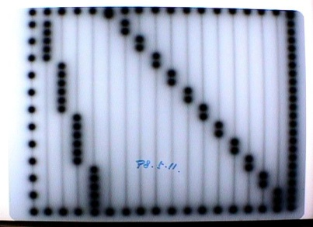
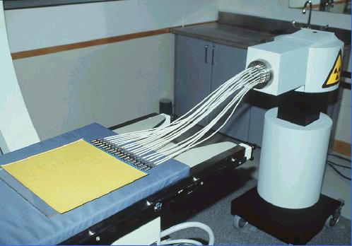
- Source Dwell Position Check
- PDD & TMR
- Symmetry, Flatness
- Collimator cross hair line

Q85. Which of the following statements best describes FIF (Field In Field) Technique?
  - Dose homogeneity is improved without the use of Wedge.
  - Fluence optimization is conducted with the way of inverse plan.
  - Hot spot around a chest wall can occur due to the increase of MU.
  - It improves dose Conformity.
Q86. Choose the right statement about biological effect of proton.
- It is regarless of depth
- It is less than ⁶⁰COgammaray
- It is related to LET
- It is almost same as clinical energy area of electron

Q87. Choose the majority of Head and neck cancer.
  - Adenocarcinoma
  - Transitional cell carcinoma
  - Squamous cell carcinoma
  - Lymphoma

Q88. Which one is used in high electrical field inside of waveguide of Linac to suppress arcing?
  - Hi-energy power pulses
  - Air
  - SF6
  - Steering coil

Q89. Choose the Biologic index in Plan Evaluation Indices.
- Effective Volume
- Equivalent Uniform Dose(EUD)
- Dose Volume Histograms(DVH)
- Normal-tissue complication probability(NTCP)

Q90. ODI (Optical Distance Indicator) of LINAC indicates 100 cm while actually it is 98 cm and the treatment was processed. In this case, what is actual dose?
  - 4% over dose
  - 4% dose in short
  - 2% over dose
  - 2% dose in short

