The Korean Radiological Technologists Association

The 53rd KRTA Annual Meeting and International Conference

Dear Friends,
The 53rd KRTA Annual Meeting and International Conference will be held from October 26 to 27, 2018 at K-hotel, Seoul.
Please submit abstracts before June 31, 2018. The abstract should have the “Purpose” of your study, “Materials and Methods”, “Results”, principal “Conclusion” and “Keywords”. An oral presentation is 10 minutes in length but your actual speech is 7 minutes and the rest of time should be for a question and answer session.
If you have any question about this call for paper or about 53rd Annual Meeting of KRTA, feel free to ask for any cooperation. (Email: krta6525@hanmail.net)

Important Notice:
Date: Oct 26 (Fri) – 27 (Sat), 2018
Place: THE K Hotel Seoul
Presentation: Oral (up to 7 mins), Poster
Paper: Abstract
Submission Deadline: July 20 (Fri)
Notice of acceptance: July 31 (Tue)
Registration Deadline: Aug 31 (Fri)
Registration Fees: USD 150 (Including lunch, dinner reception at Oct 27 (Sat))
Contact: krta6525@hanmail.net

p,s : When you are write a abstract, please follow the submission guideline at next page.

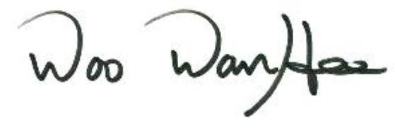

Woo, Wan Hee
President,
The Korean Radiological Technologists Association

Call for Abstracts and Submission Guidelines

53rd KRTA Annual Meeting and International Conference

Submission Form
Name:
Institute: Department: E-mail:

Presentation Option:
□ Oral Speaker： □ Poster
Title (Times New Roman, 12 Points, Bold, Centered)
Name^{1,2} XXX² (Times New Roman, 11 Points, Bold, Centered)
¹Authors Affiliation ²XXX (if any) (Times New Roman, 11 Points, Bold, Centered)

Purpose (Times New Roman, 11 Points, Bold type)
……………………………………………………………………………..………………………………………………………………………………………..………………………..…………………………………………………………………………(Times New Roman, 11 Points, Single space)

Materials and Methods (Times New Roman, 11 Points, Bold type)
……………………………………………………………………………..………………………………………………………………………………………..………………………..…………………………………………………………………………(Times New Roman, 11 Points, Single space)

Results (Times New Roman, 11 Points, Bold type)
……………………………………………………………………………..………………………………………………………………………………………..………………………..…………………………………………………………………………(Times New Roman, 11 Points, Single space)

Conclusion (Times New Roman, 11 Points, Bold type)
……………………………………………………………………………..………………………………………………………………………………………..………………………..…………………………………………………………………………(Times New Roman, 11 Points, Single space)
Keywords: Please list 3-5 keywords
……………………………………………………………………………..………………………………………………..………………(Times New Roman, 11 Points, Single space)

