2013年MRI

1. The function of gradient coil is not relative to _________?

1) Slice thickness

2) Flip angle

3) Spatial encoding

4) Frequency encoding

1. Which is true about Gradient wave form?

1) Gradient amplitude unit is mT/m or G/m and the maximum amplitude is relative to maximum resolution of image.

2) Gradient slew rate unit is T/m/sec and effect in TR but not TE.

3) Increasing receive bandwidth is increasing SNR but decreasing sampling time.

4) Maximum gradient duty cycle is gradient off time.

1. Slew rate is _______?

1) maximum amplitude / increasing time to maximum amplitude

2) maximum amplitude / area of maximum gradient

3) area of maximum gradient / increasing time to maximum amplitude

4) maximum amplitude / area of minimum gradient

1. When main magnetic field strength is stronger, _____________________?

1) chemical shift effect is increased.

2) SNR is decreased.

3) T1 relaxation time is decreased.

4) T2 relaxation time is increased.

1. The method of decreasing magnetic susceptibility effect is _________?

1) FSE(TSE)

2) SE

3) EPI

4) GE

1. The reason of dephasing of spin excited by RF pulse is _______?

1) inhomogeneity of external magnetic field and inhomogeneity of adjacent spin in body.

2) inhomogeneity of external magnetic field and homogeneity of adjacent spin.

3) homogeneity of external magnetic field and inhomogeneity of adjacent spin in body.

4) homogeneity of external magnetic field and homogeneity of adjacent spin.

1. The two images are T1WI of brain. The arrows are __________?

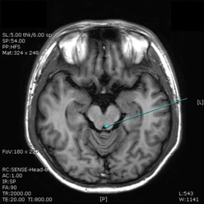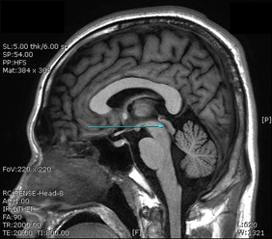

1) cerebral aqueduct

2) fourth ventricle

3) third ventricle

4) lateral ventricle

1. In the below picture, What is not true?

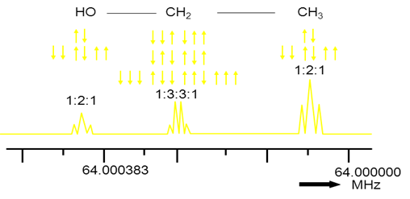

1) The MRS of ethanol

2) The peak of proton binding with high electro negativity is on the left side.

3) The signal of spin is splitted because of adjacent molecule.

4) Decreasing strength of static magnetic field, increasing resolution.

1. Which is not true in BOLD (Blood Oxygenation Level Dependent)?

1) There is a method with T1 contrast.

2) There is a method with magnetic susceptibility of oxyhemoglobin and

deoxyhemoglobin

3) Deoxyhemoglobin is paramagnetic material.

4) Signal is changed by blood volume.

1. The paramagnetic contrast agent is _____________?

1) increasing T1 relaxation time and increasing T2 relaxation time.

2) increasing T1 relaxation time and decreasing T2 relaxation time.

3) decreasing T1 relaxation and increasing T2 relaxation time.

4) decreasing T1 relaxation time and decreasing T2 relaxation time.

1. Ernst angle is ______________?

1) increasing SNR in low flip angle.

2) the flip angle making maximum signal.

3) almost T2WI (flip angle>Ernst angle)

4) almost T1WI (flip angle>Ernst angle)

1. There is a L-spine localization image in below. The blue presaturation pluse is excited ___________?

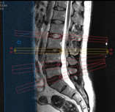

1) before 90o excitation pulse.

2) after 180o refocusing pulse.

3) between 90o and 180o.

4) before echo time.

1. When the body is in magnetic field, The magnetic field and spin is listed in the same direction. The condition is __________?

1) a half energy state

2) anti-parallel state

3) unstable state

4) low level energy state

1. Which is true in Relaxation time?

1) If external magnetic field is increasing, T2 relaxation time is longer.

2) If external magnetic field is increasing, T1 relaxation time is longer.

3) If external magnetic field is increasing, T1 relaxation time is shorter.

4) The relaxation is that the spin will go back to the equilibrium in the excited state.

1. There is gradient amplitude explanation. What is true?

1) Gradient unit is mT/m or G/m.

2) Gradient wave form is frequency axis. If flat part of gradient wave form is higher, FOV can make larger.

3) In slice thickness axis, amplitude is higher, slice thickness can make thicker.

4) Maximum amplitude of MR system is relative to image contrast.

1. The center of K-space is relative to ( A ) and ( B ) and the outer line of K-space is relative to ( C ) on MR image.

A B C

1) resolution Signal to noise ratio contrast

2) resolution contrast Signal to noise ratio

3) Signal to noise ratio contrast resolution

4) Signal to noise ratio NEX contrast

1. When frequency encoding is 256, Nyquist frequency is ____________?

1) 64 Hz

2) 128 Hz

3) 256 Hz

4) 512 Hz

1. We acquired spin echo with 2 NEX. Which is true?

1) The signals by changing the size of the slice selection gradient is obtained twice every TR.

2) The data is filled in same k-space line twice.

3) The signal is acquired twice when the amplitude of frequency encoding is increasing during continuous TR.

4) The phase encoding is performed twice matrix size.

1. What is scan time with below parameter?

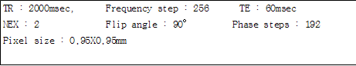

1) 6.4 min

2) 12.8 min

3) 17.06 min

4) 25.6 min

1. What is the means of effective TE in fast spin echo?

1) The echo filled in outer K-space

2) Effective TE is high phase encoding gradient.

3) Effective TE is low phase encoding gradient.

4) Effective TE is the first step of phase encoding gradient.

1. When the bandwidth is reduced, ________________________________.

(A) chemical artifact is increasing.

(B) the frequency of each pixel is changed.

(C) sampling time is increasing.

(D) SNR is improved.

1) A, B, C

2) A, C

3) B, D

4) A, B, C, D

1. There is MR spectroscopy explanation. What is true?

1) There is non-invasive analysis method analyzed metabolic material in human body.

2) The effect factor of spectrum is eddy current, water suppression, shimming.

3) The pulse sequence is STEAM and PRESS.

4) The major peak of NAA is 3.94ppm in spectrum.

1. There is super conductive magnet explanation. What is true?

1) Super conductive is the zero state of electric resistance.

2) High price refrigerant liquid Helium is used for making super conductive condition.

3) The quenching is losing super conductive condition and then making paramagnetic condition.

4) Liquid nitrogen is used for preventing evaporation liquid Helium and holding super conductive condition.

1. When matrix is changed from 128x128 to 256x256, ____________________.

(A) spatial resolution is decreased.

(B) scan time make twice.

(C) pixel size is increased.

(D) SNR is reduced by 1/ √2

1) A, B

2) B, D

3) A, B, C

4) A, C, D

1. Slice thickness was increased, __________________________.

1) the SNR is improved.

2) thickness of voxel is decreased

3) the lower spatial resolution.

4) the partial volume effect occurs.

1. The following formula is correct?

1) pixel size = FOV / matrix

2) pixel size = FOX x matrix

3) FOV = matrix2 x pixel size

4) pixel size = FOV / matrix2

1. If you doubled the FOV, SNR of ____ fold increase.

1) 1/2

2) 2

3) 3

4) 4

1. If you doubled the NEX, _________________________.

1) the SNR of 2 fold increase.

2) the scan time of 2 fold increase.

3) the SNR of 2 fold decrease.

4) the spatial resolution of 2 fold increase.

1. What image can be acquired in below image plan?

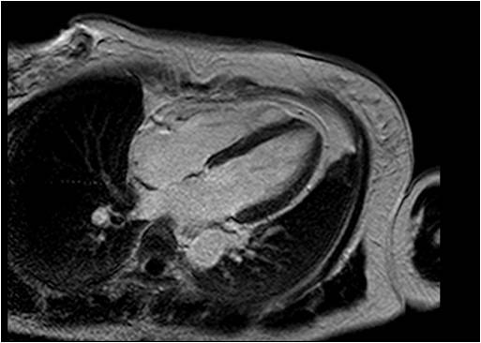

* 1. 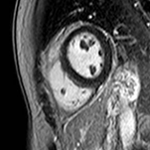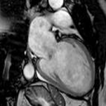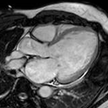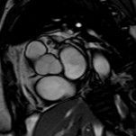 2) 3) 4)

1. Identify structure A in below image?

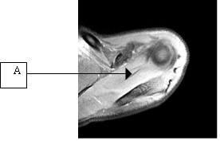

1) infraspinatus muscle

2) supraspinatus muscle

3) subscapularis muscle

4) teres minor muscle

1. The following figure is the heart of 4chamber. What is the correct anatomical structure?

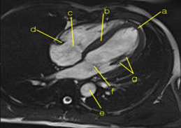

**a-** Apex, **b**-atrialseptum, **c**-tricuspidvalve, **d**-AVgroove,

**e**- Descending Aorta **f**-mitralvalve, **g**-levator muscle

1) a, b, c, d

2) b, c, d, e

3) c, d, e, f

4) d, e, f, g

1. RR interval should be calculated to acquire the image acquisition time and the time resolution in Cardiac Cine MR imaging. If the heart rate per minute is 60, What is the RR interval?

1) 600ms

2) 800ms

3) 1000ms

4) 1200ms

1. In the following EPI(Echo Planar Image) Description, what is the wrong thing?

1) High slew rate gradient is required.

2) Blipped Single shot EPI fills entire K-space in one TR with zig-zag method.

3) If Number of Shot is increased, and then Scan Time is reduced.

4) Fat suppression is needed because of Chemical Shift Artifact in EPI.

1. In the following spoiled GRE Description, what is the wrong thing?

1) If you are use long flip angle, short TR and TE, T1WI is obtained.

2) If you are use short flip angle, long TR and TE, T1WI is obtained.

3) Spoiling removes the horizontal component of the magnetization in the steady state before each RF pulse.

4) Proton density images should show a spin density of the image, the filp angle should be used slightly larger than Ernst angle.

1. What is not a method for reducing the EPI technique of magnetization susceptibility artifacts (Susceptibility artifacts)?

1) Proper shimming of the magnetic field

2) excitation shorter TE

3) apply multi shot echo

4) k-space fill only half of the even-numbered side.

1. In the following MT (Magnetizaton Transfer) Description, what is the wrong thing?

1) Magnetizaton Transfer Phenomenon occurs energy interchange(chemical exchange) between free water proton and fat proton.

2) The TOF Angiography used to reduce the background noise.

3) If free water proton in large molecule is increased, magnetizaton transfer is larger .

4) If Magnetizaton Transfer occurred, the signal of free water proton was reduced.

1. Which is not correct name in the anatomical structure in below?

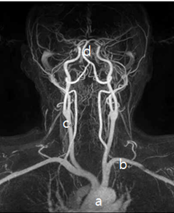

1) a - Aortic arch

2) b - Left Subclavian artery

3) c - Right Common Carotid Artery

4) d - Vertebral Artery

1. Which is not associated with the center line of k-space in the FSE?

1) Resolution in image

2) ETL

3) TR

4) Effective TE

1. Which is wrong description of phase encoding?

1) When the slope is low, get a strong echo.

2) When the slope is high, get a weak echo

3) When the slope is low, get a detail description.

4) When the slope is high, get a detail description.

1. Which of true in the slice selection excitation description below?

1) The imaging thickness improves the spatial resolution and sharpness of the image.

2) Use a shallow gradient slope for thin slice

3) Use a steep gradient slope for thick slice

4) There is no relative to between thick slice and RF pulse.

1. Which is the proper TR, TE and Flip angle in below image?

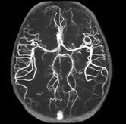

1) TR: 100ms, TE: 10, Flip angle: 90°

2) TR: 100ms, TE: 20, Flip angle: 70°

3) TR: 20ms, TE: 80, Flip angle: 50°

4) TR: 20ms, TE: 7, Flip angle: 20°

1. Which is the residual spin spoiling method with strong gradient spoiler without refocusing Mxy component that remains in the xy plane?

1) FLASH (Fast Low Angle Shot)

2) SE (spin echo)

3) FISP (Fast Imaging with Steady Precession)

4) TSE (Turbo spin echo)

1. Which is correct in Frequency encoding and phase encoding of the description?

1) Frequency encoding is changed in every TR.

2) The increase in the number of frequency encoding, the spatial resolution increases.

3) The frequency is used to find out the position of the magnetic resonance signal in phase encoding.

4) The size of phase encoding is always fixed.

1. Which is true in the HASTE description below?

1) mainly used to obtain T1-weighted images.

2) mainly used in multi shot spin echo.

3) mainly used in high resolution.

4) decreased the dephasing effect by Inhomogeneous magnetic field.

1. Which is the metabolic material indicated by the arrow in brain MR spectroscopy (TE-144ms)?

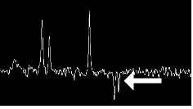

1) Lactate

2) Creatine

3) Choline

4) NAA

1. Which is true in b-value description of DWI ?

1) When the b-value is larger, get large signal.

2) When the b-value is smaller, get more weighted diffusion image.

3) The integral value of time and the strength of the diffusion weighted gradient.

4) When the b-value is small in tissue, get small signal in ADC map.

1. Which is not true in 3.0T MRI?

1) 3.0T MRI is twice the SNR of 1.5T equipment.

2) In 3.0T MRI, the RF wavelength is shorter than the 1.5T because of RF field inhomogeneity.

3) In 3.0T MRI, heat generation is less than 1.5T by the RF.

4) Magnetic susceptibility effect is stronger because of shorten T2* relaxation time.

1. Which is true in SAR (Specific Absorption Rate)?

1) SAR is proportional to the squarer of tissue density.

2) SAR is proportional to gradient.

3) SAR is inversely proportional to the RF duty cycle.

4) SAR is proportional to the squarer of magnetic strength.

1. Which is correctly connected to the area of ​​brain function and anatomical name?

1) Speech - Broca’s area

2) Visual - Superior Temporal gyrus

3) Sensory - Precentral gyrus

4) Motor - Postcentral gyrus

1. Which is not true in parallel imaging?

1) When the phase-encoding is decreased, the scan time is reduced.

2) increase SNR

3) use multiple receive coil

4) not relative to reduction factor.

1. Which is not enhanced anatomical structure in normal tissues?

1) Pituitary gland

2) Thalamus

3) Pineal gland

4) Chroid plexus

1. Which is not method to decrease SAR(Specific Absorption Rate)?

1) increase TR.

2) Increase TE.

3) decrease the number of slice.

4) decrease flip angle.

1. Which is not true in mapping images of brain perfusion post processing?

1) In general, rCBV, rCBF, TTP, MTT is mapped.

2) The color of each slice describe the direction of vessel in color mapping.

3) The TTP mapping is most sensitivity in ischemic disease.

4) That rCBV divided by MTT makes the rCBF, mathematically.

1. Which is not true in Perfusion MRI?

1) The main mechanism is causing changes in the MR signal because of the biochemical changes in a specific lesion.

2) The ASL is a imaging technique for the susceptibility to changes in the arteries when the contrast medium to reach the lesion.

3) In order to minimize image distortion and chemical shift, the EPI technique use fat suppression technique.

4) In order to prevent secondary perfusion imaging, short phase of less than 10 should be a dynamic scan.

1. Which is correct in brain tumor imaging using a contrast agent?

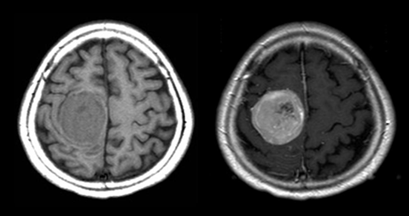

1) The contrast enhancement of the lesion with the BBB damage is due to the penetration of contrast medium into the intracellular space.

2) The mechanism of contrast enhancement is that the transfer of energy it easier because Larmor frequency and the frequency of the water protons become similar.

3) In the contrast enhancement of the lesion, the contrast agent uptake in normal tissue due to T1 recovery time is shortened because of holding the received signal than the surrounding tissue.

4) This is a non-specificity, positive paramagnetic contrast agent and is discharged more than 60% into the bile duct .

1. Which is not true in pulse diagram?

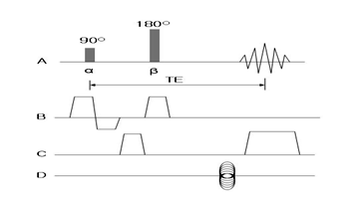

1) A is array of radio frequency pulse and echo time.

2) B is spin density.

3) C is frequency encoding slope.

4) D is phase encoding slope.

1. A spin is flowing in a constant gradient field. Which is not true about the factor of increasing the degree of phase shift?

1) increase gradient field strength.

2) The velocity of blood flow will be faster.

3) increases the gradient working time.

4) decrease gyromagnetic ratio.

1. Which is not true about flow enhancement effect?

(V : velocity, Dz: Slice thickness, Mz: transverse magnetization)

1) In V = 0, produce a signal lesser than the saturated Mz.

2) In V<Dz/TR, some part of the signal is larger than Mz and some other part of the signal is smaller.

3) In V=Dz/TR, produce a signal greater than Mz.

4) In V>Dz/TR, produce a greater signal in proportion than those of V = dz / TR

1. Which is the maximum flip angle in transverse plane?

1) 30°

2) 60°

3) 90°

4) 180°

1. Which is the appropriate TI value in TR 9000ms, TE 110ms MR image?

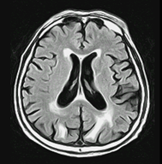

1) 150ms

2) 220ms

3) 1100ms

4) 2500ms

1. Which is the method to reduce arrow artifact?

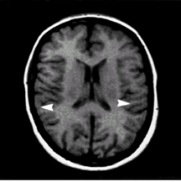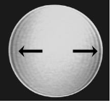

1) increase receive bandwidth

2) increase matrix of phase encoding direction

3) increase number of excitation

4) increase field of view

1. Which is not true in transverse relaxation time?

1) The 63% recovery time of magnetization Mo in thermal equilibrium state.

2) the emitted energy is transferred to other Adjacent molecules or atoms.

3) If the tissue is short recovery time, the signal strength is small.

4) Liquid active molecular vibration than a solid, so longitudinal relaxation is faster than the solid.

1. The right combination of the following?

(A)The body coil is a receive-only coil and installed inside the magnet.

(B) The unit of magnetic field homogeneity is PPM.

(C)Shimming makes inhomogeneous magnetic field to homogeneous magnetic field.

(D)Eddy current is compensated by using active gradient coil

1) A, B, C

2) A, C

3) B, D

4) A, B, C, D

1. The following is a image of a spin echo sequence. Which is the correct image acquired at each point in TR 3500ms?

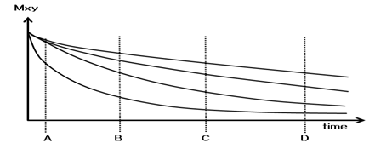

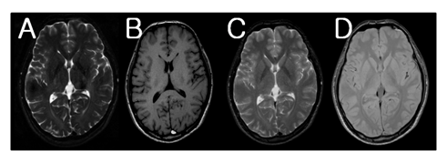

1) A

2) B

3) C

4) D

1. What is the description of the T2-weighted images?

1) It is a reducing time to 1-e-1 in Mxy vector.

2) If T1 is longer in T2WI, difference of transverse relaxation is minimal.

3) T2 is reducing time to 63% transverse magnetization.

4) As inphase time is long in slow molecular motion, he T2 relaxation time is lengthened.

1. Which is true to prevent chemical shift artifact?

1) use high field MRI

2) decrease receive bandwidth

3) use fat suppression

4) increase the number of phase encoding

1. Which parameter is changed from A to E in the following image(in same TR)?

1) TE

2) Flip angle

3) Receive BW (Bandwidth)

4) NSA (Number of signal average)

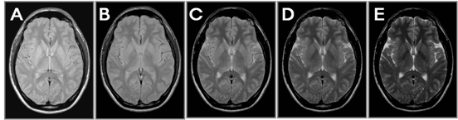

1. The factors could affect the MR image. Which is true?

(A) RF field

(B) Electrical wires coming from the external

(C) battery

(D) clip

(E) Mascara

1) A, B

2) A, B, C

3) A, B, C, D

4) A, B, C, D, E

1. Which is the true in 3D method?

1) Slice encoding gradient is added to the direction of slice selection gradient.

2) Slice encoding gradient is added to the direction of phase encoding gradient.

3) Slice encoding gradient is added to the direction of frequency encoding gradient.

4) Frequency encoding gradient is added to the direction of phase encoding gradient.

1. It is a noise during MRI scan. Which is not relative to noise level?

1) Bo

2) Gradient strength

3) Patient weight

4) Duty cycle

1. Which of the following is Not a correct explaining about RF Sheilding before installing MRI equipment?

1) RF shielding has to be attenuated below 20dB for all electromagnetic waves.

2) Copper and aluminum are used for high frequency shielding.

3) If shielding would be poor, artifact would appear in image at frequency encoding direction.

4) Steel plate is used for external shielding.

1. Which of the following technique is the best image to achieve?

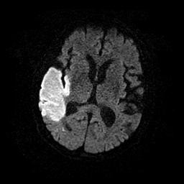

1) Ultra fast spin echo

2) Fast gradient echo

3) Steam & prove

4) Echo planner imaging

1. In whole body, what is allowable limit OF SAR(Specific absorption rate) established by FDA?

1) 0.4W/kg

2) 4W/kg

3) 40W/kg

4) 400W/kg

1. What is arrowhead pointed to?

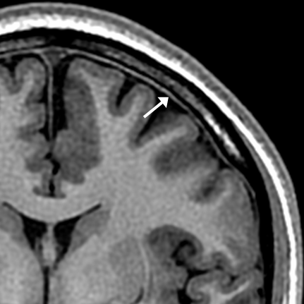

1) Dura Mater

2) Arachnoid

3) Pia Mater

4) Major extensions

1. Which of the following is not a correct about the following anatomical name?

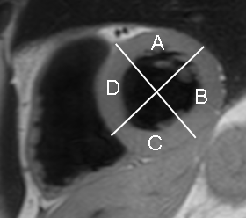

1) A - anterior

2) B - lateral

3) C - inferior

4) D - apex

1. Which of the following is a correct about anatomical name of arrowhead?

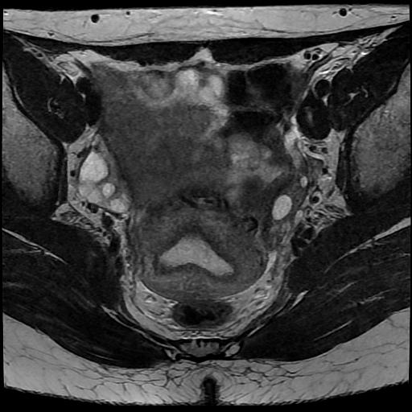

1) Rectum

2) Uterus

3) Bladder

4) Ovary

1. Which of the following is a correct about anatomical name of arrowhead?

1) Anterior labrum

2) Glenoed

3) Inferior labrum

4) Posterior labrum

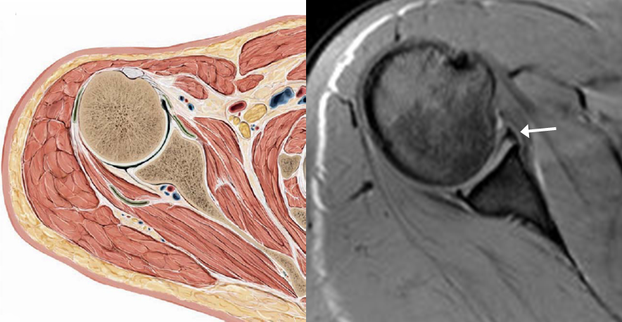

1. Which of the following is a correct explaining about arrowhead?

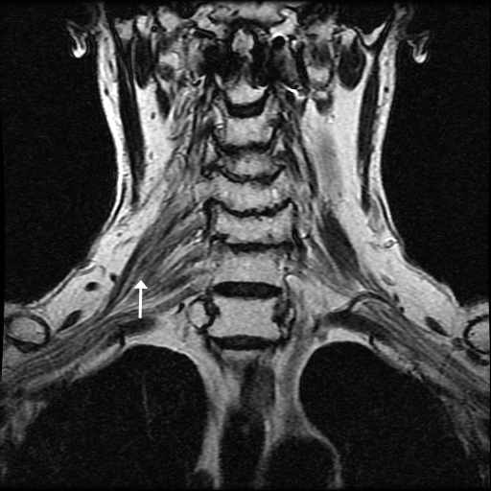

1) It is fascicles getting out C2, C3, C4, C5.

2) The bundle formed from nerve is cervical plexus.

3) In case of damage of it, there is paresthesia in chest.

4) With application with STIR technique, it is easy to detect a lesion.

1. Which of the following is a correct explaining about arrowhead?

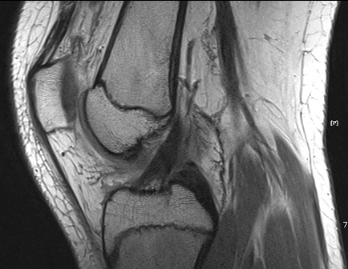

1) T2 weighted image. ACL

2) T2 weighted image. PCL

3) Spin density image. ACL

4) Spin density image. PCL

1. Which of the following is a correct explanation about below images?



1) Endogenous perfusion MR images

2) CBV, CBF, TO, TTP, and MTT can be acquired.

3) CRF or pediatric patients are not recommended.

4) It can be acquired with bolus injection of gadolinium contrast media.

1. This is a breast image of 53 years old female. Which of the following is Not correct explanation about this image?

1) T1 fat suppression technique was used after injected contrast media.

2) The artifacts from cardiac were occurred.

3) The phase encoding direction was head to feet direction (H-F).

4) This is a right breast image generally.

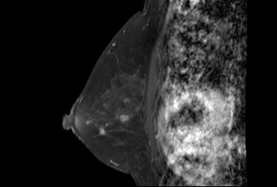

1. Which of the following is NOT correct explanation about this image?

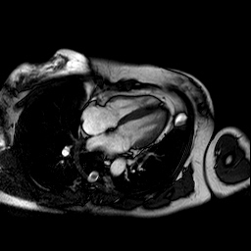

1) 2 Chamber image

2) Parallel Image technique can reduce the scan time.

3) ECG gating is needed for removing the artifacts.

4) Cine MRI can evaluate the cardiac function.

1. What is this on brain T2 weighted image (arrow)?

1) Hippocampus

2) Lateral ventricle

3) Thalamus

4) Trigeminal nerve

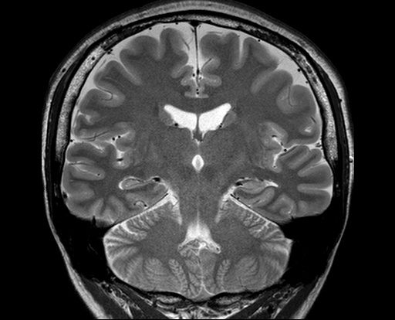

1. What is this (arrow)?

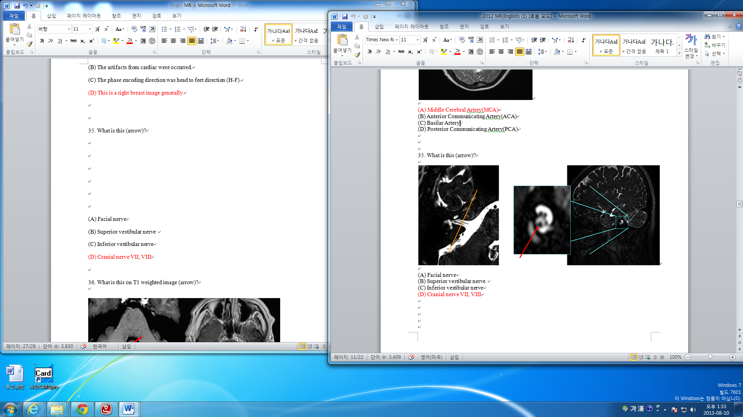

1) Facial nerve

2) Superior vestibular nerve

3) Inferior vestibular nerve

4) Cranial nerve VII, VIII

1. What is this on T1 weighted image (arrow)?

1) AVM

2) Venous Angioma

3) Cavernous Angioma

4) Capillary Telangiectasia

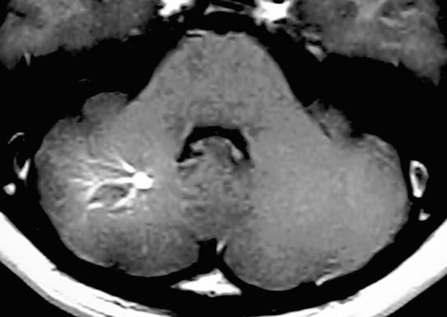[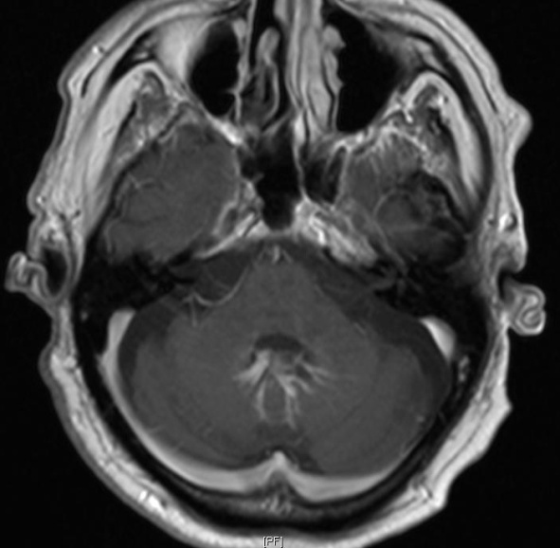](http://radpod.org/wp-content/uploads/2007/04/cerebellar_dva_gad_ax_arrows.JPG)

1. What is the struture indicated by the arrow?

1) Lamina

2) Pedicle

3) Spinous process

4) Transverse Process

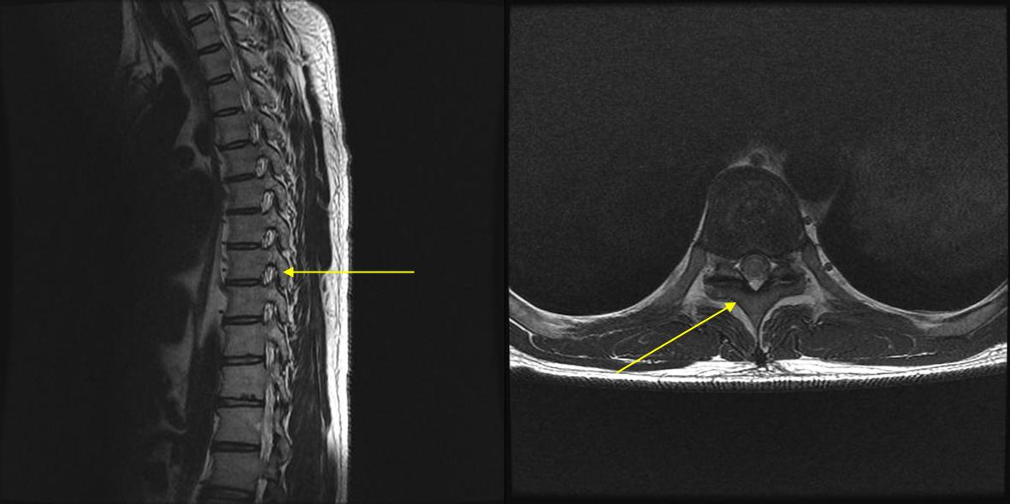

1. Which of the following used contrast media?

1) 2)

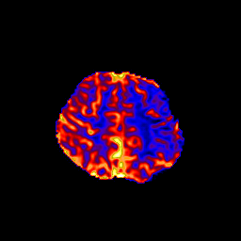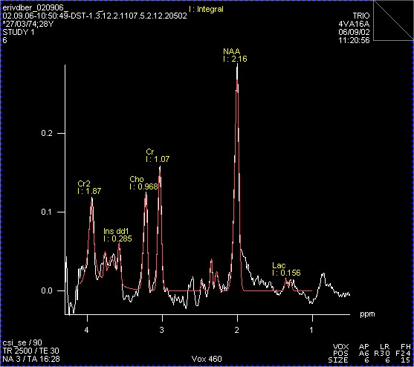

3) 4)

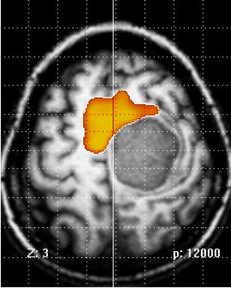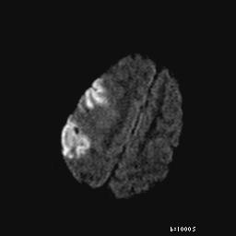

1. Which of the following is CORRECT order of dynamic study with contrast media?

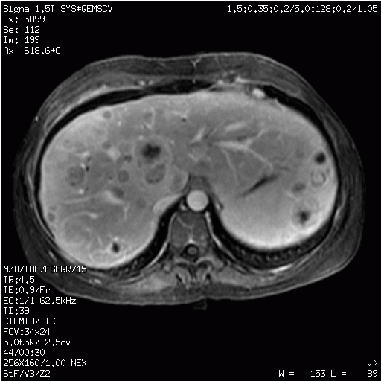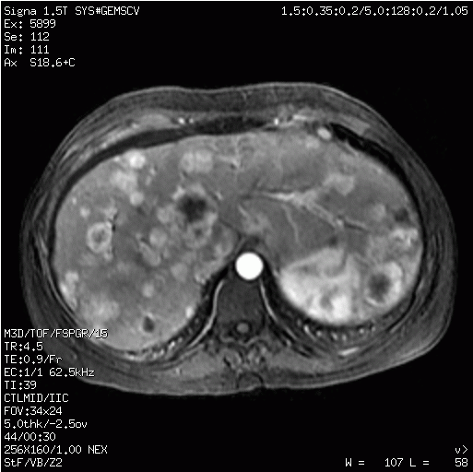(A) (B) (C)

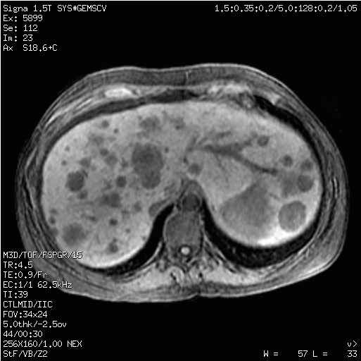

1) (A)-(B)-(C)

2) (A)-(C)-(B)

3) (B)-(C)-(A)

4) (B)-(A)-(C)

1. Which of the following is the artifact that the arrow indicates?

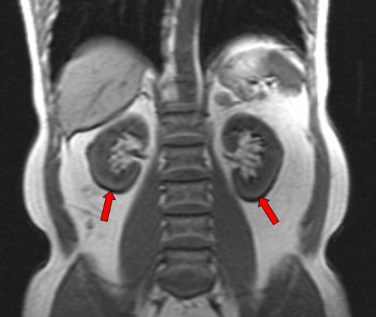

1) Chemical shift Artifact

2) Motion Artifact

3) Metal Artifact

4) Flow Artifact

1. Which of the following is NOT true about the method to remove the artifact of the following imaging?

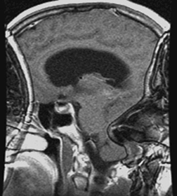

1) Make saturation

2) Increase the slice thickness

3) Increase the FOV

4) Make Over sampling