MR

1. Which of the following statement is NOT correct about RF Shielding before installing MRI equipment?

(A) RF shielding has to be attenuated below 20dB for all electromagnetic waves.

(B) Copper and aluminium are used for high frequency shielding.

(C) If shielding would be poor, artifact would appear in image at frequency encoding direction.

(D) Steel plate is used for external shielding.

2. Law of electromagnetic induction is concerned in ________.

(A) Gregor Ohms

(B) Hans Oersted

(C) Thomas Edison

(D) Michel Faraday

3. Which of the following is NOT affected to a value of net magnetization Mo?

(A) The number of nuclei reactable

(B) A factor of earth-magnetic field

(C) External magnetic field strength

(D) Flip angle

4. Which of the following statement is correct about precessional frequency?

(A) Precessional frequency (ωo) is proportional to the addition of external magnet field magnitude (B0) and gyromagnetic ratio (г).

(B) Hydrogen atoms spin and precession in situation without the effect of external magnetic field.

(C) г is gyromagnetic ratio of each element as proportional constant.

(D) A unit of precessional frequency is Hz/gauss or MHz/T.

5. Which of the following statement is correct about the nucleus of hydrogen having strong magnetic field?

(A) Because of possessing charge.

(B) Because of doing precessional movement.

(C) Because of rotating on its axis as possessing charge.

(D) Because of relaxation with rotating on its axis as possessing charge.

6. Which of the following statement is correct about T2 weighted image?

(A) T2 weighted image has short TE.

(B) If TE is short, the contrast would be low as minimizing the difference of transverse relaxation.

(C) As increasing TR, it could be large in the contrast by reducing T2 difference between the tissues.

(D) The tissue having long T2 has weak signal because dissipation of transverse magnetization is not fast.

7. Which of the following statement is correct about lattice in spin-lattice?

(A) Combined arrangement between adjacent spins

(B) Visual tissue arrangement

(C) Arrangement of elements and spins

(D) It is associated with T2(T2 star).

8. Which of the following statement is correct about diffusion weighted image?

(A) MRI only uses isotropy diffusion.

(B) Anisotropy diffusion appears larger in gray matter of the brain than white matter of it.

(C) There is no anisotropy diffusion in muscle fiber.

(D) A well-shown example of anisotropy diffusion is white matter of the brain.

9. Which of the following statement is NOT correct about flow Compensation (GMR, GMN) technique?

(A) Spine fluid in spinal cord cavity is slow in cervical spine and fastest in lumbar spine.

(B) Using of FC increases in contrast and decreases in SNR on T2 image.

(C) Rephrasing gradient field is added to rephrase phase shifted proton.

(D) Flow signal enhancement effect could appear because dispersed phase could be gathered by moving spins by gradients.

10. In Fast spin echo, the center line is associated with _______.

(A) Spatial resolution of the image

(B) ETL

(C) TR

(D) Effective TE

11. Which of the following statement is NOT correct about Echo Planar Imaging technique?

(A) It could be imaged by single 90°pulse and 180°pulse

(B) The image distortion is more than Fast spine echo.

(C) Chemical shift artifact appears at frequency direction.

(D) Fat saturation method is used to minimize chemical shift artifact.

12. Which of the following technique is the best image to achieve?

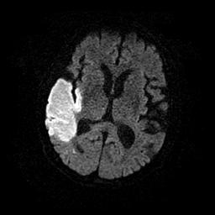

(A) Ultra fast spin echo

(B) Fast gradient echo

(C) Steam & prove

(D) Echo planner imaging

13. When using the following Pulse Diagram, which image could be achieved?

**FAT**

**CSF**

**echo**

**90°**

**180° Pulse**

**180°**

(A) (B) (C) (D)

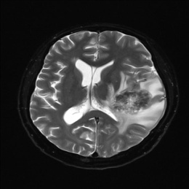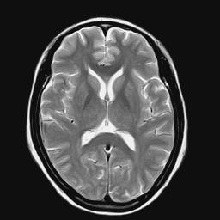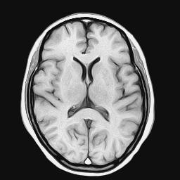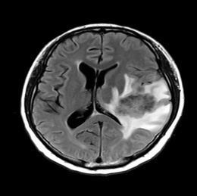

14. In spin echo technique, which of the following statement is correct about expression of the time between 90°pulse and 180°pulse?

(A) TE

(B) TI

(C) TR

(D) TE/2

15. In fast spin echo technique, when echo train length is changed 4 to 16 and other parameters are all the same. What is the scanning time?

(A) 1/2 times

(B) 1/3 times

(C) 1/4 times

(D) 1/5 times

16. Which of the following statement is correct about a method in increasing susceptibility effect?

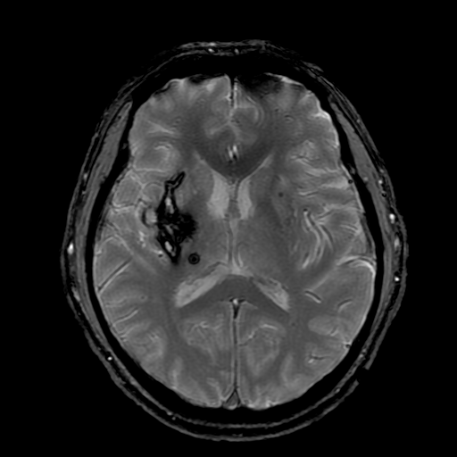

(A) Use short TE.

(B) Fast spin echo is more effective than spin echo.

(C) High magnet field is effective.

(D) Use thin slice.

17. TR is determined by_______ when using ECG triggering in study.

(A) A number of phase encoding

(B) Operator’s decision

(C) A number of frequency encoding

(D) A patient’s heart rate

18. Which of the following statement is NOT correct about a role of pre saturation pulse?

(A) It is possible to observe selective vessel according to position of saturation pulse.

(B) It is used by eliminating proton signal of water and fat.

(C) It could be used in the front and the back of image to minimize motion artifact.

(D) It is used by dealing with proton phase shift inside vessel in SE.

19. Which of the following statement is correct about image parameters?

(A) Repetition Time (TR) is proportional to scan time, but not to signal intensity.

(B) Echo Time (TE) is not associated with scan time and signal intensity and it is associated with image contrast.

(C) The smaller flip angle, it show T1 weighting and the larger flip angle, it shows T2 weighting.

(D) Short bandwidth makes high SNR and large bandwidth makes low SNR.

20. Which of the following statement is correct about perfusion?

(A) In normal tissues, contrast media flows in tissues well.

(B) In T2 weighted image, contrast media has homogenity of a part magnet field.

(C) It is calculated as a result of using contrast media two times.

(D) It uses first pass technique which measures susceptibility variance in time for contrast media.

21. Which of the following statement is correct about MR spectroscopy?

(A) It is possible to analysis biochemically metabolites.

(B) It has to use contrast media.

(C) It is more effective in low magnet field.

(D) It is a diagnostic method to detect early the change of cell tissues.

22. In whole body, what is allowable limit of SAR (Specific absorption rate) established by FDA?

(A) 0.4W/kg

(B) 4W/kg

(C) 40W/kg

(D) 400W/kg

23. What is the maximum sound pressure (dB) level allowable internationally to regulate sudden sound loss?

(A) 70 dB

(B) 95 dB

(C) 100 dB

(D) 140 dB

24. We are going to solve the problem analyzing the cause of artifacts. In generally, which of the following is different?

(A) Chemical shift

(B) Flow artifacts

(C) Truncation artifacts

(D) Motion artifacts

25. For getting the following image, it could be achieved by ____.

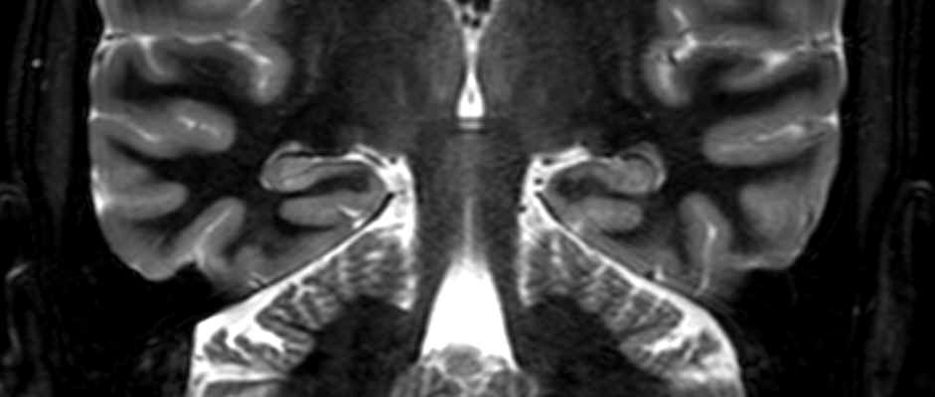

(A) (B)

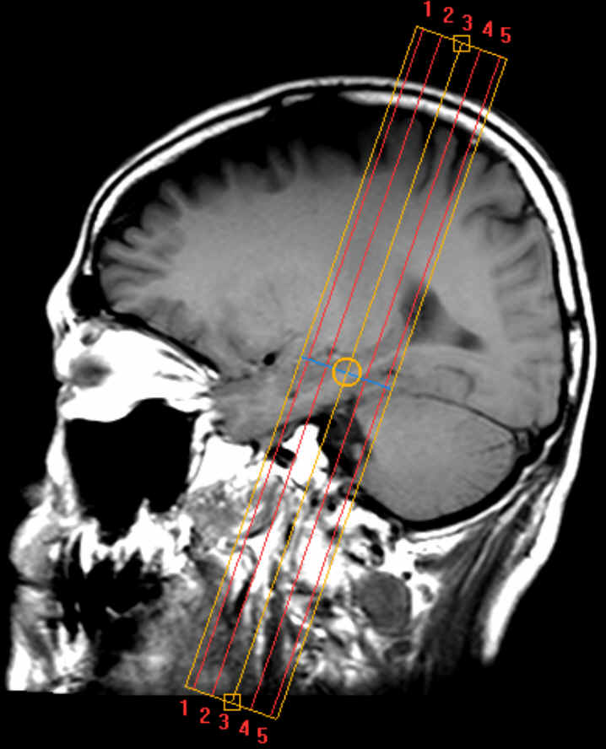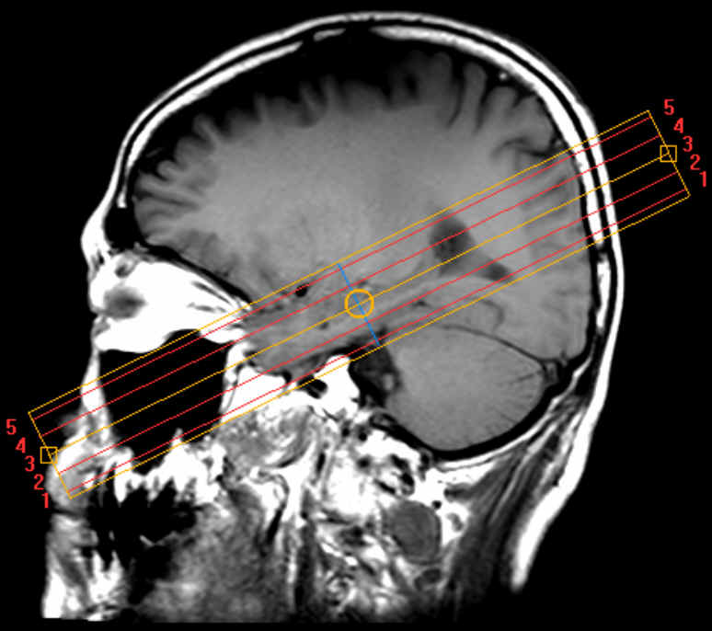

(C) (D)

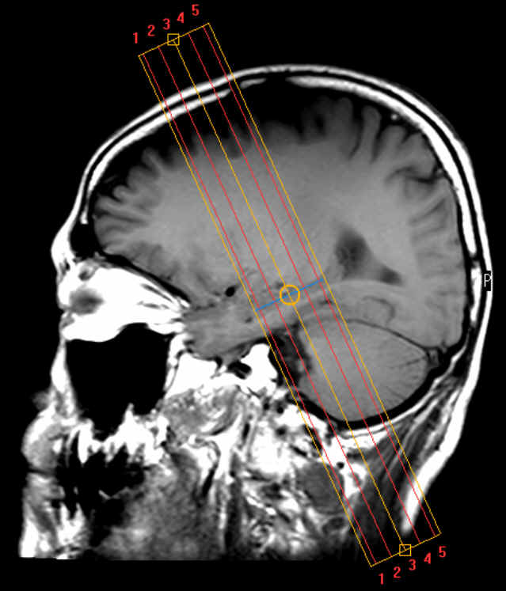

26. What is arrowhead pointed to?

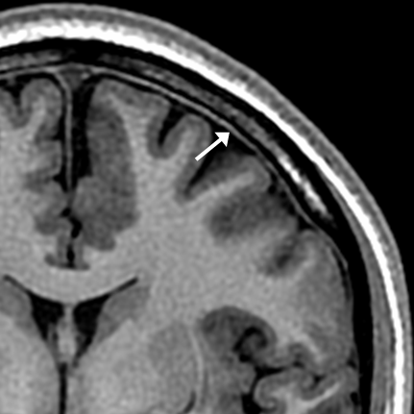

(A) Dura Mater

(B) Arachnoid

(C) Pia Mater

(D) Major extensions

27. Which of the following is correct about below images?

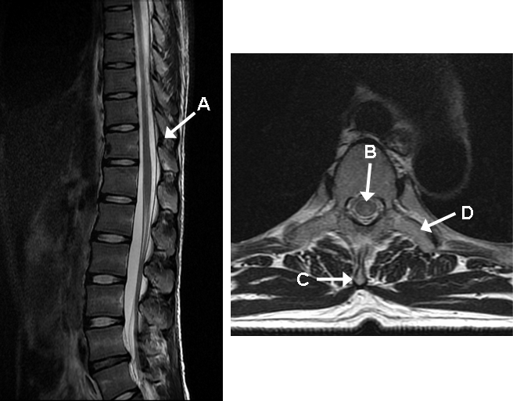

(A) A- Ligamentum flavm

(B) B- Spinal cord

(C) C- Spinous process

(D) D- Pedicle

28. Which of the following is NOT correct about the following anatomical structure?

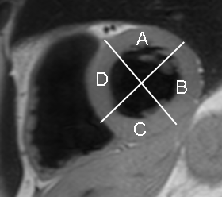

(A) A - anterior

(B) B - lateral

(C) C - inferior

(D) D - apex

29. What is the arrow indicated on the below image?

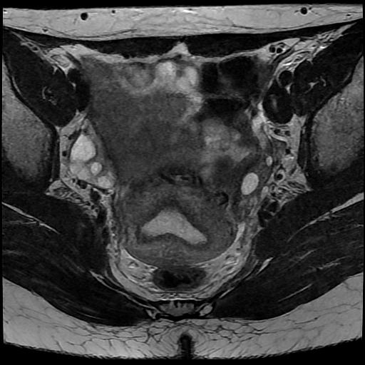

(A) Rectum

(B) Uterus

(C) Bladder

(D) Ovary

30. What is the arrow indicated on the below image?

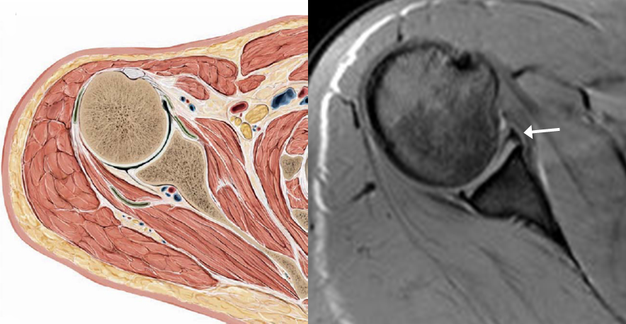

(A) Anterior labrum

(B) Glenoed

(C) Inferior labrum

(D) Posterior labrum

31. What is the arrow indicated on the below image?

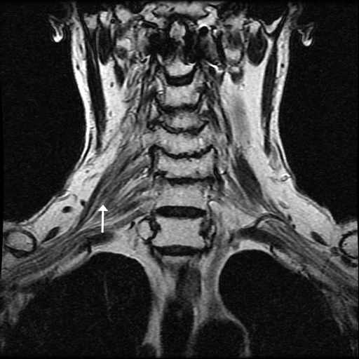

(A) It is fascicles getting out C2, C3, C4, C5.

(B) The bundle formed from nerve is cervical plexus.

(C) In case of damage of it, there is paresthesia in chest.

(D) With application with STIR technique, it is easy to detect a lesion.

32. Which of the following is NOT correct about precessional frequency of each element in 1.5T?

(A) 31P - 17.2㎒

(B) 1H - 63.8㎒

(C) 19F - 60.2㎒

(D) 13C - 16.1㎒

33. Which of the following statement is NOT correct about fourier transformation(FT)?

(A) It is a tool of mathematical calculation which translates signal of complex time domain into spectrum of frequency domain in seconds.

(B) It could get position information if we do FT of time-domain signal without applying gradients so each frequency element gets out separately.

(C) As differing phase rotating amount with each matrix, signal intensity of each matrix could be accepted by 2D FT

(D) It is called by K-space which is fourier transformed frequency space from 3D space(x, y, z).

34. Which of the following statement is NOT correct about MRS?

(A) Artifacts could be suppressed by changing homegenity of magnet field by eddy current.

(B) We could see peak of the major metabolites as suppressing water signal.

(C) Shimming is important for MRS.

(D) As a pulse sequence, STEAM (stimulated echo acquisition method) is used for it.

35. Which of the following statement is correct about BOLD (Blood Oxygenation Level Dependent)?

(A) It uses TI contrast.

(B) It uses magnetic susceptibility of oxyhemoglobin and deoxyhemoglobin.

(C) Deoxyhemoglobin is paramagnetic이다.

(D) Signal difference appears according to flow amount.

36. Which of the following statement is correct about FMRI (Functional Magnetic Resonance Image)?

(A) Signal could be achieved by mathematical calculation from getting stimulation and rest.

(B) Oxyhemoglobin is diamagnetic.

(C) In stimulation, as increasing the need of deoxyhemoglobin, signal is the maximum.

(D) There are vision hemisphere, motor hemisphere , sensory hemisphere , speech hemisphere in brain.

37. Which of the following explanation is NOT correct about Bolzman distribution formula?

(A) It defines as occupation density of nucleus spin.

(B) In true magnet field, there is the difference between the number of low energy and high energy spins.

(C) Surplus occupation rate is inversely proportion to magnet field strength.

(D) MR image is achieved by the difference between low energy spin and high energy spin.

38. Which of the following is NOT correct about a method in reducing the designated artifacts?

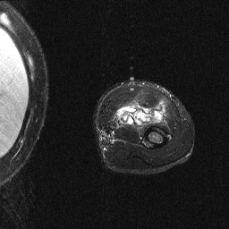

(A) Use narrow bandwidth.

(B) Use pre saturation pulse.

(C) Swap frequency and phase encoding direction.

(D) Use cardiac gating.

39. What is the arrow indicated on the below image?

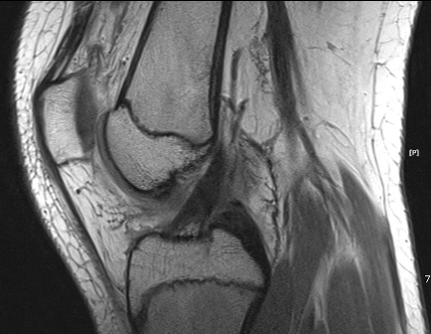

(A) T2 weighted image. ACL

(B) T2 weighted image. PCL

(C) Spin density image. ACL

(D) Spin density image. PCL

40. What is the arrow indicated on the below image?

(A) Ovary - T1 weighted image

(B) Uterus - T1 weighted image

(C) Ovary - T2 weighted image

(D) Uterus - T2 weighted image

41. Which of the following explanation is NOT correct about MR signal for MR image reformation?

(A) Twice cyclic frequency is the Cycle and frequency is called how much it repeats per a second.

(B) RF in MRI is sinc wave.

(C) X, Y, and Z gradients are needed for the localization of 3 dimensional spaces.

(D) Image is transformed through Fourier Transformation from k-space data.

42. Which of the following combination is correct about intrinsic parameters in MRI?

(A) Spin density, TR, Chemical shift.

(B) FOV, slice thickness, Diffusion.

(C) T1 relaxation time, Chemical shift, Diffusion.

(D) T2 relaxation time, Bandwidth, Perfusion.

43. Which of the following is NOT a correct reason of increasing SNR?

(A) Increases TR

(B) Increase phase encoding number

(C) Increasing NEX

(D) Increasing FOV

44. This is one of explanation of MR Angiography techniques. What is this?

If control the gradient filed, the flow with various velocity can be acquired.

It is excellent to suppress the background signal.

Saturation effect hardly appears.

(A) 2D TOF

(B) 3D TOF

(C) 2D PC

(D) 3D PC

45. Which of the following statement is correct about TR?

1. The longer TR is, the higher SNR is, and the better image quality is.
2. When TR is prolong, contrast becomes lower and scan time becomes longer.
3. Optimal TR is 300~600msec in T1 weighted image.

D. The shorter TR is, image contrast is getting closer to proton density.

(A) A, B

(B) B, D

(C) A, B, C

(D) A, C, D

46. Which of the following statement is correct?

A. FOV and Spatial Resolution are proportional relation.

B. When FOV becomes half, SNR becomes half.

C. FOV and SNR are proportional relation.

D. When FOV is smaller than anatomy structure, Cross Talk Artifacts are occurred.

(A) A, B

(B) B, D

(C) A, B, C

(D) A, C, D

47. When Matrix becomes 256*256 from 128*128, which of the following is correct?

A. Decrease spatial resolution

B. Increase scan time twice

C. Increase FOV

D. Decrease SNR 1/√2 times

(A) A, B

(B) B, D

(C) A, B, C

(D) A, C, D

48. Which of the following explanation is correct?

A. If Bandwidth is large, SNR is higher due to the higher noise.

B. If Bandwidth is 1/2, SNR is increased √2 times.

C. Bandwidth affects the change of TR.

D. If Bandwidth is small, scan time is increased and chemical shift artifacts are occurred.

(A) A, B

(B) C, D

(C) A, B, D

(D) A, C, D

49. Which of the following explanation is correct about the slice gap?

A. Using to increase SNR

B. Using to decrease Cross Talk Artifacts

C. Using to cover the larger region which is bigger than FOV.

D. Using to keep the slice gap with at least 20% of slice thickness.

(A) A, C

(B) B, D

(C) A, B, D

(D) A, C, D

50. Which of the following is correct?

(A) pixel size = FOV / matrix

(B) pixel size = FOV X matrix

(C) FOV = matrix2 X pixel size

(D) pixel size = FOV / matrix2

51. When the NEX is doubled, which of the following is correct about the effects?

(A) SNR is increased twice.

(B) Scan time is increased twice.

(C) SNR is decreased twice.

(D) Spatial resolution is increased twice.

52. In MR Angiography with MT (magnetization transfer), which of the following is correct about MT prepulse?

(A) RF pulse like a resonance frequency of free water is applied.

(B) RF pulse like a resonance frequency of immobile water is applied.

(C) Broad RF pulse like a resonance frequency of free and immobile water is applied.

(D) RF pulse unlike a resonance frequency of free and immobile water is applied.

53. Which of the following is a correct explanation about below images?



(A) Endogenous perfusion MR images

(B) CBV, CBF, TO, TTP, and MTT can be acquired.

(C) CRF or pediatric patients are not recommended.

(D) It can be acquired with bolus injection of gadolinium contrast media.

54. Which of the following explanation is NOT correct about STEAM and PRESS techniques for MRS?

(A) In STEAM, three consecutive 90° RF pulse perpendicular each other selects the three dimensional volume.

(B) In PRESS, a 90° and two 180° RF pulse selects the three dimensional volume.

(C) SNR in STEAM is twice higher than in PRESS.

(D) SAR in PRESS is twice higher than in STEAM.

55. This is a breast image of 53 years old female. Which of the following explanation is NOT correct about this image?

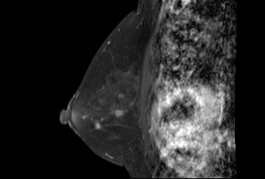

(A) T1 fat suppression technique was used after injected contrast media.

(B) The artifacts from cardiac were occurred.

(C) The phase encoding direction was head to feet direction (H-F).

(D) This is a right breast image generally.

56. Which of the following explanation is NOT correct about below image?

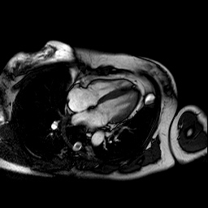

(A) 2 Chamber image

(B) Parallel Image technique can reduce the scan time.

(C) ECG gating is needed for removing the artifacts.

(D) Cine MRI can evaluate the cardiac function.

57. What is this on brain T2 weighted image (arrow)?

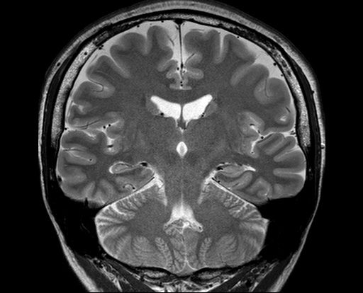

(A) Hippocampus

(B) Lateral ventricle

(C) Thalamus

(D) Trigeminal nerve

58. What is this on brain T1 weighted image (arrow)?

(A) Cerebrospinal fluid

(B) Choroid plexus

(C) Third ventricle

(D) Fourth ventricle

59. What is this in brain T1 weighted image (arrow)?

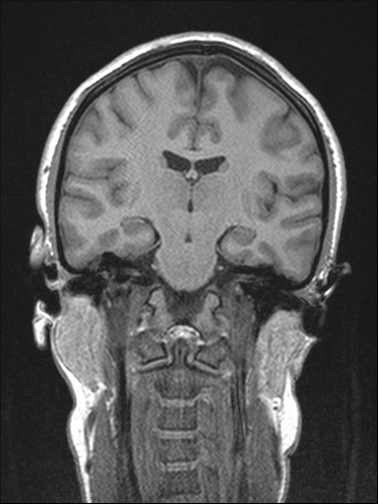

(A) Dura mater

(B) Arachoid

(C) Pia mater

(D) Gray mater

60. What is this on T2 weighted image (arrow)?

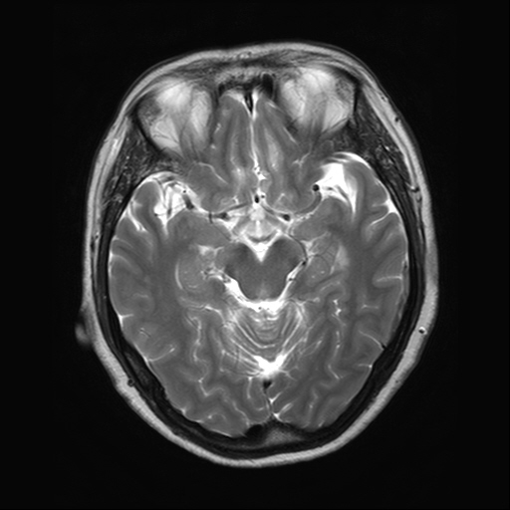

(A) Middle Cerebral Artery(MCA)

(B) Anterior Communicating Artery(ACA)

(C) Basilar Artery

(D) Posterior Communicating Artery(PCA)

61. Where is Lateral Rectus Muscle on orbit T2 weighted axial image?

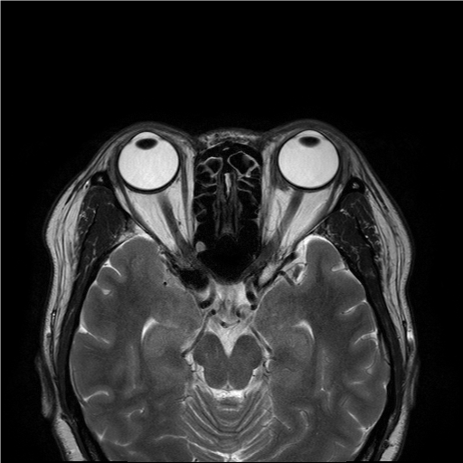

**A**

**B**

**D**

**C**

(A) A

(B) B

(C) C

(D) D

62. What is this (arrow)?

(A) Facial nerve

(B) Superior vestibular nerve

(C) Inferior vestibular nerve

(D) Cranial nerve VII, VIII

63. What is this on T1 weighted image (arrow)?

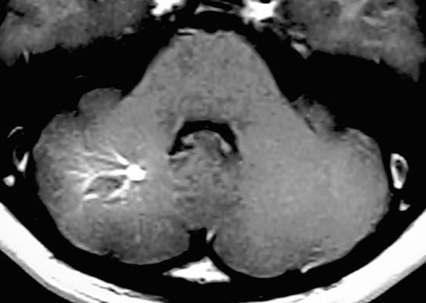[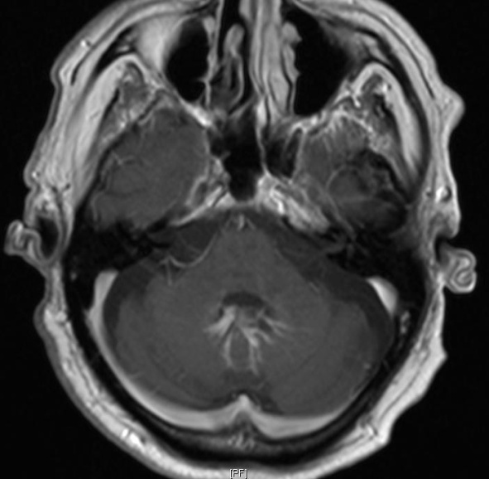](http://radpod.org/wp-content/uploads/2007/04/cerebellar_dva_gad_ax_arrows.JPG)

(A) AVM

(B) Venous Angioma

(C) Cavernous Angioma

(D) Capillary Telangiectasia

64. Which of the following is Not a correct method about reducing flow artifacts?

(A) Even echo rephasing

(B) Gradient moment rephasing(nulling)

(C) Spatial pre-saturation

(D) Intra voxel dephasing

65. When 256 frequency encoding step is acquired, what is the Nyquist frequency?

(A) 64Hz

(B) 128Hz

(C) 256Hz

(D) 512Hz

66. When the matrix of image is 4ⅹ4, which of the following is Not correct about the size of phase encoding step?

(A) π

(B) π/2

(C) 3π/2

(D) 2π/3

67. Which of the following is correct explanation about DWI (Diffusion Weighted Image)?

(A) In shorting TE, magnetic susceptibility artifacts are decreased.

(B) In shorting TR, magnetic susceptibility artifacts are decreased.

(C) In longer TE, diffusion image is emphasized.

(D) In longer TR, diffusion image is emphasized.

68. Which of the following is Not correct explanation about DWI (Diffusion Weighted Image)?

(A) Fat suppression is needed in DWI.

(B) The bigger DWI gradient is, the more Susceptibility artifacts are decreased.

(C) Isotropic diffusion movement is occurred in blast cells.

(D) The more B value is increased, the more SNR of image is decreased.

69. In Spin Echo, Which of the following is correct to acquiring 2NEX?

(A) Signal is acquired twice by changing the strength of slice selection gradient every TR.

(B) Data is filled up twice in the same line of K-space.

(C) Signal is acquired twice by increasing the amplitude of frequency encoding every consecutive TR.

(D) Phase encoding is performed in twice of Matrix size.

70. . In Spin Echo, when TE is 15ms. When is the highest SNR?

(A) A

(B) B

(C) C

(D) D

71. In Spin Echo, when TE is 10ms. Which of the following is correct?

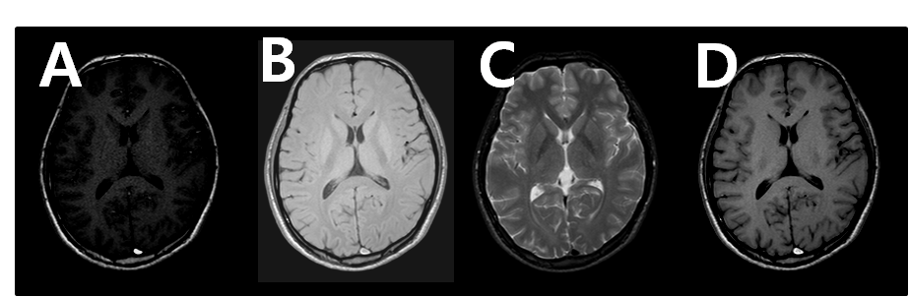

(A) A

(B) B

(C) C

(D) D

72. In Spin Echo, when TR is 2500ms. When is the highest SNR?

(A) A

(B) B

(C) C

(D) D

73. In Spin Echo, when TR is 3500ms. Which of the following is correct?

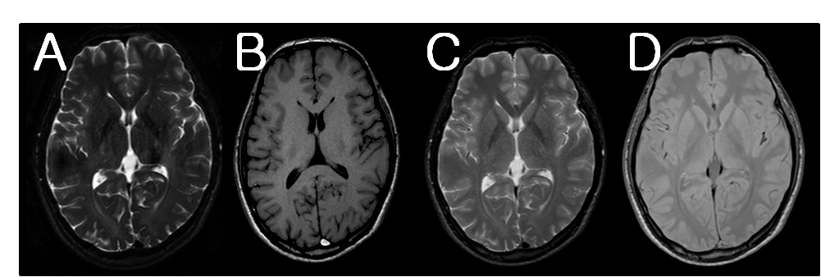

(A) A

(B) B

(C) C

(D) D

74. Which of the following is Not correct explanation about Spin echo sequence diagram?

(A) In A, longitudinal magnetization is generated firstly.

(B) In B, dephasing starts after slice selection gradient turned off.

(C) In C, T2 star effect is compensated.

(D) 라. In D, analog signal is transformed to digital signal.

75. Which of the following is Not correct explanation about image formation?

(A) Image is reformatted by back projection.

(B) The location of RF frequency and image signal can be defined by Nyquist theory.

(C) Analog data can be transformed to digital data by Fourier transformation.

(D) Low frequency is in the center of K-space.

76. Which of the following is Not correct explanation about SPIR (spatial inversion recovery) technique?

(A) It is sensitive to magnetic system or RF homogeneity.

(B) It has lower SAR level than STIR (short tau inversion recovery).

(C) It is not effective to the fat satuation in large FOV.

(D) It is effective in the high filed.

77. Which of the following is Not correct explanation about STIR (short tau inversion recovery) technique?

(A) Large FOV is good for fat saturation.

(B) It is more sensitive to T1 relaxation of the tissue than filed inhomogeneity.

(C) Fat saturation is good for the lesion detection after injection of contrast media.

(D) Uniform fat saturation can be done without external filed strength.

78. Which of the following is Not correct purpose of the brain posterior fossa MRI?

(A) Optic and Olfactory nerve lesion

(B) Hemifacial spasm and Trigeminal neralgia

(C) Brian stem lesion and acoustic neuroma

(D) Facial palsy and numbness

79. Which of the following is Not correct explanation about IAC (internal auditory cannel) MRI?

(A) Higher spatial resolution is needed for very small anatomical structures.

(B) Higher SNR protocol is needed because of low proton density of the structure compared to brain tissues.

(C) Facial and auditory nerve is better depiction in the CSF background.

(D) Flow artifacts by artery than vein should be removed.

80. Which of the following in Not correct explanation about Cervical spine MRI?

(A) The phase encoding direction is SI (superior to inferior) in Sagittal plane.

(B) Post processing is used to remove the artifacts by TSE (turbo spin echo)

(C) T2 fat saturation technique is used for discrimination between trauma and metastasis lesion.

(D) 3D balanced gradient echo is better for radiculopathy (disc disease) than myelopathy (cord lesion) clinically.

81. Which of the following is Not correct explanation about Knee MRI?

(A) PD (proton density) is used for the depiction of articular cartilage, collateral ligament, and meniscal tear.

(B) Axial plane is good for the depiction of patella and chondral damage of anterior femoral condyle.

(C) Patient’s legs are externally rotated 5 to 10 degree for whole length of ACL (anterior cruciate ligament).

(D) Muscle signal on T2 weighted in TSE (turbo spin echo) is more weighted and better used for lesion detection than in SE (spin echo).

82. Which of the following is Not correct explanation about Shoulder MR Arthrography?

(A) Diluted gadolinium contrast media is injected into the joint under Fluoroscopy.

(B) Gadolinium contrast media and saline are diluted over 1:100.

(C) Contrast media is spread into the joint space by the movement after diluted contrast media is injected.

(D) Fat saturation is used to determine the cartilage defect.

83. . What is the scan time in this parameter?

TR: 2000msec, Frequency step: 256, TE: 60msec, NEX: 2, Flip angle: 90o Pixel size: 0.95X0.95mm, Phase steps: 192

(A) 6.4min

(B)12.8min

(C)17.06min

(D) 25.6min

84. Which of the following is Not correct explanation about Inversion Recovery?

(A) Tissue is suppressed by using the selective inversion time.

(B) TR includes nulling time.

(C) Although the contrast of T1 and T2 are getting better in high filed strength, Inversion Recovery is not used.

(D) Nulling time is the time between 180o and 90 o RF pulse.

85. What is the Effective TE in Fast Spin Echo?

(A) It is the echo to fill the outside of the k-space.

(B) It is the high phase encoding gradient.

(C) It is the low phase encoding gradient.

(D) It is the first step in the phase encoding gradient.

86. Which of the following is Not correct explanation about Echo Planar Imaging?

(A) In Single-shot EPI, a RF pulse is applied and Gradient of 1/2 phase step is changed.

(B) K-space is filled right to left.

(C) EPI needs maximum gradient strength and minimum slew rate.

(D) Multi-shot EPI fills up the k-space using multiple RF.

87. Where are Eddy current from?

a. MR magnet, b. Patient, c. Cables and Wires

(A) a

(B) a, c

(C) b

(D) a,b,c

88. What is the struture indicated by the arrow?

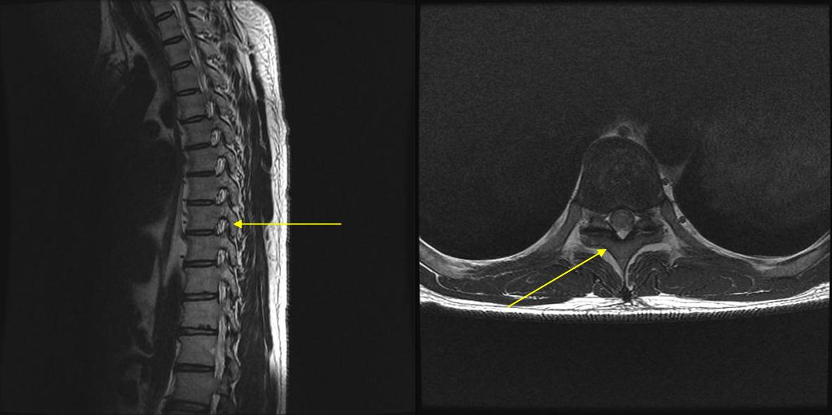

(A) Lamina

(B) Pedicle

(C) Spinous process

(D) Transverse Process

89. Which are the correct structures on the images?

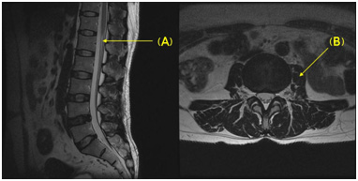

(A) (A) Cauda equine, (B) Psoas Muscle

(B) (A) Cauda equine , (B) Quadratus lumborum

(C) (A) Conus medullaris, (B) Psoas Muscle

(D) (A) Cauda equine, (B) Quadratus lumborum

90. It has thyroxin and triodothyronin hormones in our body, and dwarfism can be occurred due to the lack of it. What is it in this image?

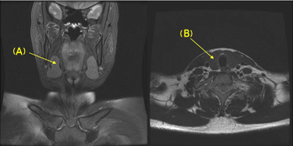

(A) Thyroid gland , (A)

(B) Submandibular gland, (A)

(C) Thyroid gland , (B)

(D) Submandibular gland, (B)