- In a T2 weighted images, a long TR is used to____________?
- Maximize T2 effects
- Minimize T2 effects
- Maximize T1 effects
- Minimize T1 effects
- On a T1 weighted image of the brain, white matter appears _______to gray matter.
- Hyperintensity
- Hypoinstensity
- Isointensity
- None of the above
- The coils used to alter the magnetic field during scanning are known as the ___________.
- (A) RF receive coil
- (B) RF transmit coil
- (C) Shim coil
- (D) Gradient coil.
- In MRI, the thin slices are archived by applying a ______ gradient slop or a _____bandwidth.
- (A) Shallow, Broad
- (B)Steep, Narrow
- (C)Shallow, Narrow
- (D)None of the above
- The area of K space filled with the shallowest phase encoding slopes is known as________.
- (A)Central lines
- (B)outer lines
- (C)Negative lines only
- (D)None of the above
- Which signal is received from the patient following 90°RF pulse?
- (A) none
- (B) a free induction decay
- (C) a spin echo
- (D) a gradient-refocused echo
- The principle characteristic of acquiring a gradient echo is :
- (A) the use of a 90° RF pulse
- (B) the use of an alpha RF pulse
- (C) the change in T1 relaxation time
- (D) the change in T2 relaxation time
- Multiecho imaging in a conventional spin echo pulse sequence results in multiple sets of images having different:
- (A) matrix size
- (B) FOV
- (C) contrast resolution
- (D)Spatial resolution
- If the Z gradient is the slice selection gradient, the X and Y gradients determine ______ within the slice.
- (A) rows and columns
- (B)phase and frequency
- (C)intensity and polarity
- (D)character and location
- Which is the kind of material for passive magnetic shielding ?
- (A)Cu
- (B)AL
- (C)steel
- (D)Co

- Which is the kind of material for RF shielding ?
- (A)Cu
- (B)AL
- (C)steel
- (D)Co

- The SNR in 3D GRE is equal to the SNR in 2D GRE times the factor:
- (A)Nz
- (B)√Nz
- (C)Ny
- (D)√Ny

- Chemical shift is decreased by all of the following except:
- (A)lowering the bandwidth
- (B)using a fat suppression technique
- (C)using a lower field magnet
- (D)using a long TE
- Cross-talk artifacts can be reduced by all of the following except:
- (A) increasing the gradient strength
- (B) increasing interslice gaps
- (C) double acquisition with 100% gaps interleaved
- (D) improving the RF profile
- In conventional spin echo pulse sequences, how many phase encoding steps are archived per TR?
- (A)1
- (B)128
- (C)192
- (D)256
- What is the true for MR imaging?
- (A)Bone always appears black on MR image
- (B) Fat always appears bright on MR image
- ©Fat appears black on T2 weighted Fast Spin-Echo image
- (D)Fat appears bright on Short time inversion recovery (STIR) image
- What is the Larmor frequency of proton in 1.5T MR scanner?
- (A) 42.6MHz
- (B) 42.6KHz
- (C) 63.9MHz
- (D) 106.5KHz
- Which MR signal is the strongest in T1W image?
- Air
- (B) Fat
- (C) Water
- (D) Metal
- Which type of cardiac gating is less sensitive to arrhythmia?
- (A) Respiratory gating
- (B) Prospective gating
- (C) Retrospective gating
- (D) Non of above

- The recommended SAR limit of whole body in MR imaging is:
- (A) 0.4Watts/kg
- (B) 4.0Watts/kg
- (C) 8.0Watts/kg
- (D) 0.8Watts/kg
- What is true for Fast Spin-Echo technique?
- (A)The SAR is higher than conventional Spin-Echo technique
- (B) The length of echo train is T2* dependent
- (C) The MR signal is obtained from FID refocusing echo
- (D) All of above
- Which procedure could be used to reduce “Chemical shift artifacts”?
- Increased bandwidth
- (B) Higher main magnetic field
- (C) Reduced field of view (FOV)
- (D) Increased slice thickness
- Which MR technique is useful to reduce “Motion artifacts”?
- (A) Fast Scan Imaging
- (B) Flow compensation technique
- (C) Respiratory gating
- (D) All of above
- What is the true for MR imaging?
- (A)Increased FOV will increase spatial resolution
- (B) Decreased bandwidth will increase slice thickness
- (C) Increased TR will reduce scan time
- (D)Reduced slice thickness will increase SNR
- What is the true for arterial spin labeling (ASL) technique?
- (A)It is a method to assess the micro-circulation with contrast agent
- (B)The MR signal is dependent on the longitudinal magnetization
- (C) By using 90-degree saturation pulse to tag the regional of interest
- (D) None of above
- What is the gyromagnetic ratio of proton (H¹) at 3T MR scanner?
- (A) 42.6MHz/Tsela
- (B) 63.9MHz/Tesla
- (C) 127.8MHz/Tesla
- (D) None of above
- How to obtain the T1-weighted MR image?
- (A)Short TE and TR
- (B)Short TE and long TR
- (C)Long TE and Long TR
- (D)None of above
- How to obtain the T2-weighted MR image?
- (A)Short TE and TR
- (B)Short TE and long TR
- (C)Long TE and Long TR
- (D)None of above
- How to obtain the Proton-density weighted MR image?
- (A) Short TE and TR
- (B) Short TE and long TR
- (C) Long TE and Long TR
- (D)None of above
- In the absence of an external magnetic field, a bulk object exhibits no net magnetic moment due to:
- (A) Nuclear magnetic moments for all nuclei are zero
- (B) Nuclear magnetic moments cancel out each other
- (C) The bulk magnetization vector is too small to be detected
- (D) All of above
- When a patient is placed inside the bore of a magnet, the hydrogen nuclei within the patient align ______ and ______ to the Bo or external magnetic field.
- (A) Transverse, coronal
- (B) East, West
- (C) Parallel, Anti parallel
- (D)Left, Right
- All monitoring devices or other electrical & mechanical devices before entering MRI scan room should always be?
- (A) Made of aluminum & steel
- (B) secured down tightly
- (C) used, because the doctor said so
- (D) Tested for ferromagnetic properties, referring to FDA clearance, and be MRI compatible
- What devices are contraindicated for MRI imaging?
- (A) Hip replacement
- (B) Intravascular coils
- (C) Contacts
- (D) Cochlear implants & duraphase penile implants
- What is a faraday cage?
- (A) A bird cage
- (B) Hardware implanted in lumbar spine
- (C)Copper place around a scan room, preventing RF leaks
- (D) Made of steel, allows RG to enter

- The MRI scan room should maintain a relative humidity of around __________.
- (A)50-70%
- (B) 65-70%
- (C) 45-50%
- (D) 95-98%
- The magnetic field strength of an MRI magnet is measured in ___________ at isocenter.
- (A) Gauss
- (B) Tesla
- (C) Ohms
- (D) Amps

- Gradient magnetic field strength is measured in ...
- (A) MTM/G per cm
- (B) Ohms/amperage
- (C) MM/cm
- (D)Tesla
- What is fourier transform (FT)?
- (A) A FM signal converted to pictures
- (B) Transforming RF to microwaves
- (C) Mathematical conversion of a time domain signal into a frequency or spatial domain signal or image
- (D) A french math teacher
- The brachial plexus is located at the level of...
- (A) C4-T2
- (B) C4-C7
- (C) C1-C7
- (D)T12-L2
- Cardiac gating can be triggered of the _______ wave.
(A) P
(B) Q
(C) R
(D) S
- To scan a patient's knee, which type of coil is used?
(A) CSP coil
(B) extremity qual coil
(C) Body coil
(D) TrosoPA
- Which scan plan best demonstrates carpal tunnel in the wrist?
(A) Horizontal
(B) COR
(C) SAG
(D) Axial
- A field of view (FOV) that is not centered at isocenter is ...
(A) large FOV
(B) offcenter FOV
(C) Medium FOV
(D) Offset FOV
- Parameters of a SE T2 sequence are ...
(A) Short TE/ short TR
(B) Short TE/ long TR
(C) Long TE & long TR
(D) High TR & low TE
- Define phase.
(A) the duration of RF center slice
(B) the time to build up gradient pulse
(C) The position of a magnetic moment on its precessional path at any given time
(D) The frequency of magnetic field pulses
- Niobium titanium wires submerged in cryogens become superconductive below what temperature?
(A) 32°F
(B) 0°K
(C) (Correct) 10°K
(D) 5°K
- What is the term used for a gradual increase of magnetization in the longitudinal plane?
(A) Horizontal Gain
(B) Flox
(C) Relaxation
(D) Recovery
- What is the term used for a gradual decrease of magnetization in the transverse plan?
(A) Recovery
(B) SNR
(C) Total recall
(D) Decay
- Define T1 relaxation.
(A) 60% transverse growth
(B) 36% longitudinal regrowth
(C) 63% of longitudinal magnetization regrowth
(D) 63% of transverse magnetization regrowth
- T2 weighted images are characterized as ...
(A) Dark water/ dark fat
(B) bright water/ bright fat
(C) bright water/ dark fat
(D) dark water/ bright fat
- Which of following is not correct explaining of Magnetic susceptibility?
(A) The Magnetic susceptibility is showing the gradient echo imaging which was effected a lot of T2*
(B) Magnetic susceptibility rate (x)=M/H ( M=induced magnetization, H=magnetic field strength)
(C) The artifact of relating with Magnetic susceptibility is happened in accordance with external magnetic field direction.
(D) The artifact is taking place in margin of air to tissue and bone to tissue
- What is this structure on the image (white arrow)?
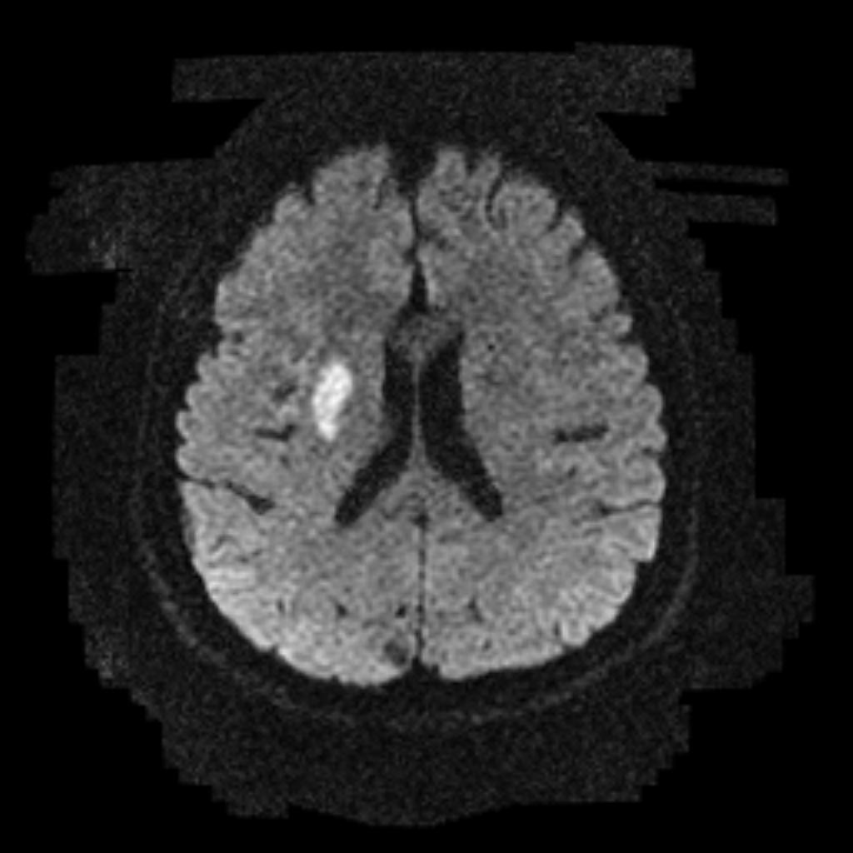
(A) Central nervous of exercise function
(B) Lacking of diffusion effect
(C) Enhancement of contrast medium
(D) Sensitive part of susceptibility
- What is the Diffusion Weighted Imaging?
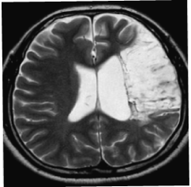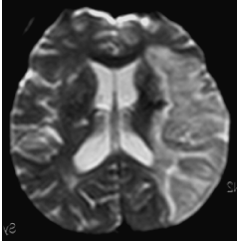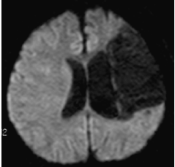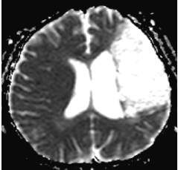
- Which of the following is a correct explaining about diffusion weighted imaging?
(A) It is only used isotropy diffusion In MRI
(B) Anisotropy diffusion of white matter is more happen than gray matter.
(C) There is no anisotropy diffusion in muscle fiber.
(D) Anisotropy diffusion is shown in white matter very well.
- Which of the following is a correct about center line of K-space in Fast spin echo?
(A) Spatial resolution of Image
(B) ETL
(C) TR
(D) Effective TE
- Which of the following is a correct about slice selective excitation?
(A) Thinner slice thickness increase spatial resolution and sharpness in image.
(B) Mild inclination of gradient magnetic field needs to get thin slice thickness.
(C) A steep slope of gradient magnetic field needs to get thick slice.
(D) There is any relative between thick slice and dispatching RF pulse bandwidth.
- Echo planar imaging (EPI) can’t acquire __
(A) Functional MRI
(B) Perfusion Image
(C) Diffusion Image
(D) Chemical Shift Image
- Which of the following is not a correct about inversion Recovery?
(A) FLAIR(Fluid Attenuated Inversion Recovery) TI time is 200~250ms.
(B) STIR(Short TI Inversion Recovery) can attenuate fat signal.
(C) Inversion time(TI) does not change when the external magnetic field change.
(D) Inversion recovery method use to acquiring real time image.
- Which of the following is a correct this diagram?

180° 90° 180° 180°
(A) This sequence can acquire angiography.
(B) A specific signal(fat, water) can attenuate.
(C) This sequence can acquire magnetization transfer image(MTI).
(D) This sequence can acquire dynamic image.
- What is the proper TR time to get this image in spin ehco?
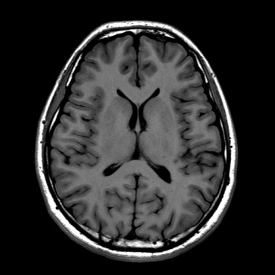
(A) 200ms
(B) 500ms
(C) 900ms
(D) 1500ms
61. Which of the following is correct about this image?
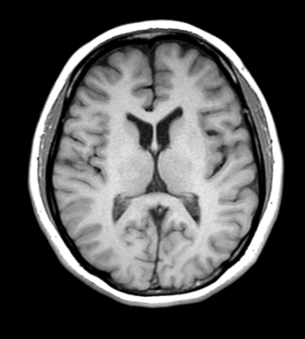
(A) TR has to set over 2000ms to increase the contrast.
(B) The Matrix has to rise to increase SNR.
(C) The signal intensities of fat, gray matter, white matter, and CSF are low in order.
(D) Short TE is needed
62. What is this kind of effect increased?
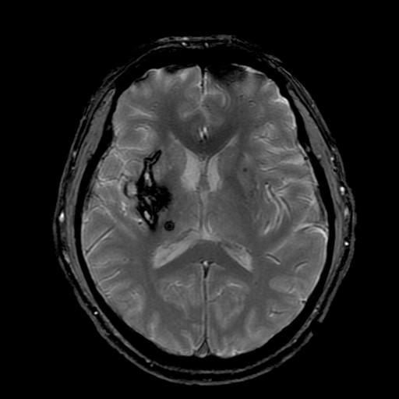
(A) Reduced TE
(B) Used fast spin echo
(C) Used high Tesla magnet
(D) Decreased slice thickness
63. What are proper scan parameters to get this image?
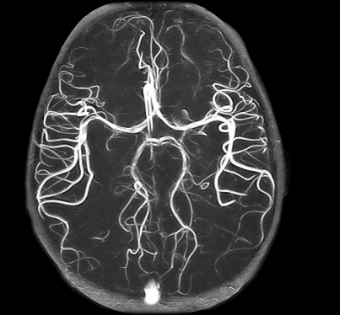
(A) TR: 100ms, TE: 10, Flip angle: 90°
(B) TR: 100ms, TE: 20, Flip angle: 70°
(C) TR: 20ms, TE: 80, Flip angle: 50°
(D) TR: 20ms, TE: 7, Flip angle: 20°
- Which of the following is a correct about Gradient echo?
(A) Homogeneity of magnet is not relate with Gradient echo
(B) Image contrast depends on flip angle.
(C) It’s hard to acquire 3D volume date.
(D) SNR of gradient echo is better than SE
- If TR is enough long, which flip angle can maximize the transverse
(magnetization?
(A) 30°
(B) 60°
(C) 90°
(D) 180°
- Which of the following is correct about the equation of pixel size?
(A) Pixel size= phase encoding number/matrix
(B) Pixel size= FOV/matrix
(C) Pixel size= frequency encodingnnumber/matrix
(D) Pixel size= matrix/FOV
- Which of the following is correct about the explanation when number of excitation (NEX) is increased?
(A) Spatial resolution is changed.
(B) Scan time is reduced.
(C) Scan time is not changed.
(D) SNR is increased.
- Which of the following is correct about the reason for placing gap between slice and slice?
(A) To increase spatial resolution
(B) To reduce Cross-talk
(C) To reduce chemical shift
(D) To reduce scan time
- What fat suppression technique is combined and used with frequency selective excitation and chemical shift between water proton and fat?
(A) CHESS
(B) Dixon
(C) Chopper
(D) STIR
- Which of the following is NOT correct about the explanation of fat suppression technique?
(A) Frequency selective excitation
(B) Phase evolution (Dixon)
(C) Hybrid
(D) Pre saturation
- Which of the following is correct about the explanation of BOLD (blood oxygen level-dependent)?
(A) It is a basic principle of fMRI and PET for researching the intrsic function in the every part of
(B) It causes oxyhemoglobin oversupply, when hypoxia is developed by the stimulation in the local cerebral region.
(C) Deoxyhemoglobin prolongs T2* relaxation time compared to oxyhemoglobin.
(D) BOLD technique gets the information about stimulated region of brain in the arterial flow not but capillary flow.
- Which of the following is correct about the explanation of MR Perfusion?
(A) Contrast media can easily pass into normal tissues.
(B) Contrast media has a good homogeneity of local magnetic filed in T2weighted image.
(C) It is calculated by acquiring twice contrast enhanced data.
(D) The first pass technique is used for detecting the rate of magnetization by contrast media according to time in brain parenchyma.
- Which of the following is correct about the explanation of MR Spectroscopy?
(A) It is possible to analyze metabolite biochemically and invasively.
(B) It must use a contrast media.
(C) It is more efficient in low magnetic field.
(D) It is a diagnostic method to find out the change of collation in advance.
- Which of the following is correct about the explanation of T1 contrast media?
(A) Metal ion (GD³⁺) as a rare earth element in Lanthanoids is used.
(B) Gadolinium represents the direct contrast enhancement.
(C) MR contrast media can pass through blood brain barrier normally.
(D) Magnetic activity should be low to change the signal intensity on the image.
- Which of the following is correct about this MRA image?
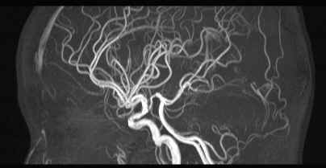
(A) It is a post contrast enhanced image.
(B) Pre-saturation pulse is placed in both flow-in and -out directions.
(C) Multiple slag is used for reducing “ In flow artifacts “.
(D) Sagittal slab is used for intra cranial vessels.
- Which of the follwing is NOT correct about these images?

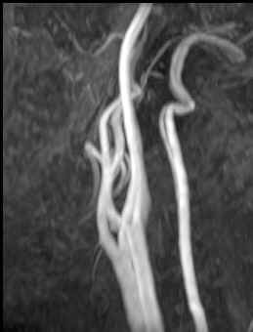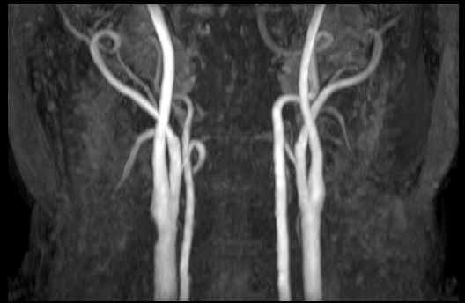
(A) Contrast media does not need to be used all the time.
(B) Pre-saturation pulse is placed the below the slab.
(C) 3 Dimensional volumetric data is acquired.
(D) It is a carotid MRA.
- Which post processing method is used on below images?
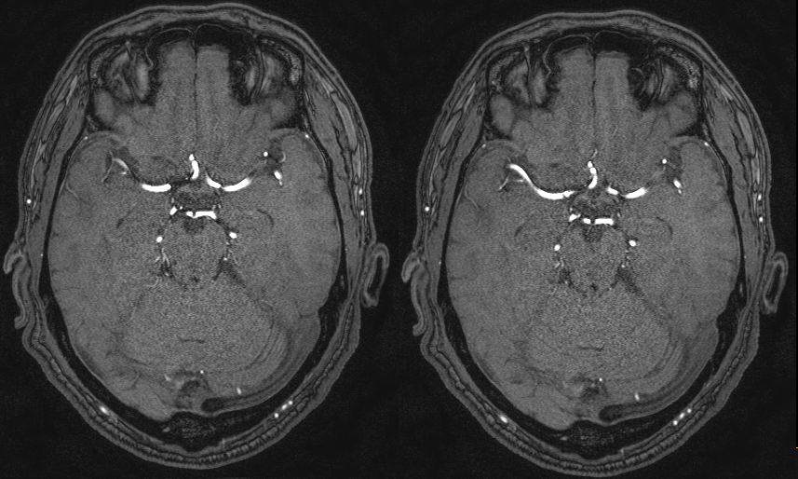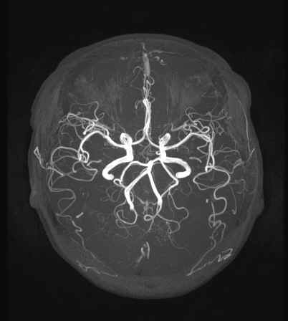
(A) MPR (B) ADC
(C) MIP (D) SCIC
- Which of the following was used for this image?
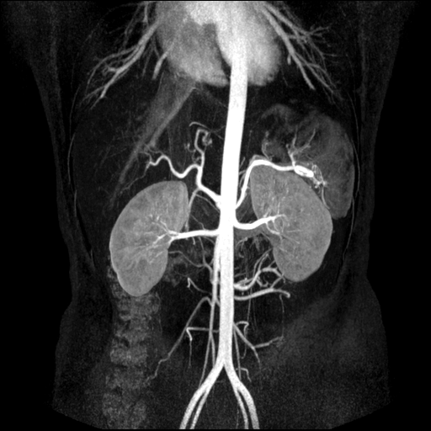
(A) 2D TOF
(B) 2D PC
(C) 3D PC
(D) Contrast Enhanced MRA
- What is the recommended rate of change in gradient or magnetic field by FDA for the safety?
(A) less than 10T/s
(B) less than 20T/s
(C) less than 30T/s
(D) less than 40T/s
- Which of the following is needed for checking the patient who is under sedation?
(A) Emergency cart
(B) Blood pressure (BP) monitor
(C) Pulse- oximeter
(D) Respiratory sensor
- What kind of artifacts is seen in this image (arrow) and what is this image?
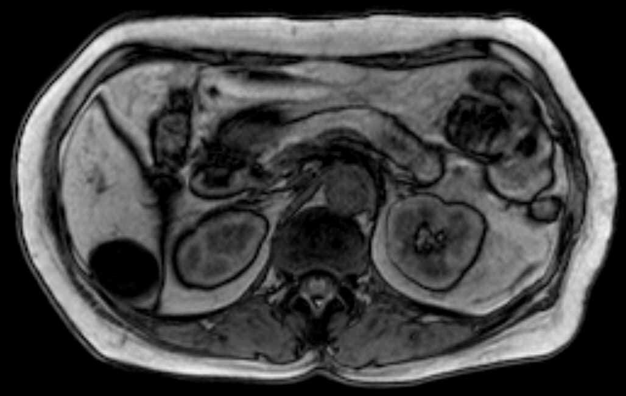
(A) Motion Artifact, In phase
(B) Truncation Artifact, Out of phase
(C) Partial Volume Artifact, In phase
(D) Chemical Shift Artifact, Out of phase
- Chemical shift artifacts are seen on this image. Which of the following is the direction of flow artifact?
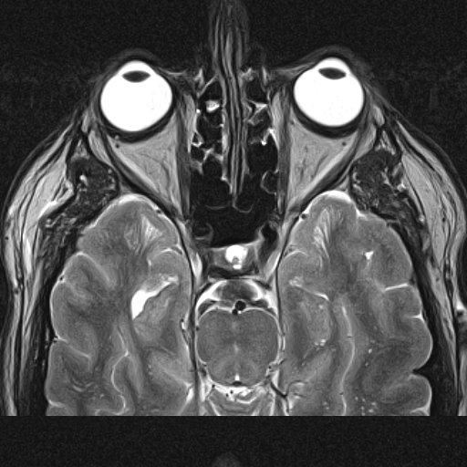
(A) Anterior - Posterior
(B) Superior - Inferior
(C) Right - Left
(D) Anterior - Inferior
- Which of the following needs a dynamic study according to the size of lesion?
(A) Cerebral infarction
(B) Pituitary adenoma
(C) Acustic neurinoma
(D) Meningioma
- Which of the following can make this image?
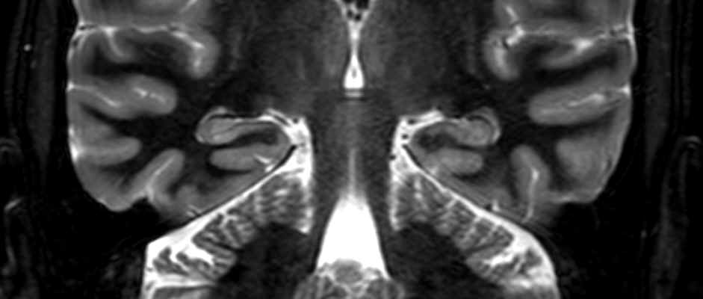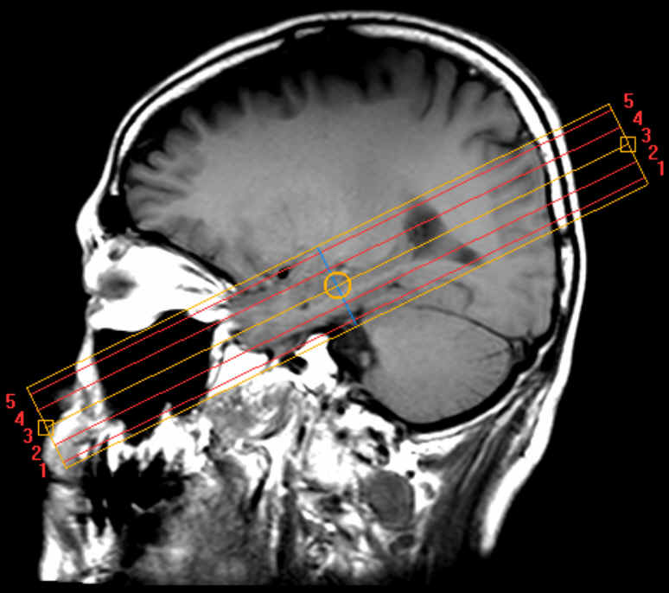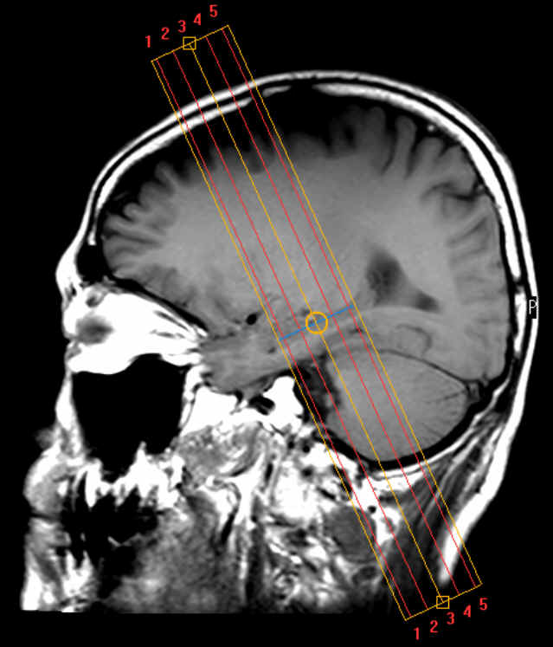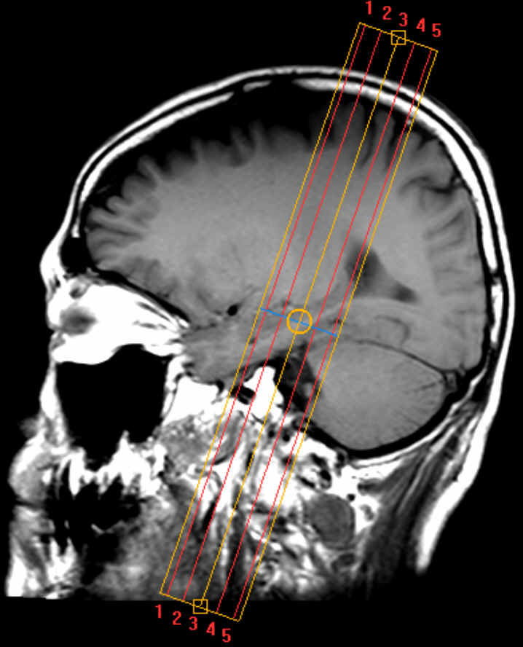

- Which of the following is NOT regarding the contrast enhanced structures normally in the brain?
(A) Dura mater
(B) Pituitary gland
(C) Choroid plexus
(D) Pons
- Which of the following is correctly connected from number 1 to 3 on this image?
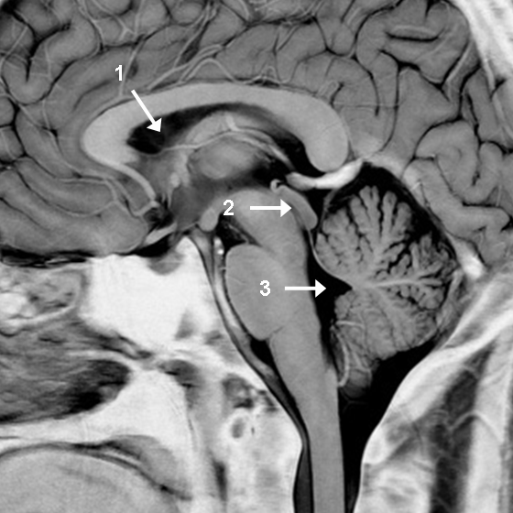
(A) Lateral ventricles - Fourth ventricle - Cerebral aqueduct
(B) Lateral ventricles - Fourth ventricle - Cerebral aqueduct
(C) Fourth ventricle - Lateral ventricles - Cerebral aqueduct
(D) Lateral ventricles - Cerebral aqueduct - Fourth ventricle
- What image can be acquired by scanning as the line on this image?
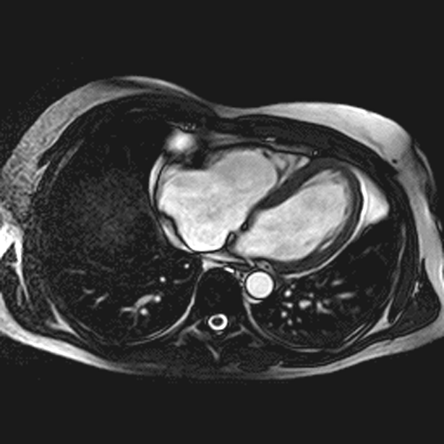
- What structure does the arrow represent in the image?

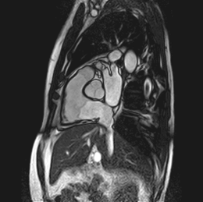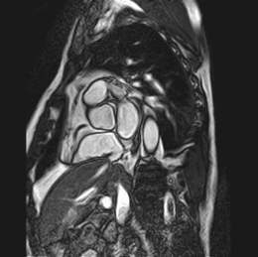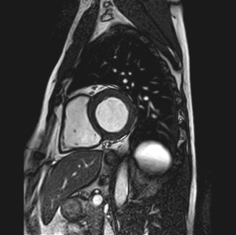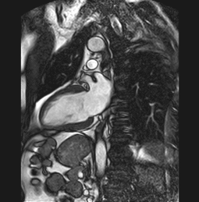
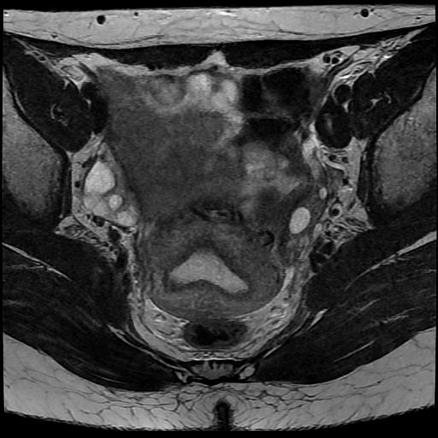
(A) Rectum
(B) Uterus
(C) Bladder
(D) Ovary
- 89. Which of the following is correctly connected between image views?
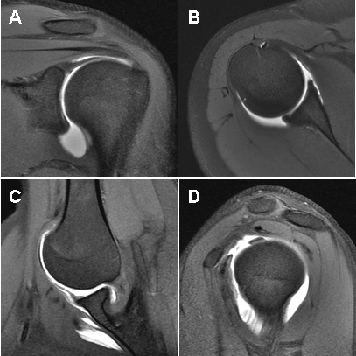
(A) A – Oblique Coronal plane
(B) B – Sagittal plane
(C) C – Axial plane
(D) D - ABER plane
- What structure is seen on this image (arrow)?
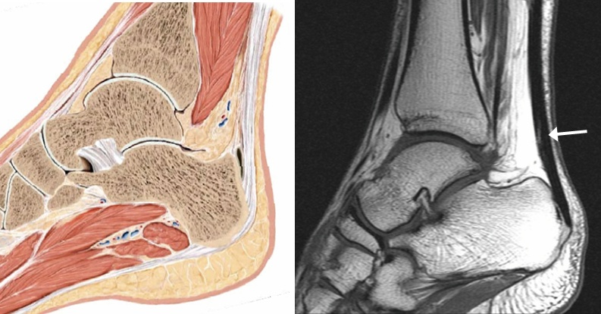
(A) Peroneus longus tendon
(B) Extensou digitorum longus tendon
(C) Achilles tendon
(D) Flexor hallucis longus tendon

