2014 SONO

Q1.Which of the following statements is true regarding the Doppler effect?

(1) The Doppler shift is the difference between the transmitted frequency

and the observed frequency

(2) The magnitude of the Doppler shift does not depend on the relative

velocity between the source and the receiver

(3) The maximal Doppler shift will occur when the direction of ultrasound

wave propagation is perpendicular to the motion

(4) All of the above

Q2.If the physical size of a cyst is 2 cm in diameter, what is the depicted size

in the image? Assume that the acoustic velocity in the cyst is 1000 m/s?

(1) 1.3 cm

(2) 2 cm

(3) 3.1 cm

(4) 6.2 cm

Q3.Which of the following properties of ultrasound forms the basis for

intermittent imaging with contrast agents?

(1) Harmonic scattering from microbubbles

(2) Solid

(3) Nonlinear propagation

(4) Stress/strain of tissue

Q4.Which of the following properties of ultrasound forms the basis for elastic

imaging?

(1) Harmonic scattering from microbubbles

(2) Tissue-dependent attenuation

(3) Nonlinear propagation

(4) Stress/strain of tissue

Q5.Which of the following represents depth vs. time scan

(1) A mode

(2)B mode

(3) C mode

(4) M mode

Q6.Increase frequency will

(1) increase resolution

(2) increase penetration

(3) increase refraction

(4) 1 and 3

Q7.Which of the following determines the operating frequency of the

ultrasound transducer?

(1) element diameter

(2) element thickness

(3) element impedance

(4) all of the above

Q8.When angle correction applied on the color Doppler display, the Nyquist

limits on the color map will

(1) increase

(2) decrease

(3) not change

(4) irrelevant

Q9.Increasing the PRF will

(1) improve detail resolution

(2) decrease frame rate

(3) decrease maximum unambiguous depth

(4) increase penetration

Q10.Tissue mimicking phantoms are composed of materials designed to

exhibit

(1) the same density and acoustic impedance of tissue

(2)the same acoustic velocity as ultrasound in tissue without regard to

attenuation so that distance accuracy can be evaluated

(3) the same attenuation rate without regard to velocity of propagation

so that sensitivity can be evaluated

(4) the same acoustic properties for ultrasound propagation through

tissue, including attenuation, velocity, and scattering

Q11.Quality control testing indicates that the distance measurements in the

horizontal direction are not accurate. What is the most likely cause?

(1) Velocity calibration is not 1540 m/s

(2) Problems with beam steering

(3) Geometric distortion from nonlinear propagation

(4)High-frequency components associated with broadband

transducers

Q12.As the supervisor, what should you do in response to complaints of poor

clinical image quality by a single sonographer?

(1) Call for service

(2) Purchase a new scanner

(3) Investigation if the problem is associated with a particular

transducer or sonographer

(4) Providing skills course to sonographer

Q13.Which of the following is used to evaluate gray-scale contrast on the

display monitor?

(1) Sensitometer

(2) Hydrophone

(3) Microbalance

(4) SMPTE test pattern

Q14.The aliasing artifact appears:

(1) CW Doppler

(2) M-mode

(3) PW Doppler

(4) compound B-mode

Q15.According to the American Institute of Ultrasound in Medicine (AIUM)

Statement on Mammalian In Vivo Biological Effects, no independently

confirmed biological effects have occurred with spatial peak, temporal

average intensities below for tissues exposed in vivo.

(1) 1 W/cm2

(2) 1,000 mW/cm2

(3) 500 dB

(4) 100 mW/cm2

Q16.What is the artifact of this image

(1) reverberation artifact

(2) grating lobe; side lobe

(3) ghost image

(4) acoustic enhancement

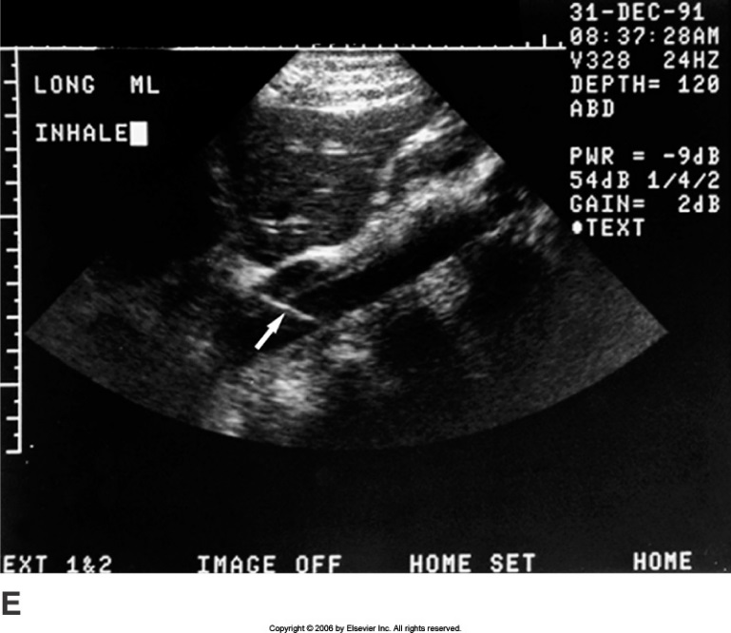

Q17.The arrow in Figure indicates

(1) reverberation artifact

(2) ghost image

(3) section thickness artifact

(4) acoustic enhancement



Q18.Which of the following can cause improper location of objects on a

display *except*?

(1) shadowing

(2) speed error

(3) mirror image

(4) refraction

Q19.The best way to distinguish hepatic veins from portal veins is by

(1) size, the hepatic veins are much small than the portal veins

(2) tracing them to their point of origin

(3) visualizing the pulsations of the hepatic veins

(4) visualizing the wall thickness of the vessels knowing that hepatic

veins have thicker walls

Q20.The arrow in Figure points to

(1) LHv

(2) IVC

(3) RHv

(4) Pv



Q21.You are scanning a patient with a known mass in the left medial

segment of the liver. What anatomical landmark can you use to identify the

left medial segment separate from the right anterior segment of the liver?

(1) left portal vein

(2) ligamentum teres

(3) ligamentum venosum

(4) middle hepatic vein

Q22.A patient is referred for a liver ultrasound with the clinical history of a

raised serum alpha-fetoprotein level. What should you look for?

(1) HCC

(2) fatty liver

(3) gallstone

(4) focal nodular hyperplasia

Q23.You are reviewing lab work prior to performing an abdominal

ultrasound exam. Elevated lab values in GGT and ALP. Which statement is

true?

(1) elevations in both of these lab values is highly specific for HCC

(2) elevation of both ALP and GGT is a sensitive indicator of

Pancreatitis

(3) concomitant elevation of both GGT and ALP indicates the source of

the elevated ALP is the liver

(4) all of the above

Q24.The most common cause of a hyperechoic liver mass on ultrasound is:

(1) Hepatoma

(2) Simple cyst

(3) Hemangioma

(4) Echinococcal cyst

Q25.A patient is referred with right upper quadrant pain and tenderness.

Patient has a history of oral contraceptive use. A solid, hypoechoic mass is

identified in the right lobe of the liver. Color Doppler reveals hypervascularity

of the mass. Which of the following scenarios is most likely?

(1) hepatic lipoma

(2) hepatic adenoma

(3) hepatic abscess

(4) fatty liver

Q26.You are scanning a patient with suspected liver cirrhosis. All of the

following are sonographic features of cirrhosis *except*:

(1) surface nodularity

(2) shrunken caudate lobe

(3) altered echo texture

(4) ascites

Q27.Compare the echogenicities of the following structures and place them

in decreasing echogenic order.

(1) renal sinus > pancreas > liver > spleen > renal parenchyma

(2) renal sinus > liver > spleen > pancreas > renal parenchyma

(3) pancreas > liver > spleen > renal sinus > renal parenchyma

(4) renal parenchyma > spleen > liver > pancreas > renal sinus

Q28.What is the arrow showed at the bottom image?

(1) hemangioma

(2) HCC

(3) metastasis

(4) mirror image

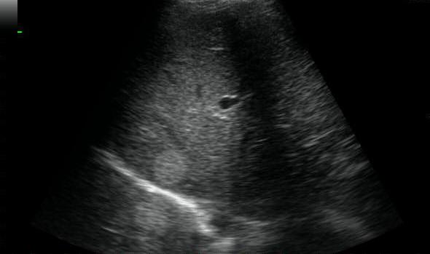

Q29.What is possible diagnosis at the sonography image?

(1) right-side heart failure

(2) fatty liver

(3) HCC

(4) portal hypertension

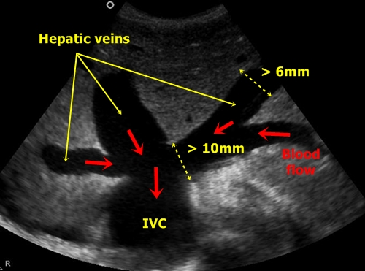

Q30.If the ultrasound beam passes through a fatty tumor within the liver,

and we know that the speed of sound in fat is lower than in soft tissue, where

will this fatty tumor be placed?

(1) further away than it really is

(2) closer than it really is

(3) its true position

(4) all of the above, depanding upon which frequency transducer is

used

Q31.When the gallbladder fundus is folded over on itself, this is referred to

as a

(1) junctional fold

(2) Hartmann’s pouch

(3) phrygian cap

(4) all of the above

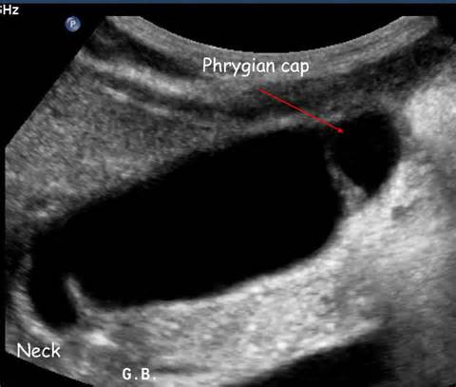

Q32.Name the "sign" associated with a dilated common bile duct. Dilated

Common Bile Duct

(1) Trademark

(2) Too many tubes

(3) Murphy's

(4) Shotgun

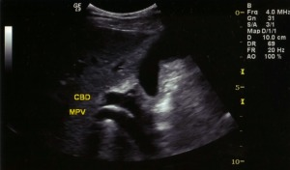

Q33.Direct bilirubin is increased in

(1) extrahepatic Obstruction  
 (2) bile duct obstruction

(3) intrahepatic disruption

(4) all of the above

Q34.Acute cholecystitis is associated with all of the following except

(1) gallbladder wall thickening greater than 3 mm

(2) obstruction of the cystic duct

(3) jaundice

(4) tender enlarged gallbladder (Murphy’s sign)

Q35.Carcinoma of the gallbladder would most likely appear as

(1) thin-walled enlarged gallbladder

(2) small gallbladder with thickened walls

(3) large gallbladder with a halo effect

(4) a diffusely thickened gallbladder with gallstones

Q36.Ultrasound of a 40 year old female demonstrates numerous ring down

artefacts (comet tail artifact) from the gallbladder wall. What is the mostly

diagnosis

(1) gallstone

(2) cyst

(3) carcinoma

(4) adenomyomatosis

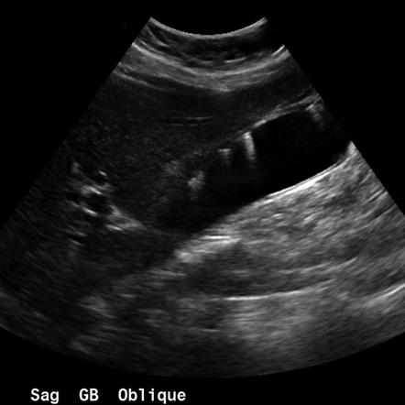

Q37.Choledochal cyst is a

(1) cyst within the gallbladder

(2) focal dilatation of the biliary tree

(3) complication of a pseudocyst

(4) associated with adenomyomatosis

Q38.Nonmobile internal echoes without shadowing in gallbladder could be

(1) gallstone

(2) blood clot

(3) gallbladder sludge

(4) polyp

Q39.Diffuse thickening of the gallbladder wall can be seen with all of the

following *except*

(1) acute cholecystitis

(2) hepatitis

(3) congestive heart failure

(4) elevated portal pressure

Q40.On the transverse sonogram, the common bile duct is located to

the head of the pancreas and lies to the inferior vena cava.

(1) anterior; medial

(2) posterior; posterior

(3) posterior; anterior

(4) anterior; posterior

Q41.High levels of serum amylase may be a result of all of the following

except

(1) liver disease

(2) acute pancreatitis

(3) blockage of the pancreatic duct by a stone within the common bile

duct

(4) pseudocyst

Q42.A 34-year-old male presents with right-upper quadrant pain and

recurrent attacks of pancreatitis. His laboratory values could indicate a(n)

(1) increase in BUN

(2) decrease in serum amylase

(3) increase in lipase

(4) increase in indirect bilirubin

Q43.Which is hyperechoic during scanning pancreas?

(1) acute pancreatitis

(2) adenocarcinoma

(3) pseudocyst

(4) chronic pancreatitis

Q44.Acute pancreatitis may led to all of the following *except*

(1) gallstone

(2) pancreatic pseduocyst

(3) common bile duct obstruction

(4) pancreatic abscess

Q45.A 50-year-old male presents abdominal pain radiating to the back. The

ultrasound image demonstrate all of the following *except*

(1) edema between the pancreas and splenic vein

(2) chronic pancreatitis

(3) acute pancreatitis

(4) dilated pancreatic duct

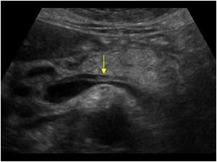

Q46.What structure mat be mistaken for a mass in the head of the

pancreas?

(1)Duodenum (2) portal vein

(3) Riedel’s lobe (4) quadrate lobe

Q47.The arrow in Figure points to

(1) renal cyst

(2) pyramids

(3) calyces

(4)tumors



Q48.The renal sinus echoes are produced by

(1) pelvis and calcyces, renal vessel, fat and areolar tissue

(2) perinephric fat

(3) renal parenchyma

(4) all of the above

Q49.Column of Bertin may be confused with psedotumor. These may be

found

(1) in the cortex surrounding and separating the renal pyramids and

are usually large

(2) in the major calyces as a rudimentary ureter

(3) in the major calyces as a rudimentary calix

(4) outside the renal capsule

Q50.The left renal vein runs

(1) parallel to the portal vein

(2) posterior to the aorta

(3) posterior to the inferior vena cava

(4) between the aorta and the superior mesenteric artery

Q51.The type of renal calculi that may be non-opaque radiographically but

appear as echogenic foci on sonography includes

(1) a calcium oxalate

(2) calcium bilirubinate

(3) cholesterol

(4) none of the above

Q52.While performing an ultrasound examination, the sonographer finds

that both kidneys measure 5 cm in length. They are very echogenic. One

should consider the possibility of all of the following *except*

(1) chronic glomerulonephritis

(2) chronic pyelonephritis

(3) renal vascular disease

(4) renal vein thrombosis

53.This ultrasound image shows increased echogenicity of the renal medulla

(the pyramids are normally hypoechoic to cortex). What is the possible

diagnosis?

(1) renal stone

(2) RCC

(3) medullary nephrocalcinosis

(4) renal abscess

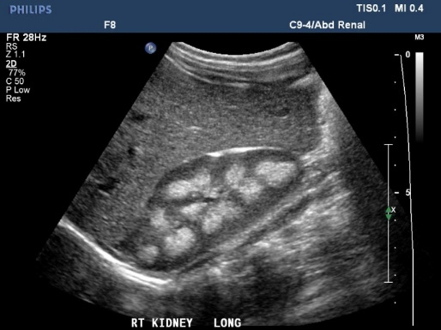

54.A 3-year-old boy presents with hematuria and palpable left flank mass.

Sonography depicts a solid renal mass. This finding would *mostly* likely

represent

(1) hypernephroma (2) Wilm’s tumor

(3) infantile polycystic kidney disease (4) neuroblastoma

55.The possible diagnosis in this abdominal image is

(1) hydronephrosis

(2) ascites

(3) RCC

(4) renal stone

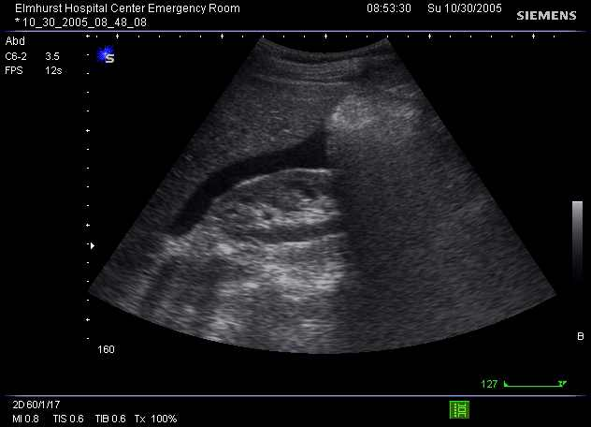

Q56.The best approach for the evaluation of the left kidney is

(1)supine

(2) prone

(3) RAO

(4) coronal

Q57.Anatomic landmarks helpful in locating the left adrenal gland are

(1) aorta, spleen, and left kidney

(2) gastric antrum, left kidney and inferior vena cava

(3) left kidney, spleen, and inferior vena cava

(4) left kidney, left psoas muscle, and left hemi-diaphragm

Q58.The sonographic texture of the normal testis is

(1) heterogeneous with high-intensity echoes

(2) homogeneous with low-level echo

(3) homogeneous with medium-level echogenicity

(4) variable echo pattern

Q59.The possible diagnosis in this image (testes) is

(1) testicular cancer

(2) hydrocele

(3) varicocele

(4) trauma

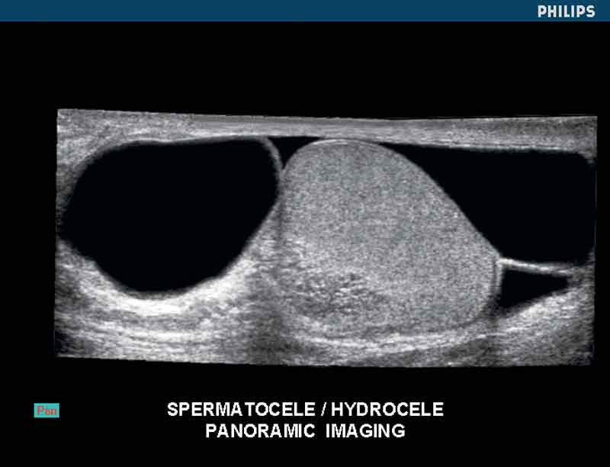

Q60.Which of the following statements regarding the prostate are false?

(1) The size of the prostate is 4 × 3 × 4 cm

(2) The largest zone and the majority of cancers occur central zone

(3) The prostate lies inferior to the seminal vesicles

(4) The prostate lies posterior to the symphysis pubis

Q61.The possible diagnosis from this TRUS images is

(1) BPH

(2) acute prostatitis

(3) prostate calcification

(4) seminal vesicle calculi

[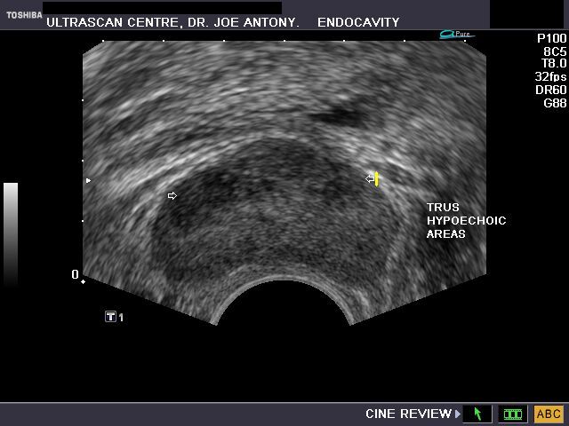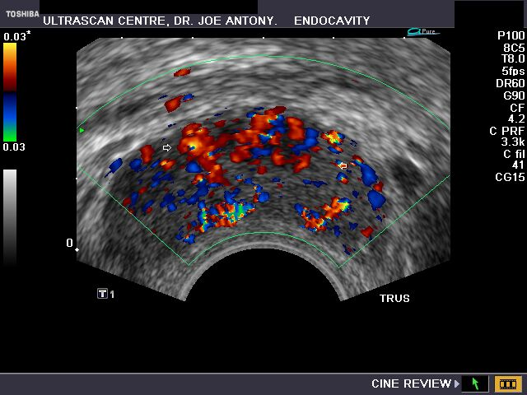](http://www.ultrasound-images.com/prostate.htm)

Q62.Which of the following statements regarding the transrectal scanning

are false?

(1) For transrectal scanning a high-frequency (7 to 10 MHz) linear

array probe is preferred

(2) Transrectal scanning was performed in the lateral position

(3) Patients were instructed to full their bladders before the procedure

(4) Scanning was performed in both the transverse and longitudinal

planes

Q63.Which of the following statements regarding the spleen are false?

(1) a prominent bulge along the medial surface of the spleen can be

seen in normal patients

(2) the normal-sized spleen should not extend caudal to the

midportion of the left kidney

(3) the spleen is a hyperechoic organ

(4) the sonographic texture of the normal spleen is homogeneous

Q64.The best sonographic window to the left hemi-diaphragm is the

(1) spleen

(2) kidney

(3) pancreas

(4) kidney

Q65.What is the possible diagnosis (arrow)?

(1) splenomegaly

(2) splenic infarct

(3) splenic calcification

(4) splenic abscess

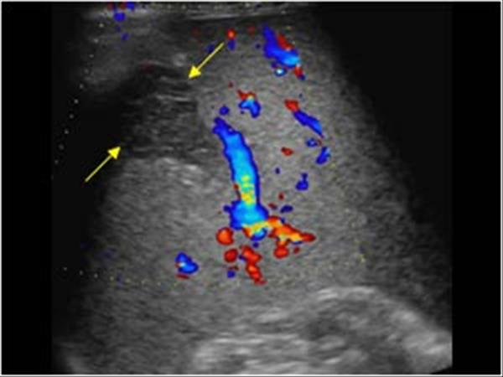

Q66.Cysts of the spleen are

(1) rare

(2) common

(3) of no clinical significant

(4) usually congenital

Q67.A 60-year-old male is suffering from cirrhosis. This spleen ultrasound

image demonstrates

(1) metastasis

(2) splenomegaly

(3) hematoma

(4) splenic abscess

[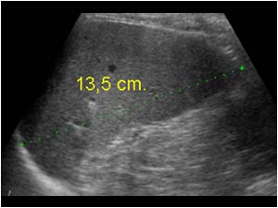](http://www.ultrasoundcases.info/files/Jpg/lbox_19372.jpg)

Q68.Which of the following is *not* retroperitoneal

(1) kidney

(2) aorta

(3) psoas muscle

(4) spleen

Q69.The minimum anterior-posterior diameter for the diagnosis of

abdominal aortic aneurysm is

(1) 1 cm

(2) 2 cm

(3) 3 cm

(4) above 3 cm

Q70.The celiac trunk originates within the first 2 cm from the diaphragm and

immediately branches into all of the following *except*

(1) common hepatic artery

(2) left gastric artery

(3) gastroduodenal artery

(4) splenic artery

Q71.All of the following describe the inferior vena cava *except*

(1) Valsalva maneuver results in a change in the diameter of the

inferior vena cava

(2) it lies immediately anterior to the surface of the spine, to the right

of the aorta

(3) the caliber of the inferior vena cava

(4) it passes through the caval hiatus of the diaphragm to enter the

left artrium

Q72.The possible diagnosis of this obese hypertension patient is

(1) congestive liver

(2) abdominal aortic aneurysm

(3) HCC

(4) CBD stone

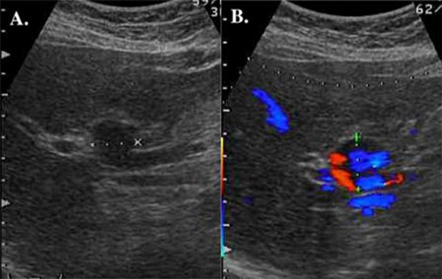

Q73.Anterior displacement of the splenic vein can be caused by

(1) pancreatitis

(2) pseudocyst

(3) left adrenal hyperplasia

(4) aneurysm

Q74.The inferior vena cava increases in diameter superior to the entrance of

the

(1) portal vein

(2) superior mesenteric artery

(3) splenic vein

(4) renal vein

Q75.The gastroduodenal artery supplies the

(1) duodenum, part of the stomach, and the head of pancreas and

arises from the common hepatic artery

(2) small bowel, duodenum, , and the head of pancreas and arises

from the common splenic artery

(3) duodenum, arises from the celiac axis

(4) duodenum, part of the stomach, and the head of pancreas and

arises from the superior mesenteric artery

Q76.Which of the following is typical sign for carcinoma in GI

(1) target sign

(2) hump sign

(3) pseudokidney sign

(4) star sign

Q77.What are the dimensions of the normal appendix as seen on

ultrasound?

(1) 7 cm × 2 cm

(2) 7 mm × 2 mm

(3) 7 inches × 2 inches

(4) None of the above

Q78.Sonographically, the gastroesophageal junction can be visualized

(1) proximal common bile duct

(2) distal common bile duct

(3) common hepatic duct

(4) pancreatic duct

Q79.In order to identify and measure the ovaries, the recommended

technique is

(1) measure length × width × thickness and divide by 6

(2) identify the internal iliac vessels running along the posterolateral

aspect of the ovary

(3) identify the internal iliac vessels running along the anteriolateral

aspect of the ovary

(4) all of the above

Q80.The range of transducer frequencies used in transvaginal sonography

(1) 3.5 to 5.0 MHz

(2) 5.0 to 7.5 MHz

(3) 2.5 to 3.5 MHz

(4) 12 MHz

Q81.What is number 6?

(1) Right lobe

(2) Longus coli

(3) Strap muscles

(4) SCM

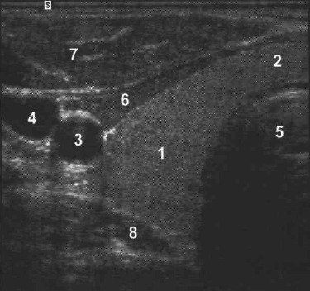

Q82.The position of the parathyroid glands are variable. Most often they are

Located

(1) posterior to the thyroid lobes and medial to the common carotid

Arteries

(2) posterior to the thyroid lobes and anterior to the strap muscles

(3) anterior to the thyroid lobes and lateral to the anterior scalene

Muscles

(4) lateral to the thyroid lobes

Q83.An increased resistivity index (RI) in the common carotid artery may

Indicate

(1) stenotic disease proximal to the sample size

(2) stenotic disease distal to the sample size

(3) disease at the sample site

(4) sample volume placement too close to the arterial wall

Q84.A 58-year-old male had elastography of thyroid. What is possible

diagnosis?

(1) hemorrhagic cyst

(2) thyroid carcinoma

(3) goiter

(4) adenoma

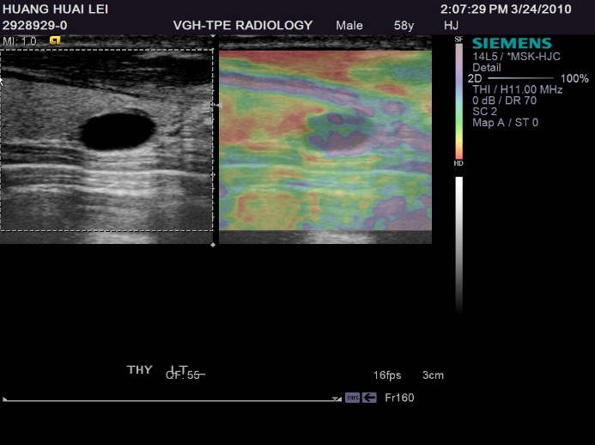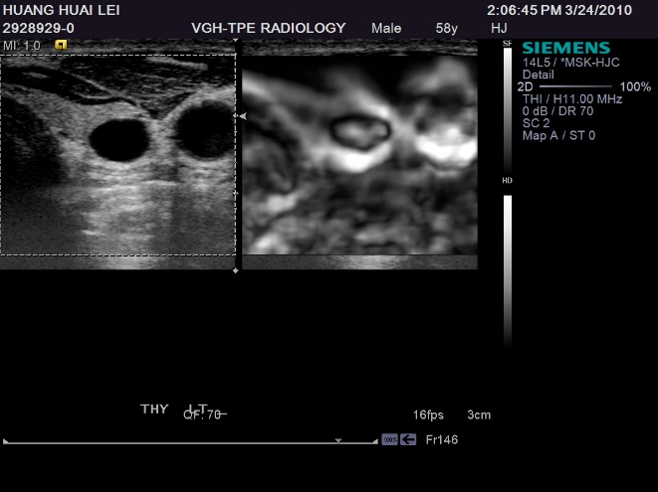

Q85.Enlarged lymph nodes will usually appear sonographically as a

(1) heterogeneous mass with poor through transmission

(2) homogeneous mass with poor through transmission

(3) heterogeneous mass with excellent through transmission

(4) none of the above

Q86.Carotid bruit is heard because of

(1) arteriovenous malformation

(2) disease of the great vessels

(3) audible turbulence localized at the carotid bifurcation

(4) valvular stenosis

Q87.The halo sign as it pertains to thyroid masses is defined as a rim of

sonolucency surrounding an intrathyroidal mass. It is most commonly

encountered in

(1) cyst

(2) carcinoma

(3) thyroiditis

(4) adenoma

Q88.How to perform this normal 3rd and 4th ventricles image?

(1) sagittal

(2) anterior coronal

(3) medial coronal

(4) Using the 4 MHz convex probe

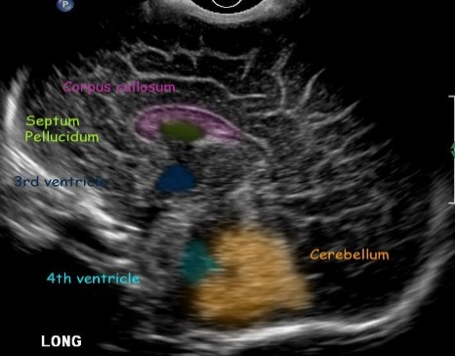

Q89.All the following statements about infantile hypertrophic pyloric

stenosis are true *except*

(1) it causes projectile

(2) it is predominantly a disorder of male infants

(3) the hypertrophied pyloric muscle measures less than 3 mm

(4) it appears sonographically as a target-shaped lesion

Q90.A 6-year-old female child presents with recurrent fever, right upper

quadrant pain, and jaundice. A sonogram showed a 2 cm cyst at medial and

separate from the gallbladder but communicating with CBD. This cystic

structure mostly probably represents

(1) choledochal cyst

(2) a pseduocyst

(3) an aortic aneurysm

(4) a mucocele