1. Which of the following is the highest concept of information?
- Character
- File
- Record
- Item

2. Which of the following combinations is FALSE?
- 8bit ― 256
- 10bit ― 1024
- 12bit ― 2048
- 16bit ― 65536

3. It is a small area of memory in a computer that can be accessed very quickly. What is this?
- Operation memory
- Virtual memory
- Cache memory
- Flash memory

4. What is a basic unit for acquired data from hard disk and fixing different sectors?
- Track
- Cluster
- Cylinder
- Field

5. Are at least several disks necessary to constitute RAID 5?
- 2
- 3
- 4
- 8

6. Which of the following will be inspected autonomously for the first time as soon as booting up a computer?
- RAM
- HDD
- CD-ROM
- FDD

7. Which of the following is NOT a computer operating system?
- Windows 2000
- Windows 7
- UNIX
- HDD

8. Choose the method to deliver Token in Network?
- Bus topology
- Ring totpology
- Mesh topology
- Tree topology

9. Which of the following is a correct terminology for checking whether network is well connected in remote-host or not?
- Telnet
- Ping
- FTP
- Ipconfig

10. Which of the following herb is in Network Management Protocol?
- Dummy herb
- Intelligent herb
- Switching herb
- Full Duplex herb

11. Which is NOT the operating system?
- UNIX
- Windows
- I/O
- iOS

12. Which of the following is network using TCP/IP in application layer of OSI 7 Layer?
- FTP
- UDP
- SNMP
- Ethernet

13. Choose the right explanation of IP Address version 6?
- The length of the address is 32 bits.
- There is no broadcast address.
- IP address is divided into 5 classes.
- The number of address is about 4.3 billion.

14. Which of the following is NOT acquired information through DICOM Header?
- Sex
- Date of birth
- Name of modality
- Address

15. Which of the following is NOT a composition of DICOM Standard?
- PART 2: Conformance
- PART 6: Data dictionary
- PART 8: Security
- Part 14: Grayscale standard display function

16. There is a 14-bit 512 × 512 image. What is the size of image data?
(Only, 512 × 512 = 262144)
  - About 36.7 Kbyte
  - About 367 Kbyte
  - About 45.9 Kbyte
  - About 459 Kbyte

17. It is expressed to DICOM header and matched with delivered information to PACS as a specific value?
- UID
- DIMSE
- SOP
- Accession number

18. Which of the following is needed for the modality when transferring image from modality to server?
  - Query/Retrieve SCU
  - Query/Retrieve SCP
  - Storage SCU
  - Storage SCP

19. What is the following is NOT acquired from DICOM header?
  - sex
  - pixel size
  - Modality
  - the date of image copy

20. Which of the following is the most related when storing the images in DICOM?
- HL7 layer
- DICOM DIR
- Modality SCU
- Modality SCP

21. Which of the following is NOT the photostimulable phosphor of IP?
- BaFCl : Eu²⁺
- BaFBr : Eu²⁺
- BaFI : Eu²⁺
- BaFAg : Eu²⁺

22. Choose image acquisition method which has the most narrow full width at half maximum(FWHM) of Signal Profile.
- CR
- Direct digital radiography
- Indirect digital radiography
- CCD

23. Which of following is NOT a type of imaging data?
- Functional MRI
- Fiber tractography
- Magnetic resonance spectroscopy
- Diffusion weighted MRI

24. What is used for erasing latent image in IP of CR?
- Blue color laser
- White color laser
- Red color laser
- Purple color laser

25. Which of the following is NOT correct as VR(Value Representation) in DICOM?
  - UL
  - DA
  - CS
  - TC

26. Which of the following name is to be divided into each modality in PACS?
- Study UID
- Station name
- AE title
- SOP instance UID

27. What is the element to convert X-ray to electric signal directly?
- a-Si
- a-Se
- CsI(Cesium Iodide)
- Gallium Arsenide

28. If a storage device is constructed by using five 750GB disks, which of the following represents the highest capability?
  - RAID 0
  - RAID 1
  - RAID 3
  - RAID 5

29. Which of the following patterns is the name of the test pattern below?

- TG18-LN
- TG18-UNL80
- TG18-BN
- TG18-CX

30. What is a media which mainly composes of Short-Term device?
  - DISK array
  - DVD
  - MOD
  - TAPE

31. Which is a luminometer?

１) 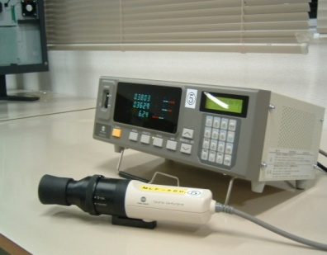 2) 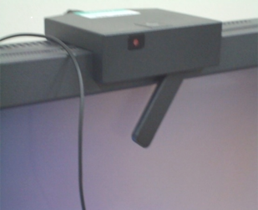
３) 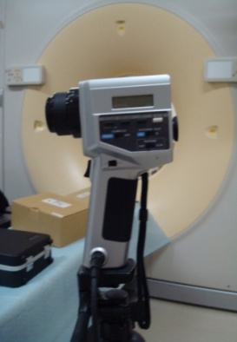 4) 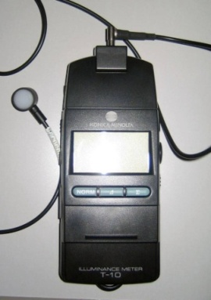

32. These images are for monitor performance test. What is indicated from L1 to L5 by assessment?
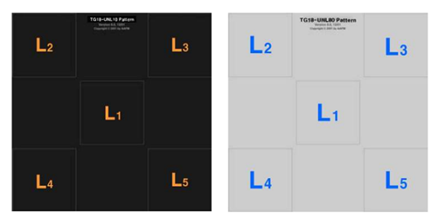
1) Luminance uniformity
2) Accumulated time of use
3) Geometric distortion
4) Gradient changes

33. Which of the following is a sharing technique for storage between Unix and Window System?
  - SAN
  - NAS
  - SAMBA
  - RAID

34. This is a diagram of DICOM Modality Work list. Fill the blank!
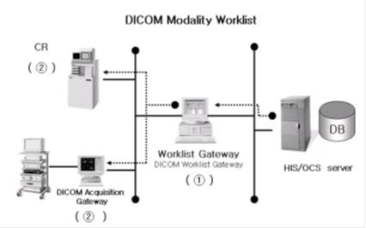
  - ① DICOM Worklist SCP ② DICOM Worklist SCP
  - ① DICOM Worklist SCU ② DICOM Worklist SCU
  - ① DICOM Worklist SCP ② DICOM Worklist SCU
  - ① DICOM Worklist SCU ② DICOM Worklist SCP

35. What does this image represent?
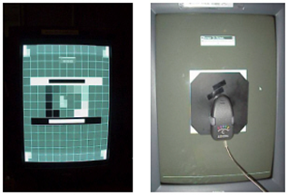
  - Illuminator calibration 2) Virus checking
    - Monitor calibration 4)Server checking
36. Which of the following elements ➀-➃ in the diagram below would be used for crosstalk judgment?
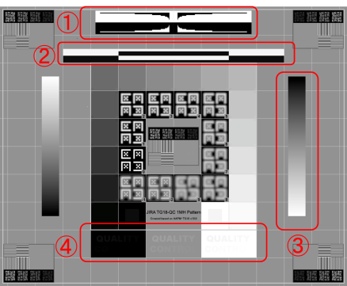

1) ➀
2) ➁
3) ➂
4) ④

37. Which is the following is the most related to sharpness in medical image quality evaluation?

  - NPS
  - DQE
  - ROC
  - MTF

38. Which of the following phantom is applicable to X-ray fluoroscopy device?

  - ACR
  - AAPM
  - NEMA
  - Catphan

39. When the pixel size is 250µm, what is the spatial resolution?

1) 1.0 lp/mm
2) 1.5 lp/mm
3) 2.0 lp/mm
4) 2.5 lp/mm

40. What are software and hardware that make it possible to compress and decompress?
  - Codec
  - Encoding
  - Decoder
  - Encoder
41. What is the process that converts continuous signal to discrete signal?
  - Scanning
  - Sampling
  - Quantization
  - Coding

42. Which of the following is NOT an influence on MTF?
1) Tube voltage
2) Focus size
3) Source-Image Distance (SID)
4) Pixel size

43. What does 5 lp/mm mean?
  - Black 5 lines in 1mm
  - 5 pixels in 1mm
  - 10 level gray scale in 1mm
  - 10 pixels in 1mm

44. This sever is able to connect directly to the images by internet regardless of computer or operation system. What is this?

1) DB server
2) Web server
3) UNIX server
4) NT server F-3-1 middle

45. In which quadrant is conducted frequency processing in EDR Characteristic Curve of CR image?

  - 1 quadrant
  - 2 quadrant
  - 3 quadrant
  - 4 quadrant

46. Choose the appropriate window setting in Chest X-ray.
  - Set the window level to bone and broaden the window width.
  - Set the window level to soft tissue and narrower the window width.
  - Set the window level to bone and narrower the window width.
  - Set the window level to soft tissue and broaden the window width.

47. Which of the following is NOT a parameter for a high quality 3-dimentional image?
1) Sufficient slice number
2) High matrix size
3) Wide z-axis resolution
4) Decrease of breath and move artifacts

48. What is the method of global operation in image processing?

  - histogram processing
  - window setting
  - Low pass filtering
  - Fourier Transform

49. What kind of image compression algorithm is used for supporting Wavelet transform?

  - MPEG
  - JPEG 2000
  - Motion JPEG
  - JPG

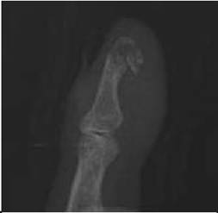
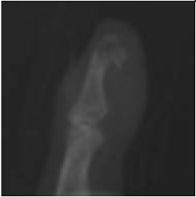
50. Following images are before and after filtering images. What kind of kernel is used?

1) 2)

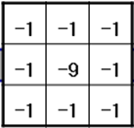
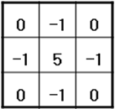
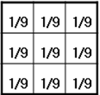
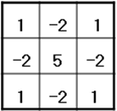
3) 4)

51. Which is this image processing technique called?

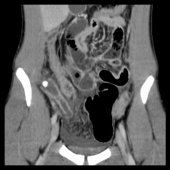

  - SSD (Shaded surface display)
  - VRT (Volume rendering technique)
  - MPR (Multi planner reformat)
  - Virtual endoscopy

52. Choose the compression method which is the most rarely destroyed of copy work?
  - Run-Length compression
  - Cosine transform coding
  - Wavelet transform coding
  - Truncation coding

53. What is this 3-dimentonal image processing technique called?
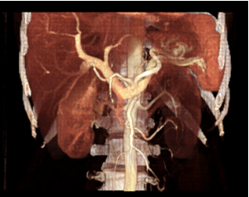

1) SSD (Shaded surface display)
2) VRT (Volume rendering technique)
3) MPR (Multi planner reformat)
4) Virtual endoscopy

54. Which is the part of the security profile of DICOM?

1) Part 1
2) Part 5
3) Part 10
4) Part 15
55. What is the TAG to know the compression method of DICOM file?

  - file meta information version (0002, 0001)
  - media storage SOP class UID (0002, 0002)
  - transfer syntax UID (0002, 0010)
  - SOP instance UID (0008, 0018)

56. What is the most proper compression method when compress the dual structure document like laboratory report of patient information?

  - JPEG
  - G3/G4
  - motion JPEG
  - MPEG

57. What is the displaying method a mix of red, green, blue colors of light on color display such as television or computer?
  - RGB
  - Composite
  - NTSC
  - Super-VHS

58. Which of following method is used for feature that each connection frame does not have big difference during recording pixel in prediction compression technique?

1) DCT (Discrete cosine transform)
2) DPCM (Difference pulse coded modulation)
3) PCM (Pulse coded modulation)
4) Wavelet transform

59. Which is NOT a kind of connection relation data base Management System (RDBMS)?

  - IBM DB2
  - SYBASE
  - Oracle
  - O2

60. Consider input A is 0 and input B is 1, which of the following outputs is 0?

1) A AND B
2) A OR B
3) NOT A
4) A XOR B

61. Which is the right IP address?

1) 140.124.3
2) 140.35.14.6.3
3) 258.24.38.166
4) 168.95.7.21

62. Which of the following is NOT a function of an operating system?
1) Effective use of hardware resources
2) Reduction of the burden of application software development
3) Support of computer operation and management
4) Power activation

63. Which of the following is about security and management of personnel information by American law?
1) DICOM
2) HIPPA
3) IHE
4) HL7

64. Which of the following is NOT correct about PACS data?
  - PACS data is divided into image and database information.
  - Database Information is larger than DICOM image.
  - Database information contains organized index value, patient information, examine information of DICOM image .
  - Most of image information is stored as file type.

65. A malicious program whose aim is to replicate itself to spread to other computers through networks and has a strong reproductive ability. What virus type is it?

1) Trojan horses
2) Worms
3) Macro
4) Mutation

66. Which of the following has service of various image data in workgroup after connecting server and SCSI or fiber channel?

  - NAS(Network Attached Storage)
  - Disk array
  - Gigabit ethernet
  - HL7(Health Level 7)

67. In the data element structure of DICOM data, which is TRUE?

1)（0008，00010）
2)（001，001）
3)（7FE0，0010）
4)（00K5，0001）

68. Which is the netmask of 202.13.180.0/24?

1) 11111111.11111111.11111111.00000000
2) 00000000.11111111.11111111.11111111
3) 11001010.00001101.10110100.00000000
4) 11001010.00001101.10110100.11010010

69. Which of the following is representing the monitor size?

A
B
C

1) Length of C
2) Length of A × B
3) Length of A + B
4) Length of A + B + C

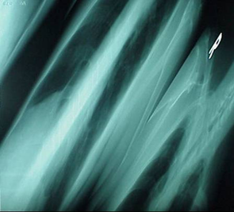
70. What is this error image meant?

  - CR error
  - IP scratch error
  - Compression error
  - DB connect error

71. Which of the following is NOT consideration of image acquisition device?

  - Network interface
  - DICOM
  - Short-Term storage connection
  - Workstation resolution

72. Which of the following explanation is NOT correct about CRT monitor?
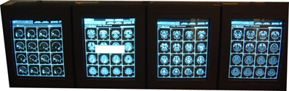
  - It is mostly used in clinic.
  - It provides high quality resolution.
  - It makes a lot of heat.
  - It makes possible to observe minute leision.

73. Which of the following is NOT DICOM Message Service Element(DIMSE)?

  - C-store
  - C-get
  - N-store
  - N-get

74. Which of the following definition is NOT correct in medical image field?

  - PACS - Picture Archiving and Communication System
  - CAD - Computer Aided Design
  - CAS - Computer Aided Surgery
  - MDCT - Multidetector-row Computed Tomography

75. After handling image A, it became image B. Which filter did you use?

Image A ImageB
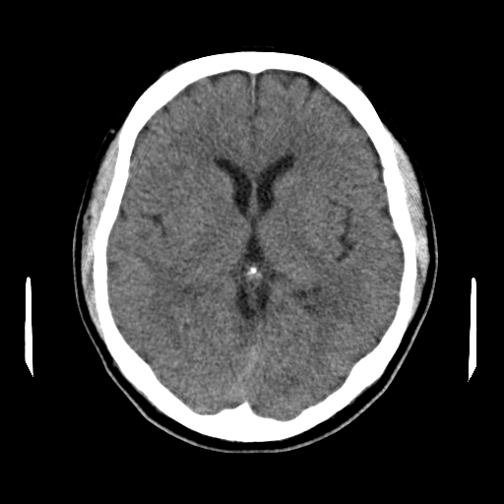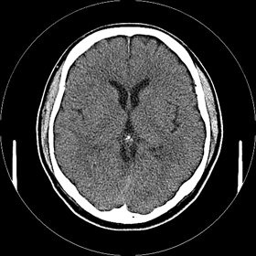
－1
－1
－1
－1
－1
－1
－1
－1
10
1
1
1
1
1
1
1
1
１
－1
－1
０
０
1
1
1
－1
０
０
－1
1
－1
1
０
－1
1
０
1)

2)

3)

4)

76. Which of the following is NOT necessary for connection modality worklist?

  - Examination information
  - Reading information
  - Patient information
  - Prescription information

77. What is the terminology of required time when it starts to store or read data in storage device?

  - Idle time
  - Run time
  - Access time
  - Seek time

78. This compression technique is suitable for the application of telemedicine and proposed to solve the cosine transform limitations. What is this?

1) JPEG
2) MPEG 4
3) Wavelet compression
4) Run-Length compression

79. Which of the following defines resolving limit and resolving power in terms of imaging?

  - Nyquist frequency
  - Furier transform
  - Coltman
  - Aliasing error

80. What is the procedure or standard about what, when, how to network between entities?
  - Interface
  - Protocol
  - Procedure
  - Timming
81. Which of the following is NOT correct about HL7?
  - It is a international standard for exchanging information between medical information systems.
  - It is a transmission standard in medical information field which is used world widely.
  - It is a open standard which is developed by information developer, etc together.
  - It is a regulation of data transmission which is utilized in order to connect different types of image information devices using network firstly used in RSNA(Radiological Society of North America).

82. When the pixel size of diagnostic monitor is 2 Mega, what is the resolution?

  - 1024 × 2048
  - 1600 × 1200
  - 2048 × 1536
  - 2048 × 2560

83. Which of the following standard is NOT used in PACS?
  - HIS(Hospital Information System)
  - HL7(Health Level 7)
  - IHE(Integrating the Healthcare Enterprise)
  - DICOM(Digital Imaging and Communication in Medicine)

84. What header information is described in following image?
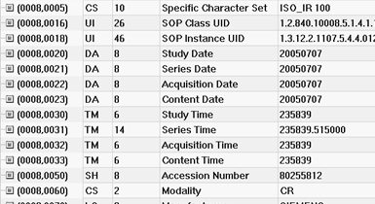
  - PACS
  - HL7
  - IHE
  - DICOM

85. Which of the following method is NOT digitizing film?
  - DICOM gateway
  - Modality worklist
  - Film digitizer
  - Backup

86. Which of the following consideration is NOT included to operate PACS?
  - A measure of obstacle management
  - PACS security
  - PACS manufacture progress
  - Actual image quality problem

87. Which of the following is NOT included Hub?
1) Dummy
2) Intelligent
3) Switching
4) Full Duplex

88. What is the technique when one of servers come up with problems, it doesn't make any problem because other servers make role of its job in compensation?
- clustering
- SAN
- DAS
- NAS

89. Following image is a fusion image of PET and CT. What image processing technique is used?
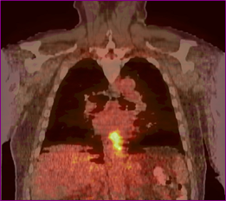
  - Pseudocoloring 2)Registration
- Rendering 4)Subtraction

90. Which of the following is NOT a characteristic of a computer virus?

  - Self-infectious ability
  - Latent ability
  - Onset ability
  - Immune generative ability

