2014 MRSM

Q1.Which of the following is included in the development of hypothesis among 4 steps of Quality Improvement?

1. The step to decide what to improve
2. The step to know discovered problems or understand improve opportunity in detail
3. The step to find that which changes will connect improvement
4. The step to verify hypothesis to assure solution presented whether improve expected results.

Q2.This technique was developed in 1930 and be used currently. Which of the

following is the gradual approaching method to obtain the goal effectively to set up

the goal, facilitate the improvement process, take actions, and evaluate and maintain?

1. CPDA
2. DAPC
3. PDCA
4. ACPD

Q3.Which of the following is not concerned with Quality Assurance?

1. 6sigma
2. Quality Plane Treatment
3. Total Quality Management
4. Continuous Quality Improvement

Q4.Choose the answer that does NOT correctly describe a regular inspection.

1. Regular inspection shall take time to cover the items that are not covered by daily inspection.
2. Inspection items shall be determined as necessary according to the modality.
3. Regular inspection can be delegated to the manufacture under a maintenance contract.
4. The user shall conduct a regular inspection to control quality by setting a certain interval for each item.

Q5.Which consideration of the following is not true in brain storming?

1. Handle the subjects in inclusive concept
2. Begin with setting the time of brain storming
3. Arrange the list and plan for performing
4. Giving the time for establishing their own opinions to participants.

Q6.What is the reason of a quality change?

1. difference of knowledge and skill
2. difference of process
3. difference of expense
4. patient’s risk

Q7.Choose the answer that correctly describes the mammographic X-ray equipment.

1. The heel effect of the X-ray tube is not utilized.
2. Aluminum is used at the radiation aperture.
3. Molybdenum is used for the additional filter.
4. A focus size with a nominal large focus of 1.0 mm is used.

Q8.Which is the following is correct about 4 steps of quality improvement?

|  |
| --- |
| A) Discovery of a problem  B) Analysis of a problem  C) Development of hypothesis  D) verification and action |

1. A→B→C→D
2. A→B→D→C
3. A→C→B→D
4. A→C→D→B

Q9.Next following is the important reason of equipment management. Choose the incorrect answer.

1. need an effort that follow recommendation on international organization such as ICRP
2. There is no meaning if the thing needs lots of expense and effort.
3. The most important thing is constituents’ spontaneous effort.
4. have to aware it is important key to be a good result

Q10.Which is right about the proper average glandular dose in one exposure for a

mammography?

1. 1.5mGy and below
2. 2.0mGy and below
3. 2.5mGy and below
4. 3.0mGy and below

Q11.What is the quality measurement item using this test tool(Star test pattern)?

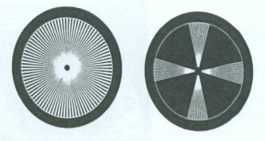

1. mALinearity
2. Focal spot test
3. Kvp accuracy
4. mAs reciprocity

Q12.The minimum HVL for x-ray units operating at 80kVp is ------------mm of aluminium

1. 1.3
2. 1.8
3. 2.3
4. 2.8

Q13.Choose the answer that does NOT correctly describe grids.

1. The exposure factor increases with increasing grid ratio.
2. The size of the exposure field affects the content of scattered X-rays.
3. The gird ratio is the ration between the height of lead strips and the distance between them.
4. The degree of grid contrast improvement is expressed by the reciprocal of total X-ray transmittance.

Q14.Which is right about phantom that is used to measure the MTF in the

fluoroscopy device?

1. Burger-Rose
2. Slit camera
3. Resolution
4. Start test

Q15.The maximum variability allowed for the reproducibility of exposure is ± ---------- %

1. 2
2. 5
3. 10
4. 15

Q16.Each step on the density selector switch on an AEC system should change the exposure by this range:

1. 10% to 20%
2. 25% to 30%
3. 35% to 40%
4. 45% to 50%

Q17.The indicated level of the tomography section and the actual level of the section must correspond to within is ± ---------- mm

1. 2
2. 5
3. 10
4. 15

Q18.What is the purpose of these tools in quality measurement of diagnostic X-ray generator?

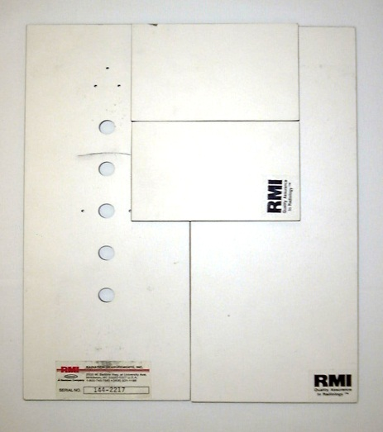

1. Grid alignment test
2. AEC(Automatic Exposure Control) reproducibility test
3. HVL(Half Value Layer) test
4. Timer accuracy test

Q19.Which of the following is the right answer about next figure?

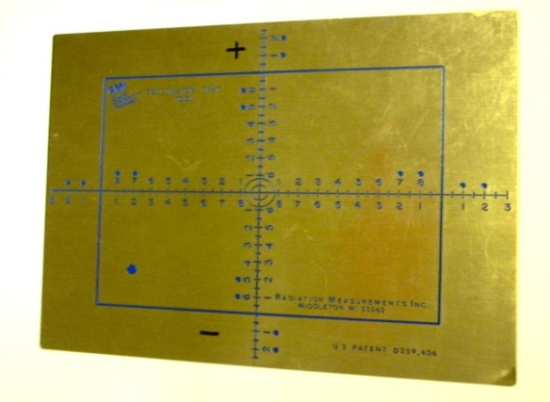

1. Star test phantom using at focal spot test
2. Beam alignment test tool
3. collimator template using at Beam alignment test
4. Bucky tray

Q20.What is the purpose of grid?

1. resolution
2. sharpness
3. density
4. contrast

Q21.What is the right answer about the following statement?

|  |
| --- |
| * Provision of same density of image information without any relationship with wide range of kVp and patient’s thickness * Preservation mA and kVP, reappearance of light field and controlling exposure by changing of light field * The machine to control an exposure time by object’s thickness |

1) Generator

2) HVL(Half Value Layer)

3) AEC(Automatic Exposure Control)

4) Timer

Q22.Next feature is a tool for quality management in diagnostic X-ray generator. What is a name?

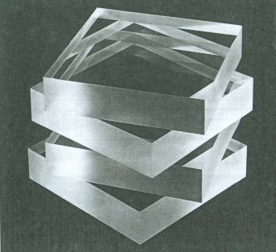

1. Grid alignment test KIT
2. AEC(Automatic Exposure Control) Phantom
3. HVL(Half Value Layer) attenuator
4. Test phantom for timer correctness

Q23.Which is NOT right about DAP?

1. It is mainly used in the fluoroscopy device.
2. DAP is attached on the front side of an iris, where an additional filter is attached.
3. A rear dispersion coefficient is included.
4. If the SOD changes, the value of DAP measurement changes too.

Q24.How much is the limitation of leakage dose of X-ray tube in the distance of 1 m?

1. 10mR/min
2. 10mR/hr
3. 100mR/min
4. 100mR/hr

Q25.How much is the absorber thickness for resolution pattern using in fluoroscope?

1. 0.01mmPb
2. 0.05mmPb
3. 0.1mmPb
4. 0.2mmPb

Q26.What is reasonable SID (Source-Image receptor Distance) in Mammography?

1. 55 cm
2. 65 cm
3. 75 cm
4. 80 cm

Q27.Which of the following measure using Burger-Rose phantom?

1. low contrast
2. Sharpness
3. MTF
4. RMS

Q28.What is the filtration that absorption of radiation at collimator, X-ray tube, tube

housing, filter assembled X-ray tube, and insulating oil? [express lowest aluminum

equivalent for highest kVp]

1. additional filtration
2. duplicate filtration
3. characteristic filtration
4. load filtration

Q29.Choose the incorrect answer about Dose area product(DAP).

1. Use at radio-fluoroscopic equipment
2. mounting site is the part of the front side of collimator.
3. it contains back scatter factor.
4. DAP value changes through SOD.

Q30.Which of the following is true score of the fake lesion in these mammographic images?

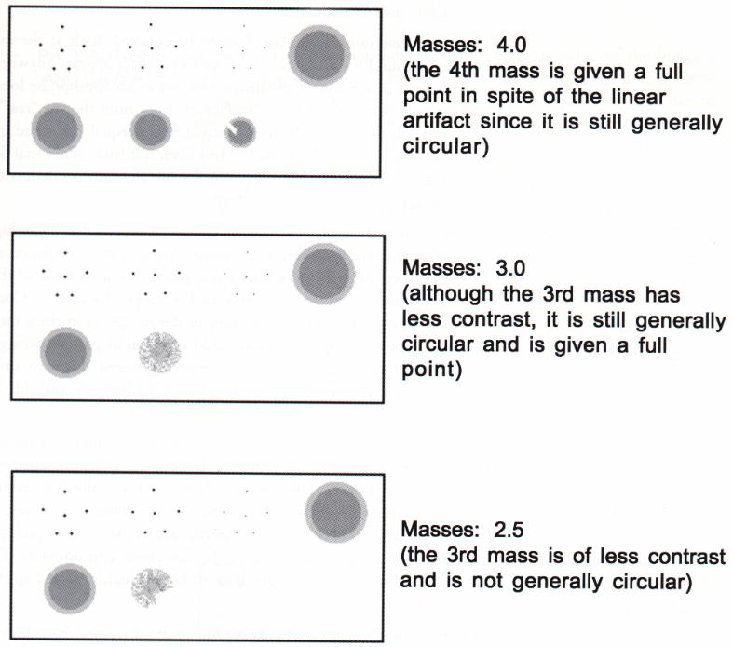A.

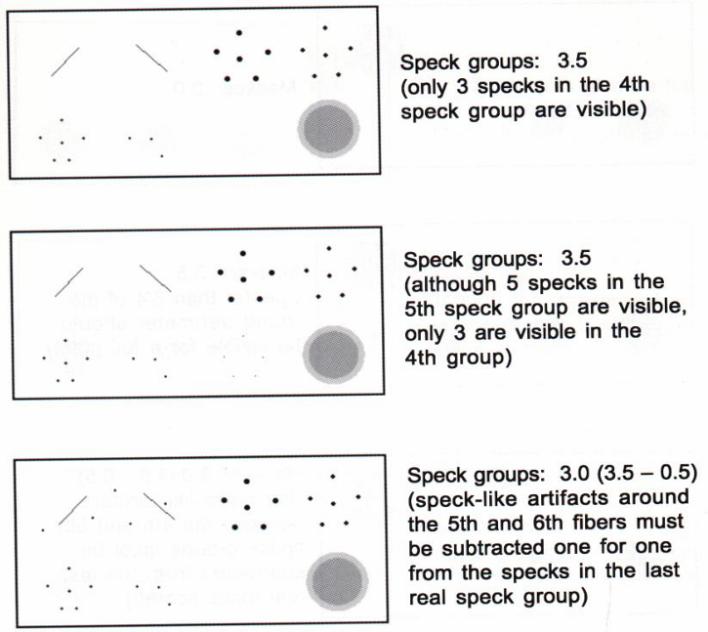

B.

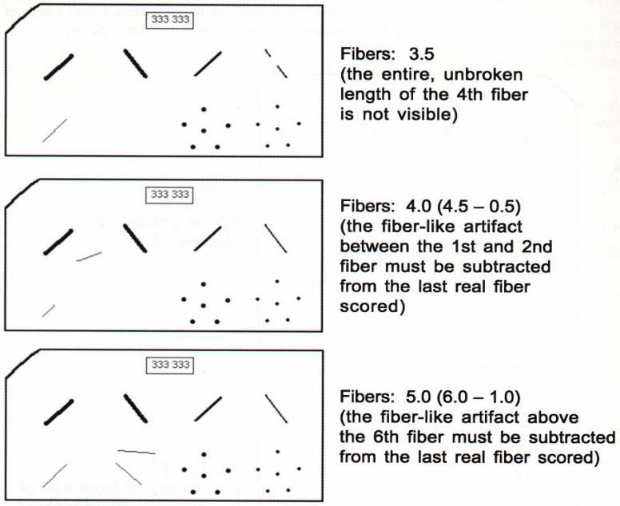

C.

1. mass 4 point speck 3.5 point fiber 5 point
2. mass 3.5point speck 4point fiber 4.5point
3. mass 4point speck 5point fiber 5.5point
4. mass 3.5point speck 3.5point fiber 6point

Q31.Which of the following test is true with a main purpose that is the bad pixel verification at an item of weekly check in quality management of DR mammography?

1. MTF
2. DQE
3. Flat Field Test
4. SNR & CNR

Q32.Choose the right answer about a standard value of resolution when we take an image of a resolution chart with 4.5 cm upon the film in resolution test for finding a microscopic calcification in mammography.

1. 3 line pairs/mm or more
2. 5 line pairs/mm or more
3. 7 line pairs/mm or more
4. 11 line pairs/mm or more

Q33.What is this CT image for?

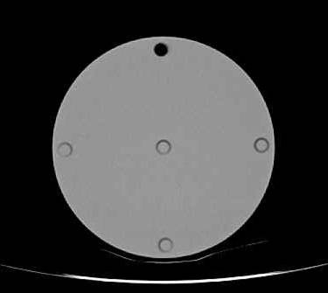

1. uniformity
2. contrast resolution
3. spatial resolution
4. Computed Tomography Dose Index(CTDI)

Q34.What do we figure out from this image?

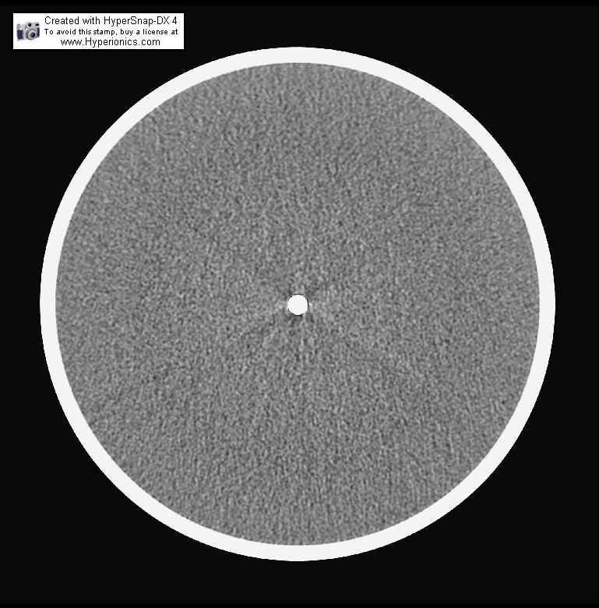

4cmⅹ4cm

* 1. Noise
  2. Artifact
  3. CT number
  4. Uniformity

Q35. What do we figure out from this image?

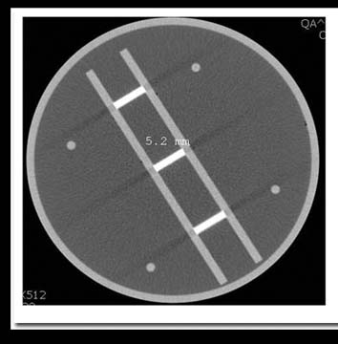

* 1. noise
  2. uniformity
  3. slice thickness
  4. artifact

Q36.How much is CTDI value when a monitor displays 10 mR in single slice scan with 120 kVp, 340 mAs, and 10 mm thickness for dose measuring?

1. 78 mGy
2. 7.8 mGy
3. 10 mGy
4. 20 mGy

Q37.Which is right as the CT dose index of a patient’s CT radiation exposure?

1. mR/100mAs
2. mSv/100mAs
3. mGy/100mAs
4. kV×mAs

Q38.How much difference has CT number between A and B at the image for the

contrast resolution?

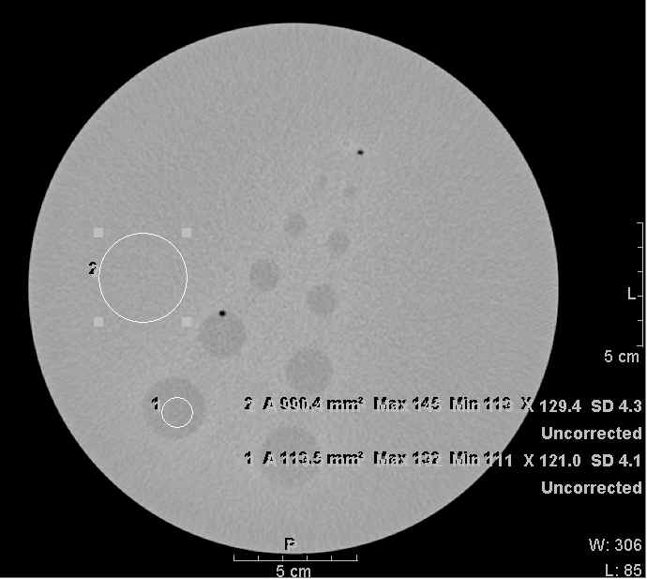

1. 10 HU
2. 15 HU
3. 30 HU
4. 50 HU

Q39.Which effect is true about inhomogeneity of CT number from characteristics of

X-ray in an object in Computed Tomography?

1. Beam hardening effect
2. Cupping effect
3. Partial volume effect
4. Photon effect

Q40.How much is the discriminable range of spatial resolution in the test of CT

standard phantom?

1. above 0.6 mm
2. below 0.8 mm
3. below 1.0 mm
4. below 1.2 mm

Q41.What is the recommended limit of magnetic field strength for cardiac pacemaker

inserted person in MRI examination room?

1) 0.5 gauss

2) 5 gauss

3) 10 gauss

4) 50 gauss

Q42.Which of the following is different with their character from international standard system in MRI quality management?

1. AAPM standards
2. ACR
3. NEMA standards
4. MDD evaluation Report

Q43.MR examination is generally accompanied by a very large noise. Choose the type of coil that leads to noise reduction when plan placed in a vacuum.

1. Body coil
2. Phased array coil
3. Gradient coil
4. Magnetostatic coil

Q44.Which of following is not measurement item of MRI phantom image?

1. linearity
2. contrast resolution
3. accuracy of slice thickness
4. percent ratio of ghost signals

Q45.What is this image for?

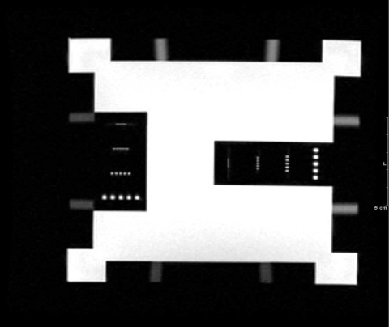

1) spatial resolution

2) linearity

3) uniformity

4) slice thickness

Q46.The acoustic noise from MRI equipment is caused by repetitive interaction of electro-magnetic field and gradient magnetic field. This phenomenon causes accidental loss of hearing by reason of big and short noise. How much level is maximum sound pressure (dB)?

1. 95 dB
2. 100 dB
3. 70 dB
4. 140 dB

Q47.Choose the allowance error range of geometrical accuracy in a phantom image in MRI?

1. ± 5mm
2. ± 3mm
3. ± 4mm
4. ± 10mm

Q48.The next figure is an image about accuracy of slice thickness. If it is disqualified,

what is the reason?

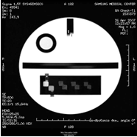

1. Slice region setting error
2. Table moving error
3. Gradient calibration or uniformity of main magnetic field badness
4. Eddy current correction failure

Q49.The next figure is an image about accuracy of slice thickness. Which of the following is suitable for the passing range of a difference of distance at a tip of the arrow?

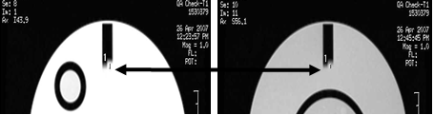

1. 5mm or below
2. 5mm or more
3. 6mm or more
4. 7mm or more

Q50.This image is about the inspection for transducer. Which of following can be said about this?

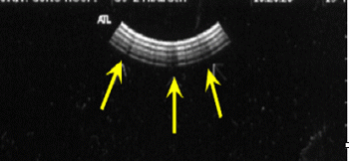

1. it is main bang effect.
2. it is about crystal defect check.
3. it is about inspection of cables.
4. this inspection is for checking that the rubber has a gap.

Q51.Which of following is not true about receiver function?

1. Amplification(Gain)
2. Compensation(T.G.C)
3. Rejection
4. Converting TV signal

Q52.We obtain the image through the medical video processing devices because of different kinds of images. What is the image processing device at this time?

1. PACS
2. Gateway
3. Petamotion
4. DICOM

Q53.Which of following is not true about transducer check?

1. check the rubber has a gap
2. check on crystal defect
3. freeze after scan
4. sterilize with heat for disinfection of probe

Q54.Which of the following tests does not need to be performed routinely as part of a quality assurance program?

1. Uniformity
2. Distance
3. Axial resolution
4. Maximum depth of visualization

Q55.Which of the following is not correct about a check point after scan ultrasound equipment?

1. checked the probe lens
2. verified a defect of the cable cover of the probe
3. leaved a gel on the probe
4. Arranged the cable of the probe

Q56.Which of the following is not correct about the character of standard phantom (ATS-539)?

1. Estimate the accuracy of ultrasound equipment and accomplishment skill
2. It is same acoustic character to human tissue.
3. Rubber-based tissue-mimicking material (acoustic velocity: 1450m/s±1.0 at 23˚)
4. Attenuation Coefficient is 0.7dB/cm/MHz±5%

Q57.Which of the following is not correct about the maintenance method of standard phantom (ATS-539)?

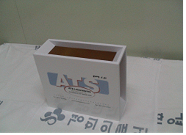

1. keep the phantom at room temperature cleanly for the largest result
2. It may not leave dried gel upon scan surface.
3. Phantom have to be clean by warm water and a fabric without nap.
4. clean a dirtiness that cannot clean easily with a petroleum solvent

Q58.Which of following is not included in radiation survey about acceptance test of Linear accelerator?

1. outside of the treatment room
2. inside of the treatment room
3. the outside wall of the treatment room
4. head leakage

Q59.What is the related QA procedure to the following items?

- Gantry angle indicator

- Collimator angle indicator

- Optical distance indicator

- Field size indicator,

- Laser alignment at the Isocenter

1. Jaw symmetry test
2. Accuracy of Radiation out-put
3. Mechanical accuracy test
4. Equipment accuracy test

Q60.What are the correct measurement result and the tolerance level in the items of

photon beam QA as following image?

설명: 그림1

1. Flatness – 2% 2) Flatness – 3%

3)Symmetry – 2% 4)Symmetry – 5%

Q61.What is the item of Quality Control for radiation treatment devices in this picture?

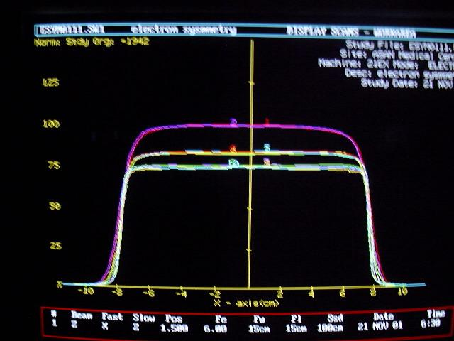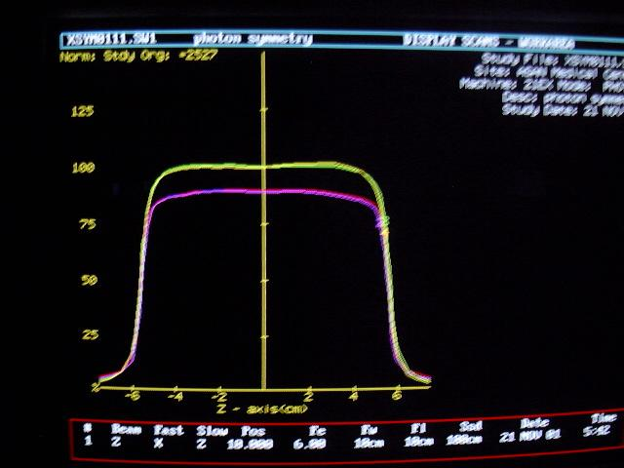

1. PDD
2. Energy
3. Symmetry, Flatness
4. TMR

Q62.What is the correct explanation about image (1) and (2) ?

그림4(1) 그림3 (2)

1. image (1) is Gantry rotation isocenter check

image (2) is Collimator rotation isocenter check

1. image (1) is Collimator rotation isocenter check

image (2) is Gantry rotation isocenter check

1. image (1) is Couch rotation isocenter check

image (2) is Collimator rotation isocenter check

1. image (1) is Collimator rotation isocenter check

image (2) is Couch rotation isocenter check

Q63.Which is the acceptable limitation of X-ray output constancy for Linac?

1) 1%

2) 2%

3) 3%

4) 5%

Q64.Which QA procedure is related these images?

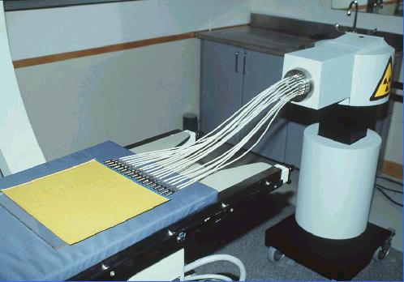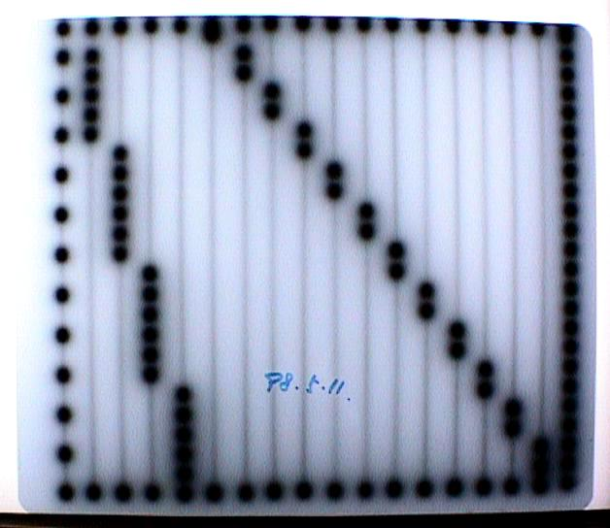

1. Source Dwell Position Check
2. PDD & TMR
3. Symmetry, Flatness
4. Collimator cross hair line

Q65.What do we check from this image ?

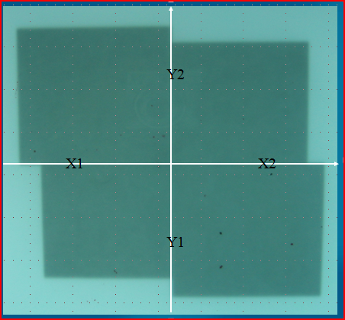

* 1. Monitor chamber linearity
  2. Jaw Symmetry
  3. Collimator rotation isocenter
  4. Collimator cross hair line

Q66.Which of the following is true about measuring method for radiochemical purity of a labeled compound?

1. HPLC (High performance liquid chromatography)
2. radio-Gas chromatography
3. radio-Thin layer chromatography
4. enzyme assasys

Q67.Next figure is an image for uniformity. Choose an incorrect answer?

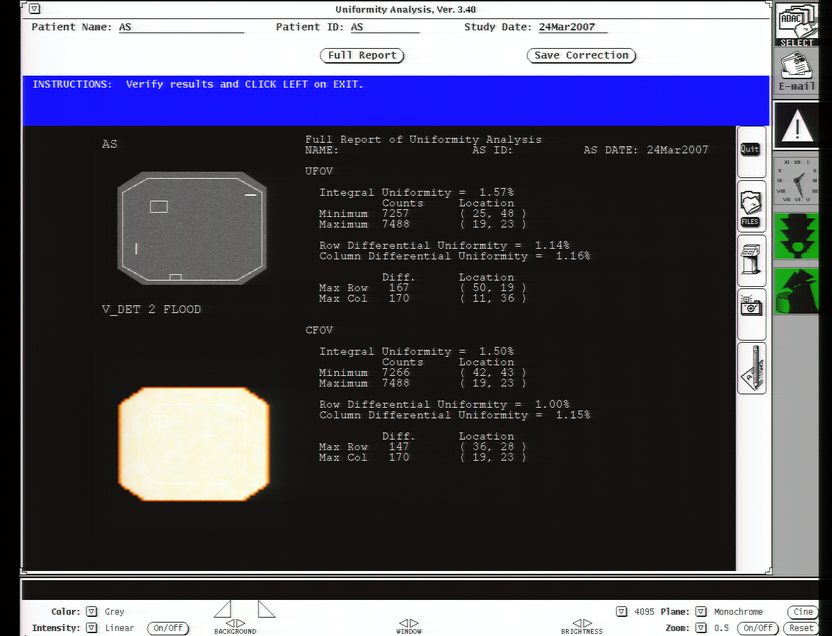

1. Acquire an image using 57-Co sheet source.
2. 57-Co has 122keV energy and 271days half-life.
3. UFOV calls effective visual field and CFOV calls central visual field.
4. The loss of uniformity is due to the image artifact from a defect of scintillator and collimator, lens’ uncleanliness, excessive dust in the air, and a crack of screen of CRT.

Q68.Which is the following is correct about next figure?

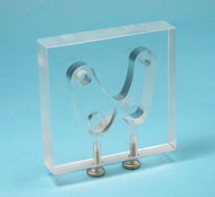

1. It is the specimen of thyroid tissue.
2. It is neck phantom.
3. It is thyroid phantom.
4. It is kidney phantom.

Q69.Next figure is a subsidiary tool for a part of NEMA(National Electrical Manufacturer’s Association) test. What kind of feature do we want to acquire? 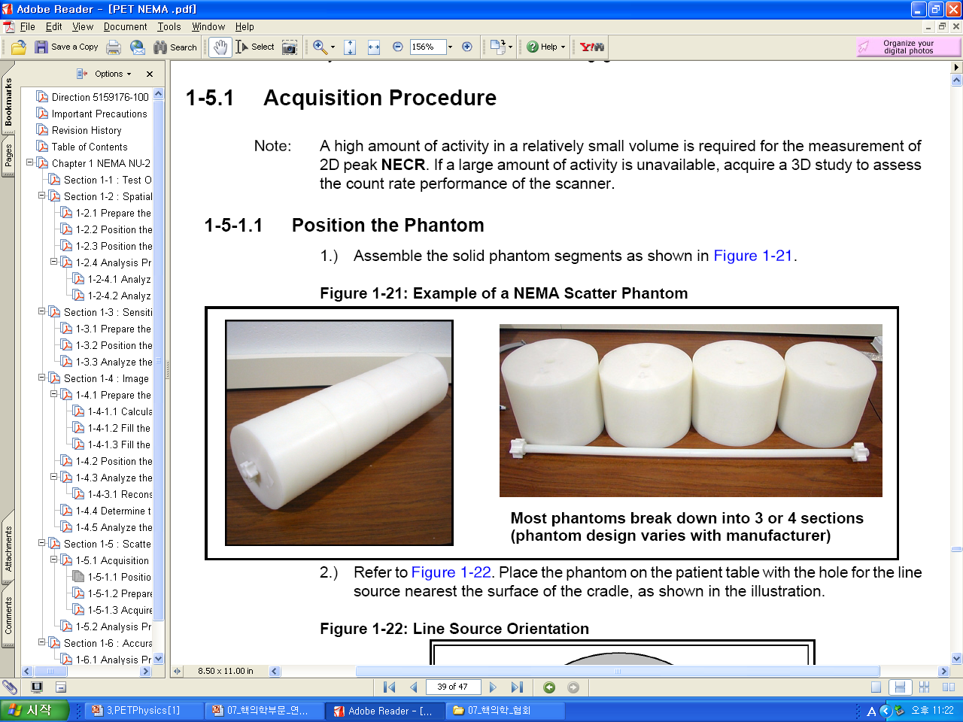

1. Spatial Resolution
2. Sensitivity
3. Scatter Fraction
4. Image Quality Measurement

Q70.Which phantom is not related with resolution measuring?

1. Sheet phantom
2. Quadrent bar phantom
3. FWHM
4. Derenzo phantom