放射線機器管理士測驗

Medical Imaging and Radiologic Systems Manager

2013年8月25日星期日

1. 除題意不清楚或是圖片有問題，禁止詢問與試題有關的問題。

2. 應答時禁止使用任何文件。

3. 請在電腦答案卡上圈選作答

|  |  |
| --- | --- |
| ***項目*** | **填寫內容：** |
| *姓名* | 您的中文與英文姓名 |
| *試題名稱* | MRSM Test |
| *項目* | 不用填寫 |
| *科目* | 不用填寫 |
| *受試者識別代碼* | 您的准考證號碼 2**”000**”**  將您選定之數字的圓圈塗滿。 |
| *科目代碼* | 不用填寫 |
| *地點代碼* | 不用填寫 |
| *作答方式* | 本測驗共有70題問題。請使用1到70作答欄位。  請將測驗卷Q1的答案填入答案卷的解答番號1。Q2 = 解答番號2，Q3 = 解答番號3…Q70 = 解答番號70。 |

1. Choose the correct criterion for replacing an image intensifier.
2. When five years have passed.
3. When the quality of perspective images is degraded.
4. When a certain level of irradiation dose is reached.
5. Decide the time of replacement by managing both irradiation dose and luminance.
6. Choose the answer that correctly describes daily inspection.
7. Start-of-day checks, based mainly on visual inspection, intended to minimize any influence on clinical practice.
8. End-of-day checks shall take time to focus on the items that cannot be covered by start-of-day checks.
9. Daily inspection shall take time to ensure quality by checking predetermined items.
10. Daily inspection is reliable enough to prevent failures.
11. Choose the answer that does NOT correctly describe a regular inspection.
12. Regular inspection shall take time to cover the items that are not covered by daily inspection.
13. Inspection items shall be determined as necessary according to the modality.
14. Regular inspection can be delegated to the manufacture under a maintenance contract.
15. The user shall conduct a regular inspection to control quality by setting a certain interval for each item.
16. Choose the answer that does NOT correctly describe the maintenance of equipment.
17. The safety tests include those related to mechanics, electricity, and radiation.
18. The maintenance includes regular parts replacement as a preventive measure.
19. Performance test items shall be determined by the user and conducted by the manufacture.
20. Care must be taken to prevent infection as a safety measure.
21. Which of the following is included in the development of hypothesis among 4 steps of Quality Improvement?
22. The step to decide what to improve
23. The step to know discovered problems or understand improve opportunity in detail
24. The step to find that which changes will connect improvement
25. The step to verify hypothesis to assure solution presented whether improve expected results.
26. Which of the following is not concerned with Quality Assurance?
27. 6 sigma
28. Quality Plane Treatment
29. Total Quality Management
30. Continuous Quality Improvement
31. Which consideration of the following is not true in brain storming?
32. Handle the subjects in inclusive concept
33. Begin with setting the time of brain storming
34. Arrange the list and plan for performing
35. Giving the time for establishing their own opinions to participants.
36. Choose the answer that does NOT correctly describe X-ray tube.
37. The tube current is inversely proportional to the square of the inter-electrode distance.
38. The distribution of radiation intensity depends on target angle.
39. Extra-focal X-rays are caused by electrons that are not converged by the electric field.
40. The effective focus size increases with decreasing tube voltage and increasing tube current.
41. Choose the answer that correctly describes the mammographic X-ray equipment.
42. The heel effect of the X-ray tube is not utilized.
43. Aluminum is used at the radiation aperture.
44. Molybdenum is used for the additional filter.
45. A focus size with a nominal large focus of 1.0 mm is used.
46. How many limitation lesions are there in the mammo-phantom( It is made out of 50% breast parenchymal/50% fat and is pressed into 4.2cm)?
47. fiber 6 speck 5 mass 5
48. fiber 6 speck 6 mass 5
49. fiber 5 speck 5 mass 6
50. fiber 5 speck 6 mass 6
51. Which is right about the proper average glandular dose in one exposure for a mammography?
52. 1.5mGy and below
53. 2.0mGy and below
54. 2.5mGy and below
55. 3.0mGy and below
56. Choose the answer that does NOT correctly describe grids.
57. The exposure factor increases with increasing grid ratio.
58. The size of the exposure field affects the content of scattered X-rays.
59. The gird ratio is the ration between the height of lead strips and the distance between them.
60. The degree of grid contrast improvement is expressed by the reciprocal of total X-ray transmittance.
61. Choose the answer that correctly describes image intensifiers.
62. Output luminance increases with the decreasing size of the field of view.
63. Resolution improves with the increasing size of the input field of view.
64. The conversion factor is given as the ratio between output luminance and X-ray dose at the center of the incident field.
65. In a view-variable tube, the field of view is controlled by changing the current of the acceleration electrode.
66. Which is right about phantom that is used to measure the MTF in the fluoroscopy device?
67. Burger-Rose
68. Slit camera
69. Resolution
70. Start test
71. Choose the answer that does NOT correctly describe inverter-type X-ray equipment.
72. The maximum rating is restrained by the supply power capacity.
73. The efficiency of the high-voltage transformer is improved by adopting a higher frequency.
74. X-rays can be blocked regardless of the power supply phase.
75. Even with a single-phase power supply, the quality of X-rays comparable to that obtained with a 12-peak generator can be achieved.
76. Which description is NOT right about the image intensifier?
77. The input screen converts X-ray into light.
78. The photocathode converts light form the input screen into the photoelectron.
79. The image intensifier is a vacuum tube.
80. Digital signal is detected directly from the output screen.
81. Which is NOT right about DAP?
82. It is mainly used in the fluoroscopy device.
83. DAP is attached on the front side of an iris, where an additional filter is attached.
84. A rear dispersion coefficient is included.
85. If the SOD changes, the value of DAP measurement changes too.
86. What is the quality measurement item using this test tool (Star test pattern)?

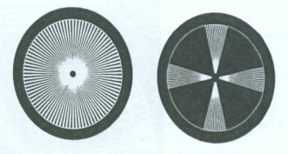

1. mA Linearity
2. Focal spot test
3. kVp accuracy
4. mAs reciprocity
5. The maximum variability allowed for the reproducibility of exposure is ± ---------- %
6. 2
7. 5
8. 10
9. 15
10. What is the purpose of grid?
11. resolution
12. sharpness
13. density
14. contrast
15. What is the purpose of these tools in quality measurement of diagnostic X-ray generator?

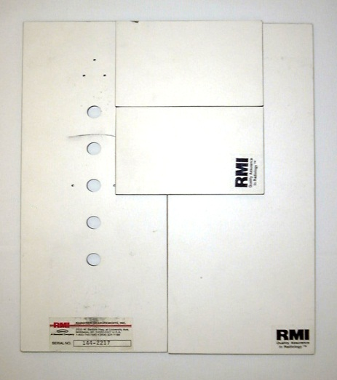

1. Grid alignment test
2. AEC (Automatic Exposure Control) reproducibility test
3. HVL (Half Value Layer) test
4. Timer accuracy test
5. How much is the absorber thickness for resolution pattern using in fluoroscope?
6. 0.01mmPb
7. 0.05mmPb
8. 0.1mmPb
9. 0.2mmPb
10. The reason why using a low kVp in mammography is to:
11. reduce contrast and reduce patient dose
12. increase contrast but increase patient dose
13. reduce contrast but increase patient dose
14. increase contrast and reduce patient dose
15. What is the usual range of force for mammographic system compression device?
16. 5 to 20 lb
17. 15 to 30 lb
18. 25 to 45 lb
19. 45 to 60 lb
20. What is reasonable SID(Source-Image receptor Distance) in Mammography?
21. 55 cm
22. 65 cm
23. 75 cm
24. 80 cm
25. The indicated level of the tomography section and the actual level of the section must correspond to within is ± ---------- mm
26. 2
27. 5
28. 10
29. 15
30. How much is the limitation of maximum value of Entrace Exposure Rate(EER) in the device equipped with AEC?
31. 1R/min
32. 5R/min
33. 10R/min
34. 100R/hr
35. Choose the item that is relevant to CT resolution in the axial direction.
36. Display pixel size
37. Detector sensitivity
38. Slice thickness
39. Scan time
40. Choose the item that is relevant to artifacts in X-ray CT.
41. Multiple reflection
42. Side lobe
43. Beam hardening
44. Misregistration
45. Choose the correct characteristic of computed tomography dose index (CTDI).
46. Proportional to slice thickness
47. Proportional to tube current
48. Proportional to tube voltage
49. Proportional to objective thickness
50. Which is right as the CT dose index of a patient’s CT radiation exposure?
51. mR/100mAs
52. mSv/100mAs
53. mGy/100mAs
54. kV×mAs
55. Which is right about the load and movement distance of a table in inspecting the accuracy of the movement interval of a patient’s table?
56. 50-60kg,10cn
57. 50-60kg,30cm
58. 70-80kg,10cm
59. 70-80kg,30cm
60. What is this CT image for?

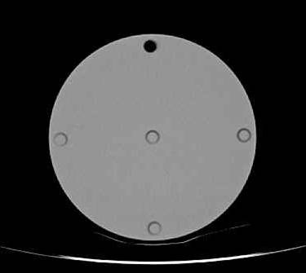

1. uniformity
2. contrast resolution
3. spatial resolution
4. Computed Tomography Dose Index (CTDI)
5. How much is the discriminable range of spatial resolution in the test of CT standard phantom?
6. above 0.6 mm
7. below 0.8 mm
8. below 1.0 mm
9. below 1.2 mm
10. What do we figure out from this image?

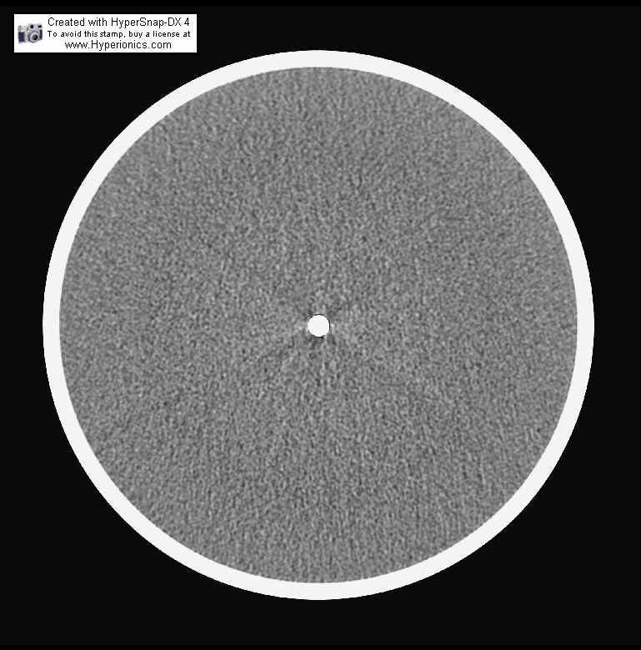

1. Noise
2. Artifact
3. CT number
4. Uniformity
5. What do we figure out from this image?

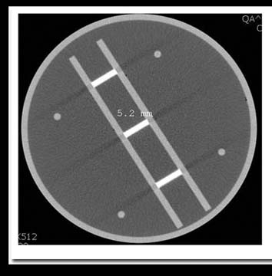

1. noise
2. uniformity
3. artifact
4. slice thickness
5. Which of following is not true about Multi Detector Computed Tomography?
6. using cone beam X-ray
7. decision slice thickness by collimator
8. acquisition of multiple slice images
9. Pencil type ionization chamber dosimeter
10. MR examination is generally accompanied by a very large noise. Choose the type of coil that leads to noise reduction when plan placed in a vacuum.
11. Body coil
12. Phased array coil
13. Gradient coil
14. Magnetostatic coil
15. There are several methods of signal-to-noise ratio (SNR) measurement based on different definitions of noise. Choose the most precise and recommended method.
16. Background noise method based on standard deviation
17. Background noise method based on average
18. European Union (EU) method
19. NEMA and AAPM methods
20. Which is the recommended value of magnetic strength for the entry restriction to the MRI room for people who have a cardiac pacemaker?
21. 50 gauss
22. 10 gauss
23. 5 gauss
24. 0.5 gauss
25. Which of following is not measurement item of MRI phantom image?
26. linearity
27. contrast resolution
28. accuracy of slice thickness
29. percent ratio of ghost signals
30. What is learned about this MRI image?

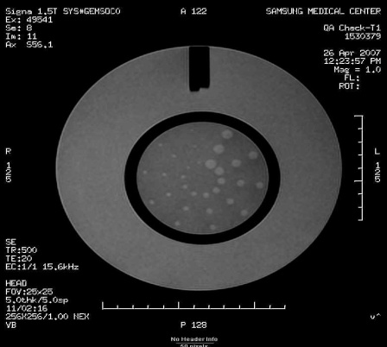

1. Uniformity
2. Slice thickness
3. Spatial resolution
4. Contrast resolution
5. What is this image for?

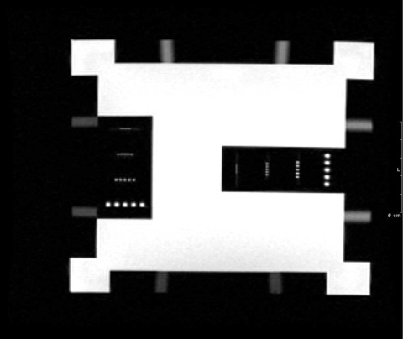

1. spatial resolution
2. linearity
3. uniformity
4. slice thickness
5. This is for evaluation of ghost artifact creation. What is the passing grade of proportion range of ghost in this image?

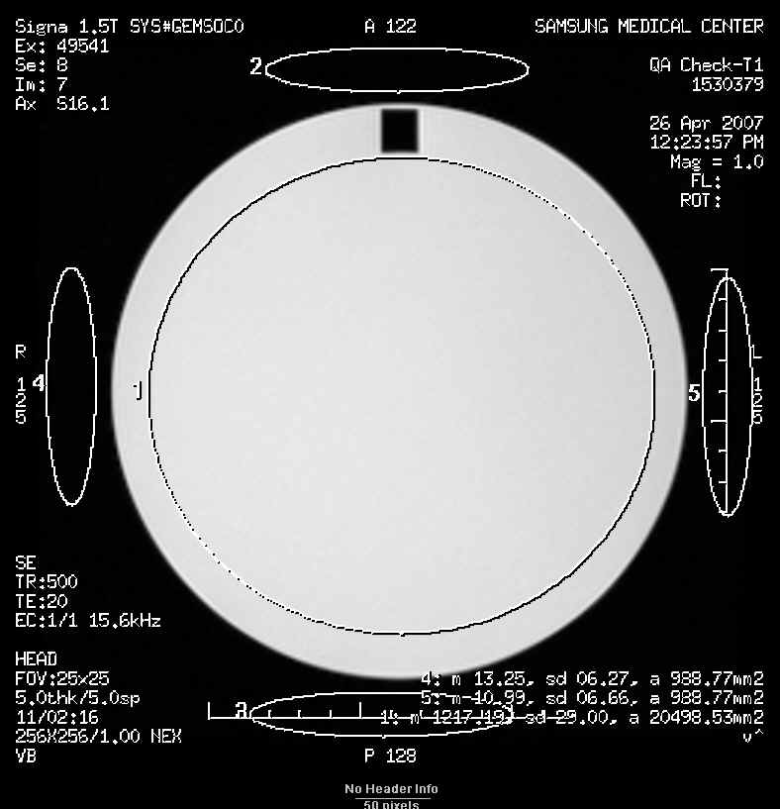

1. above 2.5~2.8%
2. below 2.5%
3. above 2.5%
4. above 3.0%
5. Choose the combination of correct actions.
6. Check for any cracks or damage on the probe surface before ultrasonic examination.
7. Check for any looseness in the probe connector that connects the probe qith the main unit.
8. Always wipe off gel from the probe surface.
9. Disinfect or sterilize the probe according to the procedure recommended by the manufacturer.
10. A,C,D
11. B,C
12. D
13. A,B,C,D
14. Choose the combination of correct descriptions.
15. Exercise due care not to drop or impact the probe.
16. If the probe can be disinfected, tis connector part may be exposed to water or chemicals.
17. Probes and cables may be degraded by high-temperature disinfection.
18. Check for any distortion in the probe cable.
19. A,C,D
20. B,C
21. D
22. A,B,C,D
23. Choose the combination of correct descriptions about ultrasonic diagnostic equipment.
24. Regular inspection can be totally delegated to the manufacturer.
25. Tap water is used as it is for a water phantom.
26. Degradation of image quality is easily recognized in daily use.
27. Regular inspection includes the confirmation of resolution in distance and direction.
28. A,C,D
29. B,C
30. D
31. A,B,C,D
32. Which is NOT right as a proper use of ultrasonic equipment?
33. To freeze after inspection.
34. To arrange the probe cables after inspection.
35. To pull out the probe in an acting position from the connector.
36. To remove the gel on the surface of the probe after inspection.
37. Which of following is not true about transducer check?
38. check the rubber has a gap
39. check on crystal defect
40. freeze after scan
41. sterilize with heat for disinfection of probe
42. This image is about the inspection for transducer. Which of following can be said about this?

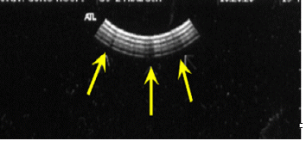

1. it is main bang effect.
2. it is about crystal defect check.
3. it is about inspection of cables.
4. this inspection is for checking that the rubber has a gap.
5. What is the thing to adjust the brightness through control of dynamics of received ultrasonic signal generally
6. T.G.C (Time Gain Control)
7. Gain
8. Dynamic range
9. Output power
10. Which of the following is not true about receiver function?
11. Amplification (Gain)
12. Compensation (T.G.C)
13. Rejection
14. Converting TV signal
15. Which of following is not included in QA for the equipment in Radiation Oncology?
16. Linac
17. Co-60 Telemedicine Apparatus
18. Treatment Simulator
19. Computed Tomography
20. What is the appropriate measurement tool for the calibration of Ir-192 source 10Ci using in High Dose Rate (HDR) Remote After Loading?
21. Film
22. Well Type ionization chamber
23. GM (Geiger Mueller) counter
24. Parallel Plate type ionization chamber
25. Choose the item that is NOT used for high-energy electron beam therapy
26. Linac
27. Betatron
28. Microtron
29. Cyclotron
30. Which is right as the basic equipment of a simulator that is used in the Department of Radiation Oncology at the geometrically-spatially accuracy examination?
31. Brachytherapy unit
32. CT
33. RTP
34. Linac
35. What is the item of Quality Control for radiation treatment devices in this picture?

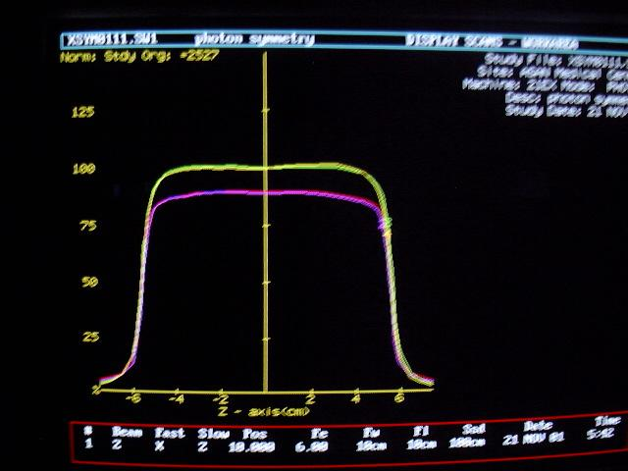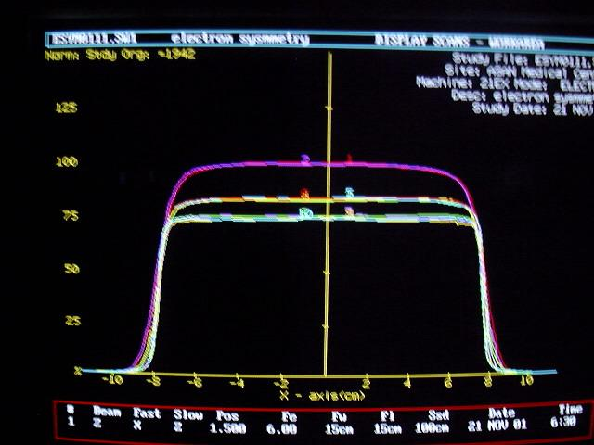

1. PDD
2. Energy
3. Symmetry, Flatness
4. TMR
5. What is the item of Quality Control for radiation treatment devices in this picture?

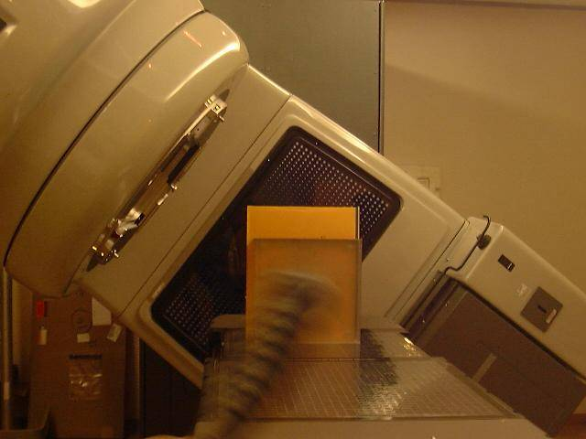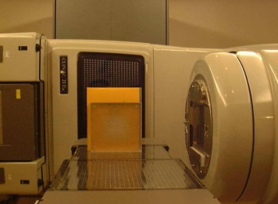

1. Center of rotation test of Couch
2. Center of rotation test of Gantry
3. Collimator cross hair line
4. Center of rotation test of Collimator
5. What are the measurement result and the allowable level in the item of photon beam test as following image?

그림1

1. Flatness – 2%
2. Flatness – 3%
3. Symmetry – 2%
4. Symmetry – 5%
5. Choose the item that is NOT required for measuring the size of a high-energy X-ray irradiation field.
6. Gird sheet
7. Angle gage
8. Slide gage
9. High-energy photographic film
10. Choose the correct way to measure the performance of gamma cameras.
11. Ring artifacts in SPECT are affected by integral uniformity.
12. Co-60 is used as a standard source to measure energy resolution.
13. Precise measurement of radioactivity is not required in count rate measurement.
14. Inherent uniformity test results improve with increasing cunt rate.
15. Choose the item that is NOT included in the performance test of gamma cameras.
16. Directional dependence
17. Spatial resolution
18. Shield capability
19. Spatial linearity
20. Choose the answer that does NOT correctly describe RET equipment.
21. A collimator comparable to that of SPECT is not required.
22. Smaller detector ring radii are suitable to obtain higher resolution images.
23. Different positron-emitting nuclides result in different levels of resolution.
24. Image quality is improved by extending the time window of coincidence counting.
25. Choose the answer that correctly describes PET imaging.
26. The proportion of coincident counts in PET increases with increasing counting rate.
27. In three-dimensional PET equipment, data is collected by placing a shield between detector rings.
28. The resolution of PET is higher in the periphery than the center of the field of view.
29. The dosage for the BGO scintillator PET is smaller than that for the for the GSO scintillator PET.
30. Normal FDG distribution would show the least activity in the:
31. brain
32. bone
33. bladder
34. myocardium
35. The philosophy of the ALARA program is to keep the radiation dose:
36. as low as recently authorized
37. as long as reasonably attained
38. as long as reasonably acceptable
39. as low as reasonably achievable
40. Which of the following measures absorbed doses?
41. millicurie
42. becquerel
43. gray
44. all of the above
45. Which of the following collimators will magnify an image?
46. flat field
47. diverging
48. converging
49. high resolution
50. Which of following is not included in the evaluation item of monitor inspection using SMPTE test pattern?
51. 50% APL pattern
52. Cross pass pattern
53. Noise
54. Gray scale
55. Which length of following is dot pitch in the monitor?
56. absolute value of difference between width and height
57. diagonal line
58. height and diagonal line
59. length between dots