Q1.If a patient is taking metformin (antidiabetic drug), it should be withheld ___ hours after a contrast media study?
(1) 12
(2) 24
(3) 48
(4) 72

Q2.which of the following is/are symptom(s) of inadequate oxygen supply?
1. diaphoresis 2. Cyanosis 3. dyspnea
(1) 1 only
(2) 1 and 2 only
(3) 2 and 3 only
(4) 1,2, and 3

Q3.Which of the following statements about contrast medium is true ?
(1) A ccurate prediction of a contrast reaction could be achieved by test injection.
(2) Vasovagal reactions are common and characterized by hypotension with tachycardia.
(3) Prior reaction to contrast injection is the best predictor of recurrent adverse reaction.
(4) Nearly all life-threatening reactions occur 20 minutes later after contrast medium administration.

Q4.Which of the following is not a category of iodinated contrast agents?
(1) Ionic monomer
(2) Ionic dimer
(3) Nonionic dimer
(4) Nonionic trimer

Q5.Ionic contrast agents may be formulated with either _____ salts or _____ salts.
(1) meglumine; sodium
(2) chlorine; sodium
(3) meglumine; chlorine
(4) bromine; chlorine

Q6. Non-ionic dimeric, iso-osmolar, contrast agents have an osmolality of _____ mOsm/Kg water.
(1) 100
(2) 200
(3) 250
(4) 290

Q7. All of the following diseases or conditions may increase a patient’s risk for contrast-induced nephropathy, except:
(1) diabetes
(2) cardiovascular disease
(3) colitis
(4) multiple myeloma

Q8. The combination of metformin and iodinated contrast can put the patient at a higher risk for developing _____.
(1) lactic acidosis
(2) pheochromocytoma
(3) multiple myeloma
(4) extravasation

Q9.Which of the following clinical laboratory tests is not an indicator of renal function?
(1) BUN
(2) Renin
(3) Serum creatinine
(4) Glomerular filtration rate

Q10.Which of the following statements is not characteristic of epinephrine?
(1) The concentration for slow IV administration is 1:10,000.
(2) The concentration for subcutaneous or intramuscular delivery is 1:1,000.
(3) It is a vasodilator.
(4) It is a bronchodilator.

Q11.Which of the following medication may be administered to accelerate the SA node of the heart in patients exhibiting a vasovagal response to an iodinated contrast injection?
(1) Morphine
(2) Diphenhydramine
(3) Albuterol
(4) Atropine

Q12.Acceptance testing is not be performed at the time of
(1) initial installation
(2) replacing light localizers
(3) replacing the X-ray tube
(4) replacing detector array

Q13.Which of following is not correct about SI unit
(1) Radiation exposure - C/kg
(2) Absorbed radiation dose- mGy
(3) Effective dose-mSv
(4) Cumulative radiation dose- mGy

Q14.The fundamental radiation dose parameter in CT is the
(1) CT dose index (CTDI)
(2) dose length product (DLP)
(3) the effective dose (E)
(4) the peak tube voltage (kVp)

Q15.Increasing kVp of MDCT would have what effect on the CTDIw?
(1) increase
(2) decrease
(3) no change
(4) stochastic increasing

Q16.What is the relationship between tube current (mA) and the radiation dose in CT?
(1) inversely proportional
(2) logarithmic
(3) linear
(4) exponential
Q17.What is the relationship between pitch and the radiation dose during CT examination?
(1) inversely proportional
(2) logarithmic
(3) linear
(4) exponential

Q18.The image noise in CT is not influenced by
(1) kVp
(2) mAs
(3) slice thickness
(4) pitch

Q19.There are number of factors that influence low contrast resolution, but not including
(1) tube current
(2) x-ray photo flux
(3) pitch
(4) reconstruction algorithm

Q20.Partial volume artifacts are best avoided by
(1) using thin slice acquisition
(2) increasing kVp
(3) decreasing mAS
(4) using faster rotation

Q21.The image noise in CT is estimated by
(1) the standard deviation of CT numbers in the select region of interest.
(2) the mean value of CT numbers in the select region of interest.
(3) the ratio of the table feed per gantry rotation to the x-ray beam width.
(4) using modulation transfer function.

Q22.Spatial resolution could be determined objectively by using
(1) PSF (point spread function)
(2) MTF (modulation transfer function)
(3) LSF (line spread function)
(4) FT (fourier transform)

Q23.There are number of factors that influence the spatial resolution in CT
scanners, but not including
(1) x-ray focal spot size
(2) detector aperture
(3) reconstruction algorithms
(4) scan length

Q24.With MDCT scanners, the longitudinal resolution is influenced by many factors, but excluding
(1) the DAS channel width
(2) the interpolation reconstruction algorithm
(3) pitch
(4) FOV size

Q25.Which one is measured on the slice-sensitivity profiles as parameters to quantify the longitudinal resolution?
(1) FWHM (full-width at half maximum)
(2) pixel size
(3) matrix size
(4) reconstruction increment

Q26.Which of the following statement about CTDI or DLP is not true?
(1) CTDI_{vol} is a measure of exposure per slice.
(2) DLP is measure of total radiation exposure for the whole series of images.
(3) CTDI_{vol} is dependent of scan length.
(4) DLP is proportional to scan length.

Q27.Which one is related to radiation risk ?
(1) DLP
(2) MTF
(3) CTDI_{vol}
(4) FWHM

Q28.Which of the following statement about CTDI or DLP is not true?
(1) CTDI₁₀₀ is the average dose of the scanned plane in standard phantoms.
(2) CTDI_{w} is the average dose in the scanned plane.
(3) CTDI_{vol} is the average dose over the scanned volume.
(4) DLP is indicator of the total radiation dose for the scanned volume.
Q29.There are two subjects (A & B) to receive the CT examination. The scanned length (L) ratio is L_{A}：L_{B} = 1：2. The Pitch (P) ratio is P_{A}：P_{B} = 1：2. The CTDI_{vol}-A to CTDI_{vol}-B is 2 : 1.
(1) DLP_{A} is bigger than DLP_{B}.
(2) DLP_{A} is smaller than DLP_{B}.
(3) DLP_{A} is equal to DLP_{B}.
(4) DLP_{A} cannot compare with DLP_{B}.

Q30.The CT accreditation phantom from the American College of Radiology contains four modules to evaluate the CT scanner performance. This phantom provides parameters or functions for CT acceptance and annual testing, but excluding
(1) high contrast resolution
(2) uniformity and noise
(3) dose profile
(4) slice thickness

Q31.According to the following formulas, which one is not true?
(1) CTDI_{w}=1/3 CTDI_{100,center}+2/3 CTDI_{100,edge}
(2) CTDI_{vol}=pitch/ CTDI_{w}
(3) DLP= CTDI_{vol} × scan length
(4) Effective dose=k × DLP (k: a conversion factor)

Q32.Which of following is correct about Filtered Back projection (FBP)?
(1) Transformation of Data into Fourier Domain
(2) Filtering of Data
(3) Transformation of Data Back into Spatial Domain
(4) All of the above

Q33.Which of following is not correct about the advantages of Multi-slice helical scan?
(1) Large coverage and faster scan
(2) Less patient motion artifacts
(3) Near-isotropic spatial resolution
(4) Non of the above

Q34.During nonvolumetric data acquisition, which artifact of VR images is frequently encountered ?
(1) Streaking (2) Shading
(3) Rings (4) Stair-step
Q35.Which of following is not correct about 3D volume rendering methods supported?
(1) Grayscale with Opaque Voxels
(2) Grayscale with Transparent Voxels
(3) Color with Transparent Voxels
(4) All of the above.

Q36.VR image voxel opacity curve (Rander tissues) can be adjusted by
(1) kVp
(2) HU.
(3) mAs
(4) All of the above

Q37.The rendering technique is an important technical determinant of 3D images. There are a number of different methods, including which of the followings?
(1) surface-based (binary) techniques
(2) volume–based (continuous) techniques
(3) All of the above
(4) None of the above

Q38.Which of the following is correct about volume rendering?
(1) color the usually scalar data and visualize
(2) different structures transparent
(3) organs semi-transparent, or opaque
(4) All of the above

Q39.With dual source CT, which is the most improved ?
(1) temporal resolution
(2) reduce the slice width
(3) noise
(4) contrast.

Q40.What is the most important factor for enabling the similar image quality to that of transverse image without complicated interpolation steps?
(1) lower pitch
(2) reduction in portial volume
(3) isotropic voxels
(4) minimum section thickness.
Q41.What is the best reconstruction technique in radiation dose reduction for pediatric CT and maintains image quality and diagnostic confidence?
(1) filtered back projection
(2) Fouries transformation
(3) MTF(modulation transfer function
(4) hybrid interative reconstruction.

Q42.Which is the best tool in the dose reduction algorithm the PICCS (prior image contrained compressed sensing) ?
(1) FBP(filtered back projection)
(2) MTF(modulation transfer function
(3) PICCS(prior image contrained compressed sensing)
(4) Fouries transformation.

Q43.One major advantage of dual energy CT imaging in patients with masses is the
(1) reduce noise
(2) reduce the effective radiation dose
(3) improve spatial resolution
(4) improve brightness.

Q44.Using sixteen-detector row CT of abdomen and pelvis for optimization of Z-axis modulation technique. What is the best noise index(HU) in acceptable image quality and reduction in radiation exposure?
(1) 10.5
(2) 12.5
(3) 15
(4) 20

Q45.In dual-source CT, which is the best angle between the two x-ray tubes?
(1) 45
(2) 90
(3) 120
(4) 180.

Q46.Which is not correct for the description of Temporal bone HRCT?
(1) It needs thin slice.
(2) The two basic planes is axial and sagittal planes.
(3) Two petrosal bones are reconstructed separately to display in smaller display FOV to ensure optimal resolution.
(4) The organs of hearing and balance are located in the petrous ridge of temporal
bone.

Q47.Which is not correct for imaging posterior fossa?
- Different head sizes make imaging posterior fossa hard.
- Great difference in beam attenuation of brain and skull.
- It needs thin slice thickness.
- It needs higher kVp setting.

Q48.Which is not correct about CT brain perfusion scans?
(1) CBF=CBV/MTT (CBF: cerebral blood flow, CBV: cerebral blood volume, MTT: mean transit time
(2) It is used to distinguish infracted tissue from the penumbra with acute stroke.
(3) It needs more than 100mL iodinated contrast media to finish the procedure.
(4) The injection rate is about 4-5mL/sec.

Q49.Which is correct?
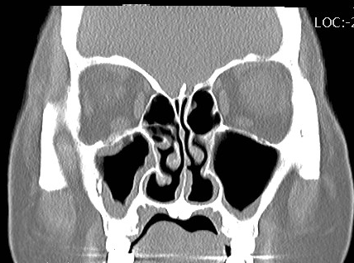
A
B
C
D
A. frontal bone B. maxillary sinus C. lateral rectus m.
D. frontal sinus
(1) AB
(2) ACD
(3) ABCD
(4) ABD

Q50.Which is correct?
A: external jungular vein , B:common carotid artery ,
C:vertebral canal with spinal cord, D: vertebral artery
- ABC
- ACD
A
- BCD
B
D
- ABCD
C

Q51.Which is not true about GI contrast media for CT scan?
- Agents with positive HU values are considered positive contrast agent.
(2) Agents with negative HU values are considered negative contrast agent.
(3) Water is a neutral agent.
(4) 50-70% conventional radiography barium sulfate suspension is used for CT scan.

Q52.Which is not true about contrast arrival times after injection into the right cubital vein in a normal patient？
- Aorta: 15-22 seconds
- Renal artery: 18-27 seconds
- Renal vein: 22-30 seconds
- Hepatic vein: 30-40 seconds

Q53.Which is the most common material of urinary tract stone？
B
A
C
D
- Calcium salts
- Cystine
- Uric acid
- Xanthine

Q54.Which is correct？
A. left external iliac artery
B. left external iliac vein
C. rectum
D. uterus
- AB
- ACD
- ABCD (4) ABC
Q55.Which is not true about adrenal masses ? Percentage washout= [Enhanced-Delayed) (HU)/ (Enhanced-Unenhanced) (HU) ]*100%
- Relative Contrast washout = [(Enhanced-Delayed(HU)/Enhanced(HU)]*100%
- To differentia adrenal mass, delayed phase is obtained at 3 minute
- A percentage washout greater or equal than 60%, or relative washout greater or equal than 40% is specific for benign adenoma.
- There are not true in the above answers.

Q56.Which of the image processing technique is used on the image below?
- Multiplanar Reformation
- Curved Planar Reformation
- Average Intensity Projection
- Maximum Intensity Projection

Q57.Which of the following statements is incorrect about “Perfusion CT Analysis of Hyperacute Ischemic Stroke”?
- Infarct core=MTT→Elevated
- Infarct core= CBF→Markedly decreased
- Infarct core= CBV→Normal or mildly increased
- Nonenhanced CT→Hypoattenuating parenchyma

Q58.What’s your diagnosis about the image below?
- Aneurysms
- Peripheral arterial occlusive disease
- Deep vein thrombosis
- Infected prosthesis
Q59.What is the diagnosis for the image below?
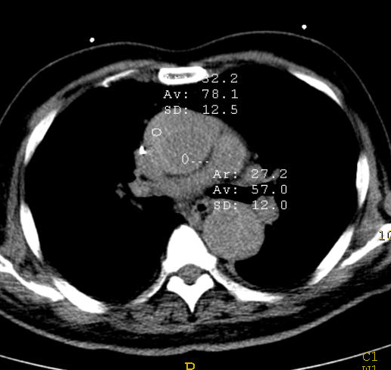
(1) Aneurysms
(2) Type A aortic dissection
(3) Type B aortic dissection
(4) Intramural hematoma
Q60.What is the diagnosis for the image below? 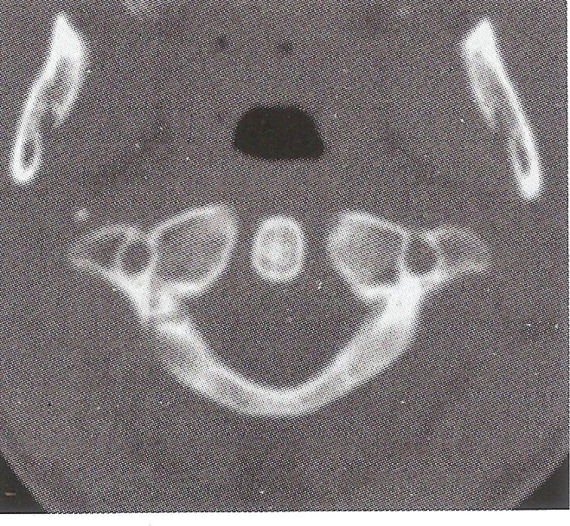
  - Occipital condyle fracture
  - C1 fracture
  - C2 fracture
  - C3 fracture

Q61.What’s the impression about the image?
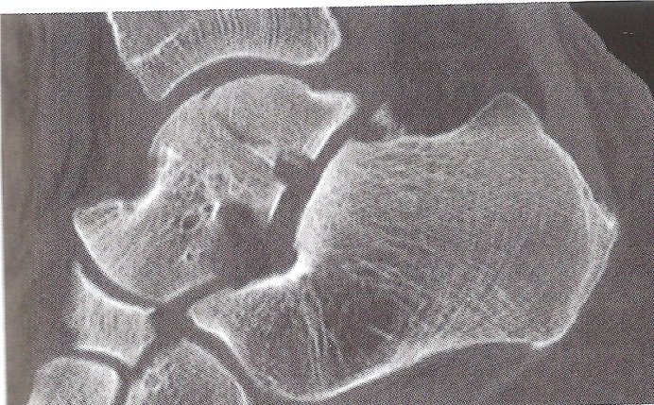
  - Talus fracture
  - Calcaneal fracture
  - Metatarsal bone fracture
  - Cuboid bone fracture

Q62.Retrospective ECG Gating has significant advantages over Prospective ECG Triggering:
Ⅰ. less sensitivity to heart rate changes during the scan.
Ⅱ. Image can be reconstructed in every cardiac cycle.
Ⅲ. requires a higher dose
- Only Ⅰ and Ⅲ are correct.
- Only Ⅱ is correct.
- Only Ⅱ and Ⅲ are correct.
- All are correct.

Q63.Which of the following statement is correct about the contraindications for beta-blockers?
- Bronchial asthma
- AV block
- Severe hypotension
- Overt heart failure
- Only Ⅰ and Ⅲ are correct.
- Only Ⅰ and Ⅱ is correct.
- Only Ⅱ and Ⅲ are correct.
- All are correct.

Q64.What does the image below show?
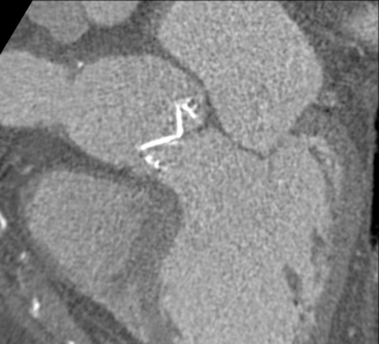
- Aortic valve Prosthesis
- Mitral valve Prosthesis
- Tricuspid valve Prosthesis
- Pulmonary valve Prosthesis

Q65.What is the major difference of HRCT of lung and conventional CT?
(1) HRCT is suitable for detecting the relationship of tumor and mediastinum and lymphadenopathy.
(2) HRCT is suitable for evaluating interstitial infiltrative diseases.
(3) HRCT is a high resolution imaging using conventional CT data set.
(4) Because the scanning thickness of HRCT is only 1 ~ 2 mm, contrast agent is needed for enhancement.

Q66.What is incorrect about infection control in CT rooms?
(1) Asepsis is applied for every invasive procedure or management.
(2) We should re-use clearly used injections and alcohol swabs as much as possible.
(3) We should keep sterilized materials in fixed place.
(4) Except single used materials, all materials used in invasive procedure should be sterilized and re-used.

Q67.Which of following is the incorrect direction for management of contrast media?
(1) Throw out the leftover contrast media.
(2) Keep it in the shading.
(3) Keep it at room temperature or in refrigerator.
(4) Don’t mix contrast media at one’s option.

Q68.Which of the following is incorrect answer for cardiopulmonary resuscitation?
(1) The chest compressions point for cardiac arrest is the middle of chest.
(2) The compression to ventilation ratio for adults is 30:2.
(3) Compress the chest at the speed of 50 times per minute.
(4) Fully inject air through the mouth for a second and check the patient’s chest.

Q69.Which one is false statement for the following images?
(1) Projection is a sum of rays from one direction.
(2) A sinogram is composed of data from all projection.
(3) Projection continuously projects anatomic structure by rotating 360 degrees.
(4) Back projection was used in the first EMI CT scanner.

Q70.How can we change A image to B image in the following images?
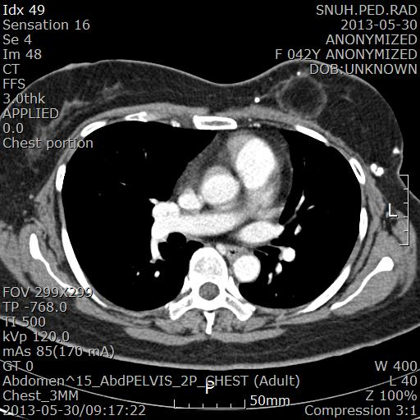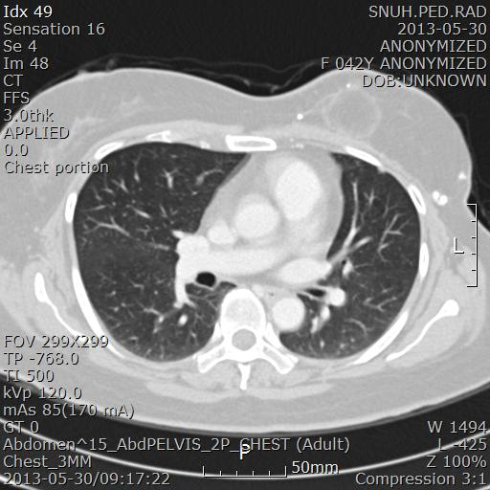
(1) by narrowing WW and lowering WL.
(2) by narrowing WW and heightening WL.
(3) by widening WW and lowering WL.
(4) by widening WW and heightening WL.

Q71.Y-axis of sonogram indicates the:
(1) Number of projection
(2) Back projection
(3) Rotation angle of irradiated X-ray
(4) Number of detectors

Q72.What is the anatomic term of indicated arrow in the following image?
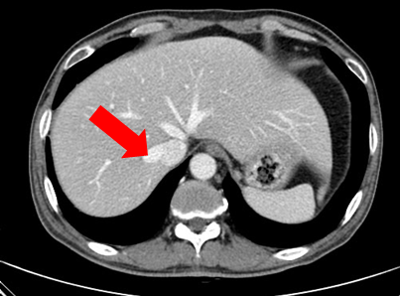
(1) Hepatic artery
(2) Superior mesenteric artery
(3) Portal vein
(4) Hepatic vein

Q73.What is the major complication regarding extravasation after CT examination?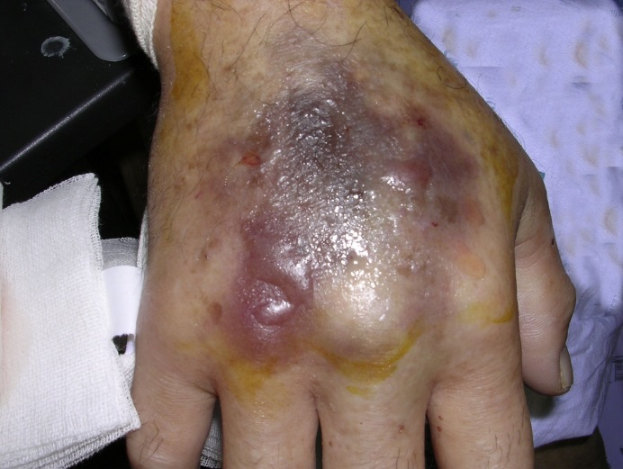
(1) Edema
(2) Erythematous
(3) Tender
(4) Compartment syndrome

Q74.The following images show intracranial aneurysm. The arrows indicate:
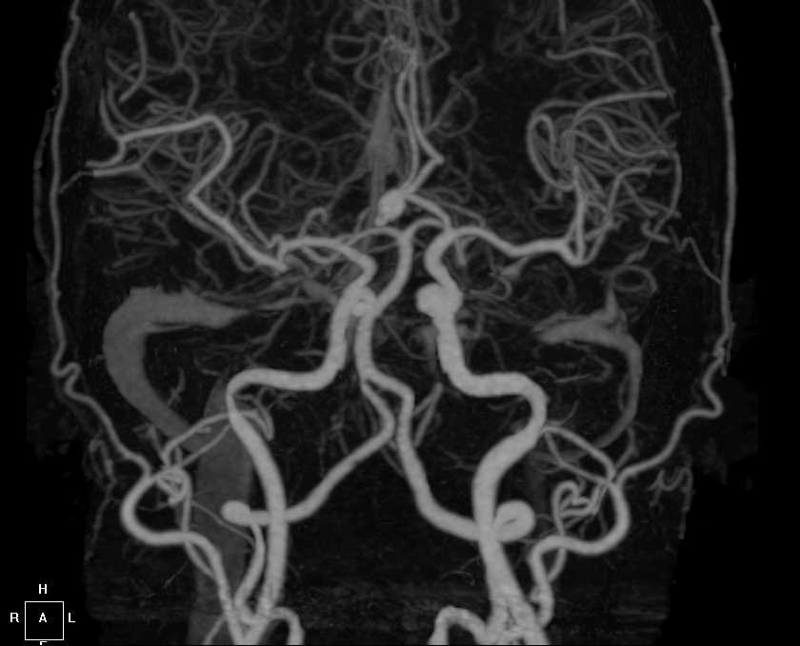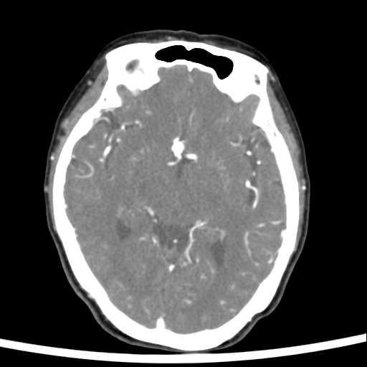

(1) Middle Cerebral Artery
(2) Anterior Communicating Artery
(3) Posterior Communicating Artery
(4) Basal Artery

Q75.A 45-year-old man suspecting SPN in chest apex in general radiography is going to take chest CT. How to reduce the artifact occurred in the following image? (arrow)
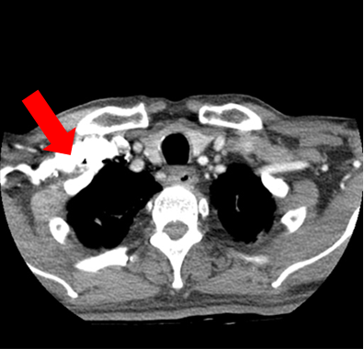
(1) Reduce contrast media dosage.
(2) Increase scan delay time.
(3) Inject contrast media through the intravenous on the foot.
(4) Use high tube voltage.

Q76.Which of the following is incorrect regarding increase factors of occurred artifact in the figure below?
(1) Tube voltage
(2) Thickness of tissue.
(3) Density of tissue.
(4) Tube current.

Q77.Which of the following is correct regarding following pictures?
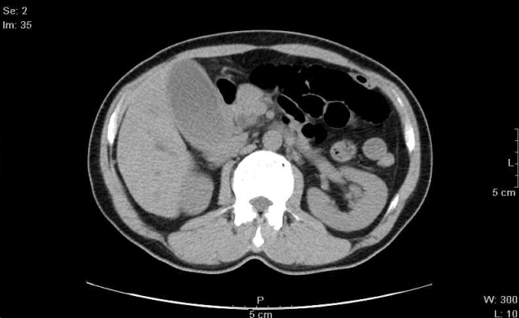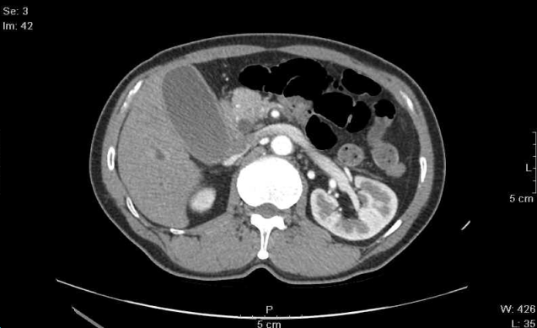
A
B
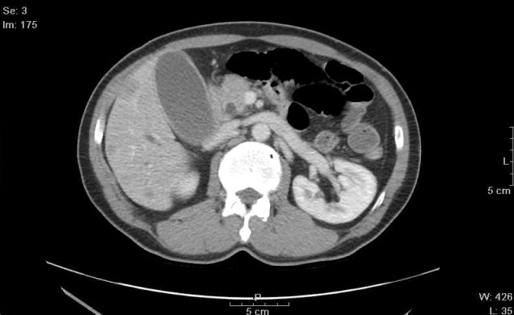
C
(1) Examination order is A-B-C.
(2) GB stone is shown in common bile duct.
(3) There is a cyst of pancreas tail.
(4) Hemangioma is suspicious in these pictures.

Q78.Choose the correct grouping regarding CT angiography in kidney donor in the following images.
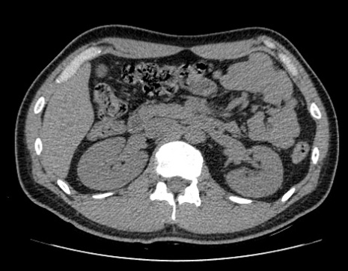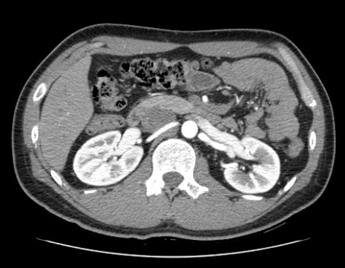
A
B
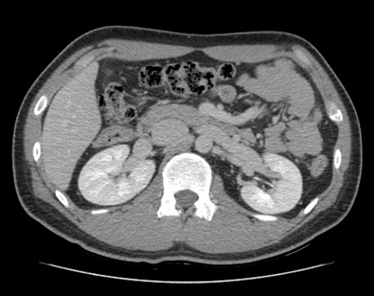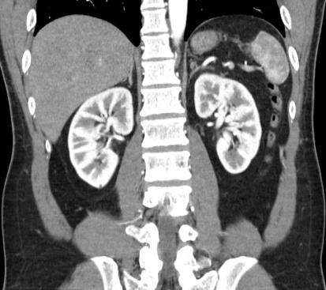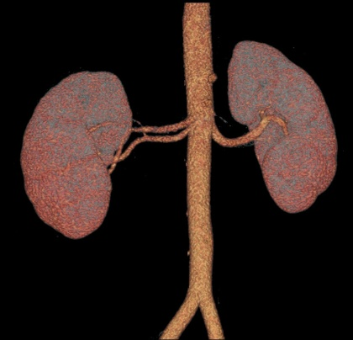
C
D
E
Figure A is pre contrast image
Figure B is arterial phase image
Figure C is delay phase image
Figure D is MIP reconstructed image of arterial phase image
Figure E is VRT reconstructed image of venous phase
(1) 1, 2, 3
(2) 1, 2, 5
(3) 2, 3, 4
(4) 3, 4, 5

Q79.Which one is the best enhanced image of renal pelvis of kidney?
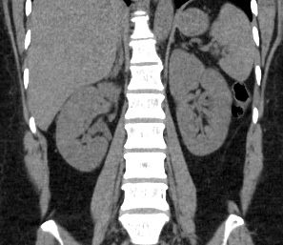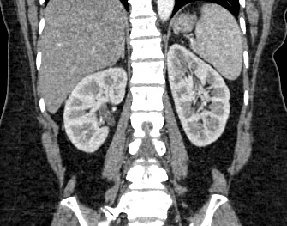
A
B
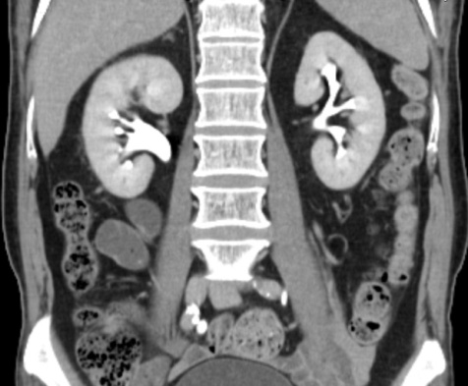
D
(1) A (2) B
(3) C (4) D

Q80.What is the anatomic term of indicated arrow in bottom figure?
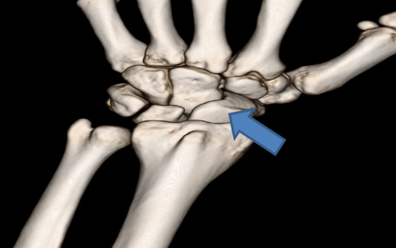
(1) Scaphoid bone
(2) Lunate bone
(3) Trapezium bone
(4) Capitate

Q81.Which of the following is incorrect explanation for bottom images?
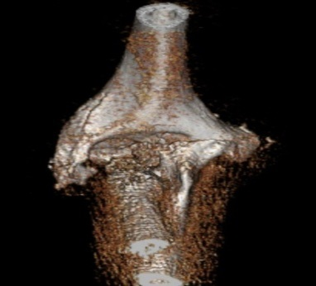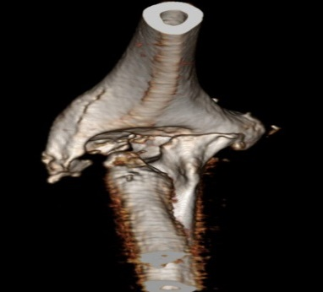
Figure 1 Figure 2
(1) Figure 1 is a 3D reconstructed image using bone algorithm.
(2) Figure 1 and 2 show lesion of fracture.
(3) Figure 2 is a 3D reconstructed image using standard algorithm.
(4) Figure 1 and 2 show metallic artifact.

Q82.What is not related to the following image?
(1) MIP (Maximum intensity projection)
(2) VRT (Volume rendering technique)
(3) LIMA (Left internal mammary artery)
(4) CABG (Coronary artery bypass graft)

Q83.This figure is reconstructed image after coronary CT angiography. What is the artifact or calcification effect of indicated arrow in bottom figure?
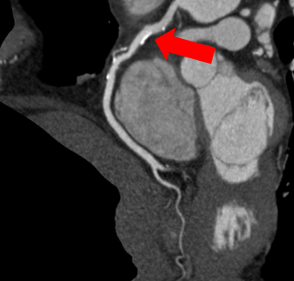
(1) Beam-hardening effect
(2) Partial volume effect
(3) Stair-step artifact
(4) Blooming effect

Q84.ECG gating is an image acquisition technique that acquires images at regular interval using electrocardiogram. Which of the following is incorrect about ECG gating?
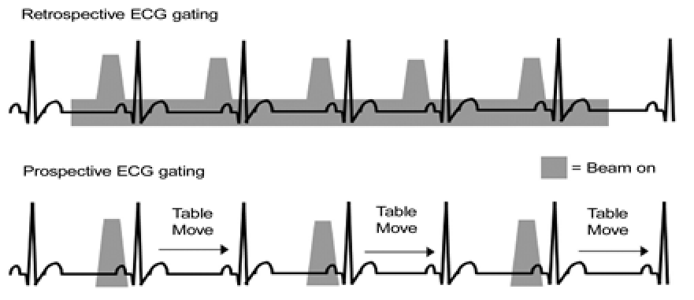

(1) Prospective gating is used in diastole to minimize the motion effect of heart.
(2) We can get obtain superior image using prospective gating to retrospective gating in case of fast heart rhythm or arrhythmia by choosing appropriate heart cycle.
(3) We can get images of various heart cycles and evaluate heart function through retrospective gating.
(4)Radiation dose is more needed in retrospective gating compared to prospective gating.

Q85.The most highest radiation sensitivity tissue or organ in head and neck CT exam is:
(1) Salivary glands
(2) Bone marrow
(3) Thyroid
(4) Nerve cell

Q86.The most dangerous radiation damage to radiation worker is:
(1) Leukemia
(2) Loss of WBC
(3) Loss of hair
(4) Skin cancer

Q87.With same scan protocol (kV, mAs), which examination shows the highest CTDI value?
(1) Head CT
(2) Chest CT
(3) Abdominal CT
(4) Pelvis CT

Q88.When the same part of body is examined, which of the following is the correct cause of increasing the radiation exposure?
(1) Short scan time.
(2) Inhibition of artifact.
(3) Decreasing the number of slice.
(4) Setting up the thin slice thickness

Q89.Which one is the appropriate method to improve this kind of low quality image?
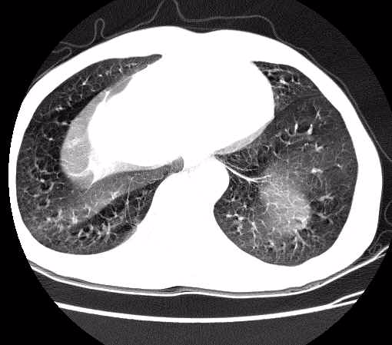
(1) Increase the pitch.
(2) Hold a respiration.
(3) Remove the metal.
(4) Magnify the SPOV.

Q90.What is radiation weighting factor for conversion of absorbed dose to equivalent dose using CT?
(1) 1
(2) 5
(3) 10
(4) 20

