Registration Form
(Officer use only)

No..............................
............/.............../............
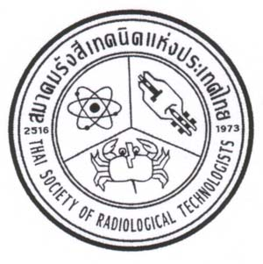
The 24th TSRT Annual Conference
A-One Hotel, Pattaya
27-29 April 2016

1 Registration details (Please Print)
Mr. Mrs. Ms. ......... | Name.....................................................Surname........................
Institute |  | Department
Contact Address
State/Province................................................Postcode..............................................
Telephone No..................................................................
Fax........................................................................E-mail ……………………………………..
2. Registration Fee including Gala dinner
Participants USD 150 (THB 5,500)

3. Payment options
Direct Transfer to TSRT Accont
Siam Commercial Bank, Siriraj Branch
Account Name: “Thai Society of Radiological Technologist”
Saving Account Number: 016-2-652808
SWIFT CODE: SICOTHBK
(Please scan payment slip and send it to E-mail: mtnpp@mahidol.ac.th)
On Site Registration
Payment Receipt Request
(Please Print)
Under participant’s name (Under company’s name)

Name of Company:
Contact Address.........................................................................................................................................
State/Province..........................................Postcode..............................................
Telephone No..................................................................
Fax........................................................................E-mail ……………………………………..
4. Dietary Request
Halal Vegetarian Regular Foods

