สมาคมรังสีเทคนิคแห่งประเทศไทย  ภาควิชารังสีเทคนิค คณะเทคนิคการแพทย์  โรงพยาบาลศิริราช กรุงเทพฯ 10700  โทร. 02-419-7173 โทรสาร 02-246-0052 ต่อ3721  http://www.tsrt.or.th | 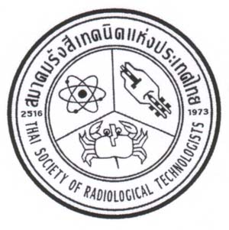 | THAI SOCIETY OF RADIOLOGICAL TECHNOLOGISTS  DEPARTMENT OF RADIOLOGICAL TECHNOLOGY  FACULTY OF MEDICAL TECHNOLOGY  SIRIRAJ HOSPITAL, BANGKOK 10700, THAILAND  www.tsrt.or.th

The 24th TSRT Annual Conference
A-One, Pattaya
27-29 April 2016
--------------------------------------------------------------------------------------
Paper Presentation/RT-Innovation Form

Title..........................................................................................................................................................................

......................................................................................................................................................................................

Author.....................................................................................................................................................................

Co-Author(s)..............................................................................................................................................................

Contact Address …………………………………………………………………………………………………

Telephone No..............................................................................................................................................................

Fax...............................................................................................................................................................................

E-mail……………………………………………..………………………………………………………………

Presentation Types Oral Poster Oral/Poster

Please send abstract before April 1, 2016 to napapong.pon@mahidol.ac.th
Poster size is 80 x 120 cm

