สมาคมรังสีเทคนิคแห่งประเทศไทย  ภาควิชารังสีเทคนิค คณะเทคนิคการแพทย์  โรงพยาบาลศิริราช กรุงเทพฯ 10700  โทร. 02-419-7173 โทรสาร 02-246-0052 ต่อ3721  http://www.tsrt.or.th | 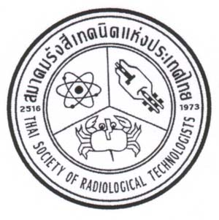 | THAI SOCIETY OF RADIOLOGICAL TECHNOLOGISTS  DEPARTMENT OF RADIOLOGICAL TECHNOLOGY  FACULTY OF MEDICAL TECHNOLOGY  SIRIRAJ HOSPITAL, BANGKOK 10700, THAILAND  www.tsrt.or.th

The 25th TSRT Annual Conference
Lotus Pang Suankaew, Chiang Mai
9-11 February 2017
--------------------------------------------------------------------------------------
Paper Presentation/RT-Innovation Form

Title........................................................................................................................................................................

Author.....................................................................................................................................................................

Co Author(s).........................................................................................................................................................

Contact Address …………………………………………………………………………………………………

E-mail……………………………………………..………………………………………………………………

Presentation Types Oral Poster Oral/Poster

Please send abstract before January 10,2017 to napapong.pon@mahidol.ac.th
Poster size is 80 x 120 cm

